
C1_REG/ST-6
Adaptation Measures for flood and storm water management

Review of existing strategies and planning approaches

Version | Document Title | Author | Review and Clearance
v.1 | Review of existing strategies and planning approaches | Ioanna Zalachori  Stelios Vavoulogiannis | Suzan TAHA

WATER ENVIRONMENT SUPPORT - BIODIVERSITY AND CLIMATE
IN THE NEIGHBOURHOOD SOUTH REGION

The "Water and Environment Support - Biodiversity and Climate Action (WES-BCA-BCA) in the ENI Neighbourhood South Region" project is a regional project funded by the European Union. Implemented in eight Countries in North Africa and the Middle East, WES-BCA aims to improve the protection of the environment, the restoration of biodiversity and the management of scarce water resources, while enhancing the resilience to climate change in the Mediterranean region, strengthening the formulation and enforcement of the relevant policies of the Partner Countries and the two regional political frameworks, namely the Union for the Mediterranean (UfM) and the Barcelona Convention.
The project will build on the experience and achievements of its predecessor projects (WES, SWIM-H2020 SM, SWIM SM, and Horizon 2020 CB/MEP) and provide continuity, further integrating new elements and institutional, scientific and technical developments. The “integration” concept will be coupled with regional exchanges of good practices and lessons learned (regional activities) and the adapted, more focused, continuation of the WES work at the national level (country-specific activities).

DISCLAIMER:
This publication was produced with the financial support of the European Union. Its contents are the sole responsibility of the WES-BCA Project and do not necessarily reflect the views of the European Union.

TABLE OF CONTENTS
Contents
1 Introduction to the project 11
2 objectives of the activity 14
2.1 objectives 14
2.2 TARGET GROUP 15
2.3 TASK 1 OBJECTIVE 15
3 CLIMATE CHANGE IN THE MEDιterrenean region 16
4 review of existing frameworks and strategies 20
4.1 INTRODUCTION 20
4.2 existing frameworks 21
4.2.1 integrated flood management (imf) plan mf 21
4.2.2 The Associated Programme on Flood Management (APFM) 23
4.2.3 EU Flood-Risk Planning Framework (EU Floods Directive, 2007/60/EC) 23
4.2.4 Flood Risk Management Plans (FRMPs) 24
4.2.5 Coordination with the Water Framework Directive 25
5 exploration of flood MANAGEMENT approaches 26
5.1 CONVENTIONAL (GREY) APPROACHES 26
5.1.1 large scale works 26
5.1.2 residential flood protection measures 27
5.1.3 benefits & limitations 28
5.2 NATURAL WATER RETENTION MEASURES 29
5.2.1 hydromorphological measures 30
5.2.2 WETLAND & AQUATIC ECOSYSTEM measures 34
5.2.3 agricultural measures 37
5.2.4 Forestry measures 40
5.2.5 URBAN measures 43
5.3 non structural type MEASURES 47
6 SELECTION CRITERIA – measures perfomance 49
6.1 evaluation criteria 49
6.2 CONVENTIONAL (GREY) MEASURES 51
6.3 nwrms 55
6.4 NON-STRUCTURAL MEASURES 59
6.5 conclusions 60
7 Review of software for flood-adaptation design 66
7.1 Why use models? 66
7.2 Modelling Tools Used in Practice 66
7.3 Hydrological Models 67
7.3.1 Hydrological Model Types 67
7.3.2 commonly used hydrological models 68
7.4 Hydraulic models 75
7.4.1 hydraulic model classification 75
7.4.2 commonly used mathemtical hydraulic models 76
7.5 Emerging Digital and AI-Supported Tools 80
7.5.1 European Flood Awareness System (EFAS) 80
7.5.2 Destination Earth (DestinE) Digital Twin Initiative 81
7.5.3 Global flood awareness system 81
7.5.4 OVERVIEW OF DIFFERENT Forecasting systemS IN eu 81
7.5.5 Google Flood Forecasting system 82
8 MEDITERRANEAN EXAMPLES 83
8.1 THE LAKE KARLA REHABILITATION PROJECT (GREECE) 83
8.2 Check dam system (MOROCCO) 85
8.3 infiltration basins (jordan) 86
8.4 NWRM PROGRAMME (CYPRUS) 87
8.5 kerkini lake (greece) 89
8.6 FLOODPLAIN restoration (Spain) 91
8.7 Summary 93
9 références 94

LIST OF TABLES

Table 1: Conventional flood protection works benefits and limitations. 28
Table 2: NWRM CATEGORIES AND EXAMPLES. 29
Table 3 : comparative summary of benefits and limitations of hydromorphological 33
Table 4: comparative summary of benefits and limitations of wetlands & AQUaTIC nwr measures 36
Table 5: comparative summary of benefits and limitations of agricultural nwr measures 39
Table 6: comparative summary of benefits and limitations of forestry nwr measures 42
Table 7: summary URBAN NWRM CATEGORIES 45
Table 8: comparative summary of benefits and limitations of urban nwr measures 46
Table 9: INDICATIVE COMPARISON between structural and non-structural nwrmS. 47
Table 10: Conventional flood protection works benefits and limitations. 51
Table 11: Detailed perfomance per different conventional flood protection measure sub-category. 53
Table 12: comparative summary of benefits and limitations of nwr measures 55
Table 13: Detailed perfomance per different NWR measure sub-category. 57
Table 14: comparative summary of benefits and limitations of non-STRUCTURAL measures 59
Table 15: comparative summary between differentl flood management approches. 62
Table 16: DIFFERENT COMBINATIONS OF FLOOD MANAGEMENT APPROACHES (HYBRID SCHEMES). 64
Table 17 : hydrological model comparison 73
Table 18 : comparison of different hydraulic models 79
Table 19: Qualitative scoring comparison of nwrm categories in the mediterranean context (Scores: 1 = very low performance, 5 = very high performance). 93

LIST OF FIGURES
Figure 1: Projected changes in temperature for the 4 seasons and both socio-economic scenarios RCP8.5 AND RCP2.6 (source: Zittis et al., 2020). 17
Figure 2: Projected changes in precipitation for the 4 seasons and both socio-economic scenarios RCP8.5 AND RCP2.6 (source: Zittis et al., 2020). 18
Figure 3: FLOOD DISTRIBUTION IN THE EU FROM 1995-2022 (SOURCE : ECB & ecmwf, 2025). 19
Figure 4: FLOOD impact on regional potential output for each year from event (SOURCE : ECB, 2025). 19
Figure 5: Schematic of flood plains urbanisation and the related FLOOD (Source : arvoreagua). 20
Figure 6: FLOOD impact in terms of Gross value added as a function of years after the event for different activities and income regions in the eu (SOURCE: ECB, 2025). 21
Figure 7: Intergrated FLOOD MANAGEMENT SCHEMATIC (INSPIRED BY WMO, 2025). 22
Figure 8: STRUCTURAL FLOOD PROTECTION APPROACHES: (a) embarkements on the lez river- france (source: france bleu), (b) retention structure (source: I. ZALACHORI), (c) Adawnib Flood Protection Dam-salalah oman (source: ntf), (D) tHE PLAN SUR PROJECT IN VALENCIA (source: metropolismag), (e) floodwall in Williamson, Mingo County, WV (source: Hatfield Construction, LLC) and (f) dredging of River Parrett (source: uk Environment Agency). 26
Figure 9: residential & industrial FLOOD PROTECTION APPROACHES: (a) flood barriers (source: https://usfloodcontrol.com), (b) flood barrier (source: vrs) and (c) flood gates (source: floodbreak.com). 27
Figure 10: DIFFERENT APPLICATIONS OF Natural Water Retention Measures IN A CATCHMENT SCALE (a) source: eu guide on nwrm, 2014 (b) Source: Gonzalez-Garcia et al., 2025 29
Figure 11: FLOODPLAIN RESTORATION IN KINGS COUNTY, UK (source: KING COUNTY, 2023). 31
Figure 12: FLOODPLAIN RESTORATION IN KINGS COUNTY, UK (source: EVA SETSAAS, NINA). 31
Figure 13: (a) wetland (source: Harriet Mackie, 2018), (b) Peatland rewetting (source: wetlands international, 2021), (C) and (d) coastal wetlands (source: epa) 35
Figure 14: agricultural nwrmS (a) riparial buffer zones(source: USDA), (b) agroforestry (source: USDA), ( c) CONTOUR FARMING, (D) Ridge-till farming system (source: w. fills, 2011). 38
Figure 15: (a) engineerd log jams (source: abbe, 2018), (b) Continuous cover forestry (source: Hjalmar et Hasselquist, 2023), (c) Fuel Breaks (source: techlinenews) and (d) understory vegetation (source: deng et al., 2023). 40
Figure 16: (a) high line baan (rotterdam), (b) permeable pavements (source: ciriminna et al., 2022) wetlands international, 2021), (C) rain garden (source: massachusetts clean water) and (d) WWT London Wetland Centre 43
Figure 17: Types of hydrological models (Dwarakish & Ganasri, 2015) 68
Figure 18: LAKE KARLA LOCATION AND DRAINAGE NETWORKS 84
Figure 19: (a) SERIES OF CHECK DAMS (SOURCE: Hassanli & Beecham, 2013), (B)gambion check dam (source: Shrestha et al., 2012). 86
Figure 20: Mansory CHECK DAMS in sifnos island (SOURCE: CARDIMED project with the cooperation of NTUA and implemented by Boulouki team). 86
Figure 21: (a) INFILTRATION BASIN EXAMPLE, (B) infiltration basin operation (source: Interstate Technology and Regulatory Council (ITRC). 87
Figure 22: (a) pitsilia terracing (source:polygnosi), (B) lake magli, (c) Oroklini Lake (source: Romos Kotsonis), (d) map of wetlands (source: “Inventory of Cyprus Wetlands”), (e) orounda check dam (source: Djuma et al., 2017), (f) permeable pavement implemented in iroon square, limassol (source: iaco ltd). 89
Figure 23: lake kerkini ecosystem (source: © GEO PICTORIAL / GEORGE S BLONSKY). 90
Figure 24: confluence of ebro and aragon river during flood episode (source: ebro resilience). 91
Figure 25: Soto de los Tetones restoration (source: ciref). 92

ABBREVIATIONS
ADI | Alternating Direction Implicit
BGI | Blue Green Infrastructure
BMP | Best Management Practice
CB/MEP | Capacity Building / Mediterranean Environment Programme
CHE | Ebro Hydrographic Confederation
CN | Curve Number
CSO | Combined Sewer Overflow
ENI | European Neighbourhood Instrument
DHI | Danish Hydraulic Institute
EFAS | European Flood Awareness System
EPA | Environmental Protection Agency
EXTRAN | Extended Transport (Hydrodynamic Routing Module)
FAST | Flood Assessment Simplified Tool (Flood Modeller 2D Solver)
FHWA | Federal Highway Administration
FLO-2D | Flood Routing Model – 2 Dimensional
GloFAS | Global Flood Awareness System
GIS | Geographic Information System
GR4J / GR5J / GR6J | Génie Rural 4/5/6 parameter model
GUI | Graphical User Interface
HBV | Hydrologiska Byråns Vattenbalansavdelning model
HEC | Hydrological Engineering Center
HEC-HMS | Hydrological Engineering Center – Hydrological Modelling System
HEC-RAS | Hydrological Engineering Center – River Analysis System
HRU | Hydrological Response Unit
HYMOD | Hydrological Model (5-parameter conceptual model)
HYSTEM | Hydrological Simulation Model
ICM | Integrated Catchment Model
IWRM | Integrated Water Resources Management
LISFLOOD | Grid-based Hydrological Rainfall-Runoff Model
MAR1 | First Mediterranean Assessment Report
MIKE | Danish Hydraulic Institute Modelling Framework
MODFLOW | Modular Groundwater Flow Model
MUSLE | Modified Universal Soil Loss Equation
NAM | Nedbør-Afstrømnings-Model (Rainfall-Runoff Model)
NCWR | Non-Conventional Water Resources
NGOs | Non-Governmental Organisations
NKE | Non-Key Expert
NOAA | National Oceanic and Atmospheric Administration
NWRM | Natural Water Retention Measures
PC | Partner Countries
PRIMA | Partnership for Research and Innovation in the Mediterranean Area
QBF | Baseflow (NAM Model)
QIF | Interflow (NAM Model)
QOF | Overland Flow (NAM Model)
RCCAF | Regional Climate Change Adaptation Framework
RR | Rainfall-Runoff
SAC-SMA | Sacramento Soil Moisture Accounting Model
SCS | Soil Conservation Service
SEI | Stockholm Environment Institute
SOBEK | Integrated Hydraulic Modelling Suite (Deltares)
SoED | State of the Environment and Development
SuDS | Sustainable Drainage Systems
SWAT | Soil and Water Assessment Tool
SWMM | Storm Water Management Model
TOR | Terms of Reference
TOPMODEL | Topography-Based Hydrological Model
TVD | Total Variation Diminishing
UfM | Union for the Mediterranean
UNEP/MAP | United Nations Environment Programme / Mediterranean Action Plan
GWP-Med | Global Water Partnership – Mediterranean
H2020 | Horizon 2020
H2020 CB/MEP | Horizon 2020 Capacity Building / Mediterranean Environment Programme
HOR | Horizontal
WEAP | Water Evaluation and Planning System
WES | Water Environment Support
WES-BCA | Water Environment Support – Biodiversity and Climate Action
WEFE | Water–Energy–Food–Ecosystems
=

Introduction to the project
The Mediterranean region is increasingly exposed to the impacts of climate change, notably to more frequent and intense floods, flash floods and extreme rainfall events, which cause severe human, environmental and economic losses. These hazards threaten both urban/peri-urban infrastructure and natural ecosystems, particularly in densely populated coastal zones and fragile inland catchments of the Southern Mediterranean. The accelerated urbanisation, sealed surfaces, inadequate drainage systems and loss of natural retention areas further exacerbate flood and stormwater risks.
According to the Climate and Environmental Change in the Mediterranean Basin (MedECC) First Mediterranean Assessment Report (MAR1), the region has already warmed by 1.5 °C above pre-industrial levels, compared with a global mean of 1 °C, and experiences a marked increase in extreme precipitation events leading to floods and landslides, especially during autumn and winter. This combination of higher temperatures, longer dry periods and heavier rainfall defines what MedECC describes as the “Mediterranean paradox”—the simultaneous intensification of droughts and floods, with Southern and Eastern Mediterranean countries being among the most vulnerable not only because of natural geomorphological and climate conditions but also due to limited adaptive capacity and rapid urban expansion.
The chronic water scarcity and the augmented frequency of severe floods make the capture, storage and controlled infiltration of stormwater a key adaptation practice that needs to be further studied and developed throughout the region. Integrating engineering measures (e.g. retention and detention basins, controlled drainage, flood-protection infrastructure) with Nature-Based Solutions (NBS) (e.g. restored wetlands, vegetated buffers, infiltration zones and green urban/peri-urban spaces) offer valuable practical, cost-effective approaches to enhance resilience while delivering multiple co-benefits for ecosystems, groundwater recharge and biodiversity. Evidence from the State of the Environment and Development in the Mediterranean (SoED) 2020¹ highlights that such hybrid approaches contribute simultaneously to climate adaptation and ecosystem restoration across Mediterranean catchments.
In parallel to Nature-Based and hybrid solutions, recent experience in the Mediterranean also highlights the role of adaptive engineering infrastructure designed to enhance flood retention while reducing downstream flood peaks. Such approaches include dams and flood-control structures equipped with removable or collapsible gates, which temporarily increase storage capacity during storm events and allow for a controlled, staged release of excess water. In cases of extreme floods, the sequential collapse or opening of gates can slow down the runoff, reducing downstream impacts while keeping stormwater temporarily stored. An example of this approach is the flood-management infrastructure implemented in Alexandroupolis by Global Water Partnership – Mediterranean, where flood protection measures were designed to both manage extreme rainfall events and improve the use of available water resources. Such infrastructure-based measures, when appropriately integrated with catchment-scale planning and complementary Nature-Based Solutions, form an important component of modern Integrated Flood Management under Mediterranean climate-change scenarios.
Despite progress under national and regional initiatives, including those of UNEP/MAP, UfM, and EU-funded projects such as WES, SWIM-H2020 SM and the Partnership for Research and Innovation in the Mediterranean Area (PRIMA) WEFE4MED, the replication and up-scaling of such integrated flood-management approaches remain limited across the region. Partner Countries continue to require targeted capacity building and South–North exchange on planning methods, as well as on tools used for hydrological analysis, flood-risk assessment, and stormwater planning, together with practical exposure to demonstration sites illustrating the integration of Nature-Based and engineering solutions in flood-adaptation design and implementation.
Against this background, a regional activity (C1_REG/ST-6) entitled “Adaptation Measures for Floods and Storms Management” was planned as part of WES-BCA 2nd year workplan. The activity aims to strengthen technical and institutional capacities in the WES-VCA partner countries through an intensive 4-day regional workshop and study tour to be held in a Northern Mediterranean country. Building on the outputs of the desk study and Guidelines developed under the activity, the event will present and illustrate planning approaches, tools, and on the ground applications of flood and stormwater adaptation interventions, including engineering, Nature-Based, and hybrid measures. It will promote peer learning and experience exchange among practitioners and decision-makers from the PCs and support the dissemination and uptake of practical guidance and recommendations for flood and stormwater adaptation under Mediterranean climatic and socio-economic conditions.
The activity is consistent with the guiding principles of the EU Strategy on Adaptation to Climate Change, the European Green Deal, and the EU Floods Directive, which provide reference frameworks for integrated and nature-based flood management. It also contributes to the implementation of national adaptation strategies and Nature-Based Solutions initiatives in WES-BCA Partner Countries, in synergy with the UNEP/MAP Regional Climate Change Adaptation Framework (RCCAF) and the UfM Water Agenda. Furthermore, the activity supports the implementation of the Pact for the Mediterranean, as part of the broader framework for a strengthened EU partnership with Southern Mediterranean countries, by promoting climate resilience, integrated water management, and regional cooperation on adaptation solutions across the Mediterranean region.
The activity contributes primarily to the horizontal topics on Promoting Circular/Blue/Green Economy and Enhancing the Dissemination of Information and Knowledge, through the integration of Nature-Based and hybrid flood-management solutions that optimise water resources and ecosystem services, and through structured regional knowledge exchange among North and South Mediterranean experts and institutions; respectively.
The activity falls under Sub-Topic 1: “Promoting the use of Non-Conventional Water Resources (NCWR) in combination with renewable energies.” It builds upon previous WES regional activities and capacity-building actions implemented under WES-BCA predecessor projects which addressed NCWR, Nature-Based Solutions (NBS) including Natural Water Retention Measures (NWRMs) as effective tools to reduce flood risk and increase water-storage potential, both at the surface and through aquifer recharge, in support of climate-resilient planning and infrastructure. These earlier activities addressed and presented shared examples of the capture, storage and management of variable water flows under Mediterranean conditions, together with related planning and management considerations. REG-6 capitalises on these foundations and broadens the scope to flood and stormwater adaptation, examining how extreme rainfall events can be managed through retention, detention and controlled release measures—combining engineering, Nature-Based and hybrid approaches, integrated flood-management concepts, planning tools and real-world applications, as reflected in the structure and content of the training and study-tour programme.
The activity also contributes to addressing key aspects of the WEFE Nexus approach and the Strategy for the Water-Energy-Food-Ecosystems Nexus in the Mediterranean Source to Sea Continuum). The present activity ensures continuity and capitalisation of lessons learned, extending earlier WES regional efforts on NBS, including NWRM, into practical, experience-sharing and site-based learning through a regional workshop and study tour dedicated to flood and storm management-adaptation solutions.

objectives of the activity

objectives
This regional activity (C1_REG/ST-6) aims to strengthen the capacity of Partner Countries to plan, prioritise, and implement effective flood and stormwater adaptation measures under Mediterranean conditions, through the review of international good practices, development of practical guidance, and regional knowledge exchange.
The specific objectives of the regional activity are to:
- Review and synthesize existing international frameworks, planning approaches, and methodological references relevant to flood and stormwater adaptation (e.g. Integrated Flood Management frameworks, APFM tools, and the EU Floods Directive), as orientation references for sound flood-risk management and storm water utilisation in the Mediterranean context.
- Review and summarise commonly used software and models for hydrological analysis, flood-risk assessment, and stormwater planning/design of flood-adaptation solutions, including their typical use cases (storage, recharge of aquifers, etc.), data requirements, limitations, user complexity, and capacity-building implications, with a focus on tools that are accessible and transferable under Mediterranean conditions.
- Compile and assess representative engineering, Nature-Based, and hybrid flood and stormwater adaptation approaches through a structured desk study, describing their typical application contexts (urban/peri-urban, rural/river-basin/agricultural, coastal), implementation prerequisites, qualitative suitability under Mediterranean conditions, and indicative benefits and limitations.
- Document and synthesise existing, documented Mediterranean site- and country-specific examples of representative engineering, Nature-Based, and hybrid flood and stormwater adaptation measures, in order to illustrate their practical application under Mediterranean conditions and to ground the analytical typology in real-world practice.
- Translate the findings of the desk study into practical, example-based Guidelines on best practices of implementation techniques, enabling conditions and operational considerations for flood and stormwater adaptation measures, structured by application contexts (urban/peri-urban, rural/river-basin/agricultural, coastal), and type of measure (engineering, Nature-Based, hybrid), and tailored to Mediterranean conditions.
- Strengthen the knowledge and practical understanding of the Partner Countries through a regional training workshop and study tour, using the reviewed frameworks, methods and Guidelines as the main learning resources.
- Facilitate regional exchange of experience and lessons learned, gather participant feedback, and support the dissemination of validated key findings and recommendations among public authorities, technical agencies, and relevant institutions in Partner Countries.

TARGET GROUP
The primary target group of the activity includes public authorities and technical institutions from WES-BCA Partner Countries that are involved in the planning, management, and implementation of flood and stormwater adaptation measures. This includes, in particular:
- National and local water authorities responsible for flood risk management, stormwater management, and water resources planning;
- River basin organisations and catchment-level agencies involved in flood-risk assessment and basin-scale planning;
- Urban and municipal authorities and technical services responsible for urban drainage, stormwater management, and resilience planning;
- Environmental and climate-change focal institutions involved in adaptation planning and the application of Nature-Based and hybrid solutions;
- Technical agencies and public utilities engaged in the operation and maintenance of flood and stormwater infrastructure.

Tasks & DELIVERABLES
The table below lists all the Tasks planned under this activity, together with the expected deliverables.
TABLE 1: INVOLVEMENT OF NKES PER DELIVERABLE
Tasks | Deliverables
Task 1: Desk Study and Technical Review of Flood and Stormwater Adaptation Measures | D1: Desk Study and Technical Review of Flood and Stormwater Adaptation Strategies, Methods, and Tools
Task 2: Preparation of draft Guidelines on Best Practices and Implementation Techniques | D2: draft Guidelines on Best Practices and Implementation Techniques for Flood- and Stormwater-Adaptation Measures
Task 3 – Organise the Regional Training and Study Tour on Flood and Stormwater Adaptation Solutions | D3.1: a consolidated concept note and detailed agenda for the regional training and study tour;
 | D3.2: training materials (presentations, exercises, quiz, pre- and post-training assessment, pre-reading material) drawing on Deliverables D1 & D2.
 | D3.3: a consolidated regional training and study tour report as per WES BCA template.
 | D3.4: Guidelines finalised and validated.
This report pertains to the first deliverable (D1) “Desk Study and Technical Review of Flood and Stormwater Adaptation Strategies, Methods, and Tools” implemented under task 1.

TASK 1 OBJECTIVE
Task 1 “Desk Study and Technical Review of Flood and Stormwater Adaptation Measures” consists of a targeted technical review and compilation of existing strategies, methods, tools and techniques for flood and stormwater management, with relevance to Mediterranean climatic and hydrological conditions. The review will cover engineering, Nature-Based, and hybrid approaches, including Natural Water Retention Measures (NWRM), green infrastructure and ecosystem-based adaptation options for water retention, detention and controlled infiltration/recharge of aquifers.

CLIMATE CHANGE IN THE MEDιterrAnean region
The Mediterranean Basin is located in a transition zone between midlatitude and subtropical atmospheric circulation regimes, with large topographic gradients. Since the 1980s, Mediterranean atmospheric warming has exceeded global average rates (WGI AR6 Chapter 11; Cherif et al., 2020). Future annual and summer warming rates are projected to be 20% and 50% larger than the global annual average, respectively.
According to the 6th Assessment Report of the Intergovernmental Panel on Climate Change (IPCC, 2023), climate change strongly interacts with other environmental problems in the Mediterranean Basin, resulting from urbanisation, land use change, overfishing, pollution, biodiversity loss and degradation of land and marine ecosystems.
Floods are the most frequent and costly natural disasters in the Mediterranean, causing significant economic damage (more than 85 billion euros’ worth of damage since 1900), affecting human life and health, drinking water supplies and hydroelectric energy production, increasing solid contribution in rivers and discharging pollutants directly into the sea.
Projections for the future are heavily influenced by the socio-economic development. Thus, in the IPCC report two main scenarios are presented: the «business as usual» (aka RCP8.5) and the scenario closer to FCCC Paris Agreement targets (aka RCP2.6). For the Mediterranean region, results presented in the IPCC AR6 report on the effect of climate change (see Section SMCCP4.1) were based on the study of Zittis et al. (2020). In general, climate change will affect the region through a combination of increased temperatures and reduced rainfall.
Specifically, Zittis et al. (2020) applied the regional multi-model ensemble EURO-CORDEX examining three test periods: NEAR future (2020-2039), MID (2040-2059) and END (2080-2099). Hereafter the scenarios RCP8.5 and RCP2.6 are presented. Figure 1 and Figure 2 present projected changes in temperature and precipitation respectively, based on a comparison with the recent reference period (1980-1999).
According to these graphs, temperatures are expected to increase in the entire Mediterranean basin and for all seasons with a slight regional variability. Precipitation is expected to be reduced drastically through winter season, but to increase significantly in summer and autumn in specific areas. Specifically, mean daily precipitation are expected to intensity and the 95th percentile of daily precipitation are also expected to increase, while precipitation frequency and wet spell length may decrease. The intensity of precipitation and hydrological extremes is already higher in the northern Mediterranean compared to the southern countries, and this difference is expected to increase further with global warming (MedECC, 2020 & Lionello and Scarascia, 2020)
Extreme rainfall events, which despite the lower total rainfall are expected to increase in intensity and frequency in some regions, generate significant risks for infrastructure and people through flash floods. Both the climatic and geomorphological characteristics of the Mediterranean region favour the generation of flash floods as a result of intense rainfall events.

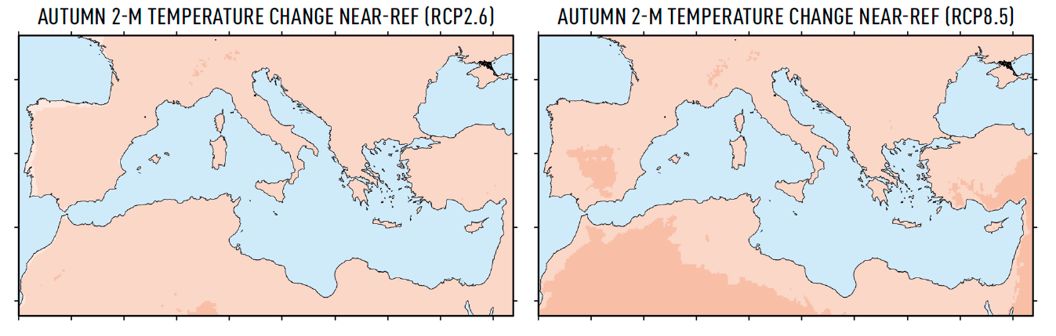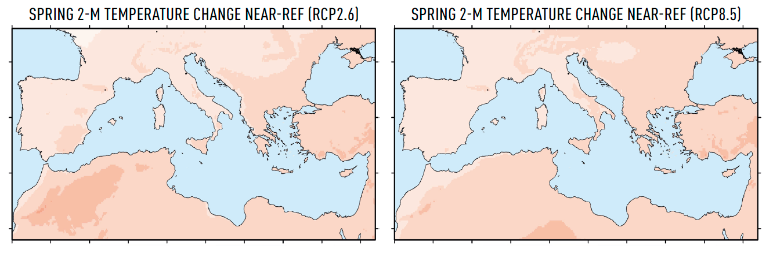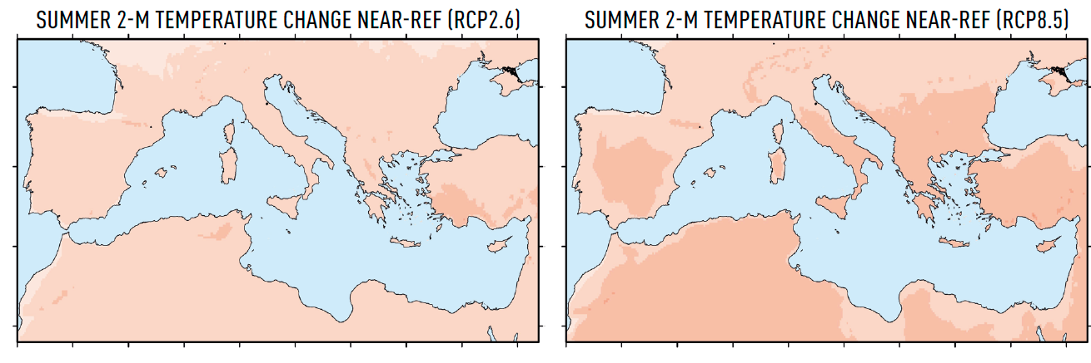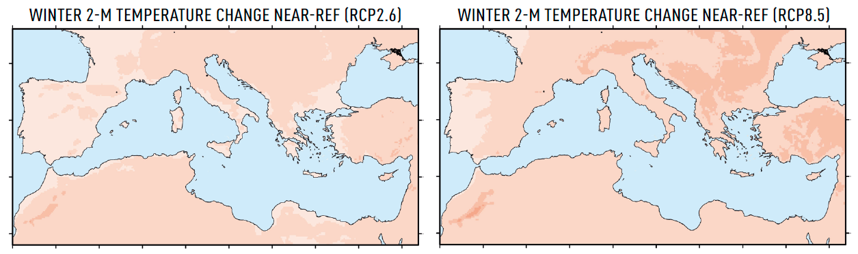
Figure 1: Projected changes in temperature for the 4 seasons and both socio-economic scenarios RCP8.5 AND RCP2.6 (source: Zittis et al., 2020).
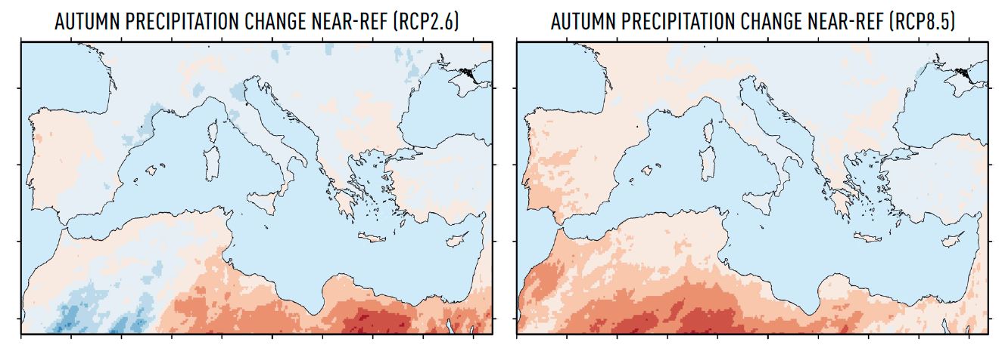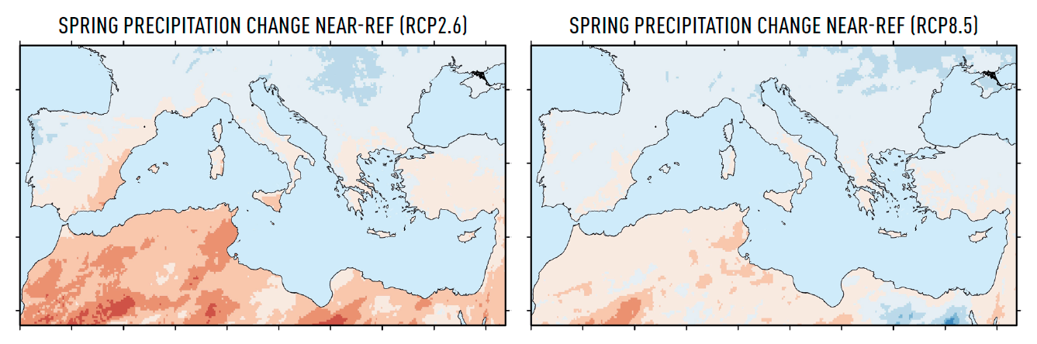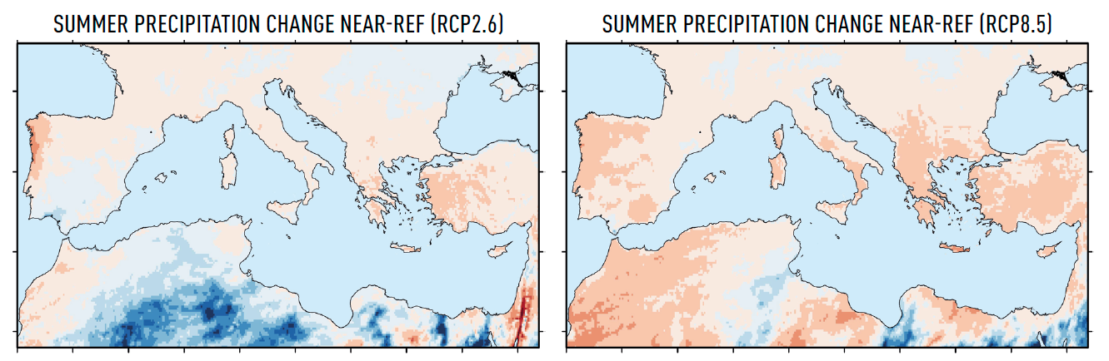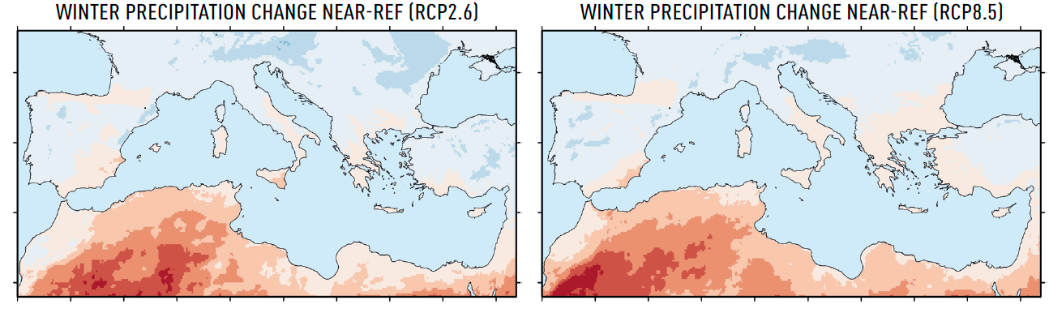
Figure 2: Projected changes in precipitation for the 4 seasons and both socio-economic scenarios RCP8.5 AND RCP2.6 (source: Zittis et al., 2020).

This is demonstrated in Figure 3, that shows that, during the period 1995 to 2022, floods are affecting significantly more the countries of the Mediterranean basin with respect to the northern countries.
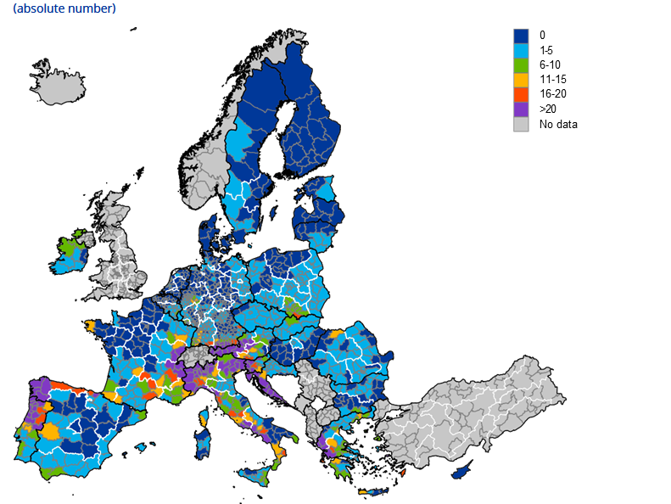
Figure 3: FLOOD DISTRIBUTION IN THE EU FROM 1995-2022 (SOURCE : ECB & ecmwf, 2025).
These uncertainties regarding the timing, duration, intensity and interval between extreme climatic events will put several sectors of the Mediterranean economy at risk (IPCC 2023, Section CCP4.3). This fact is highlighted by the ECB report (Error! Reference source not found.), which investigates the macroeconomic impact of extreme climate events. Their findings demonstrate that the regional impact of climate change suggests that the ability of regions to recover from flood events depends on income and access to finance.
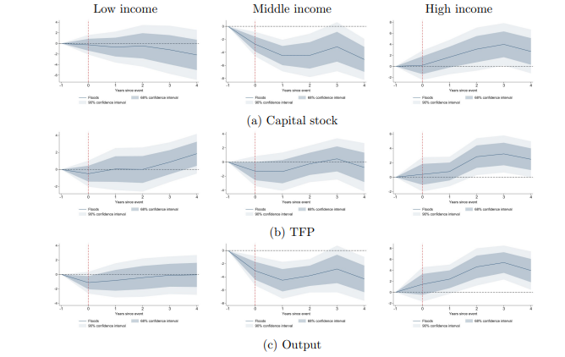
Figure 4: FLOOD impact on regional potential output for each year from event (SOURCE : ECB, 2025).

review of existing frameworks and strategies

INTRODUCTION
Throughout human history, flood plains have been the preferred place for socio-economic development, due to fertile soil, steady water supply and irrigation potential. Many major metropoles are currently established along river flood plains (e.g. Cairo, Shanghai, Kolkata, etc).

In modern cities, due to intense urbanisation, commercial and residential uses tend to further invade flood plains. At the same time river flooding remains part of the natural river cycle and thus human, environmental and economic losses from floods are increasing (Figure 5). According to ECB (2025), flood impacts severely all sectors of the economy (agricultural, manufacturing, construction) in both low- and high-income regions. However, the low-income regions tend to experience the consequences of flood events more intensively and for longer period (Figure 6).

For the past centuries, states and cities, in order to prevent loss of life and flood damages, have planned flood protection works, like levees, dams, floodwalls and barriers, drainage networks, etc. However, the intensification of flood events due to climate change in combination with the increased urbanisation around rivers is currently testing the capacity of flood protection works and impacting severely the surrounding ecosystems.

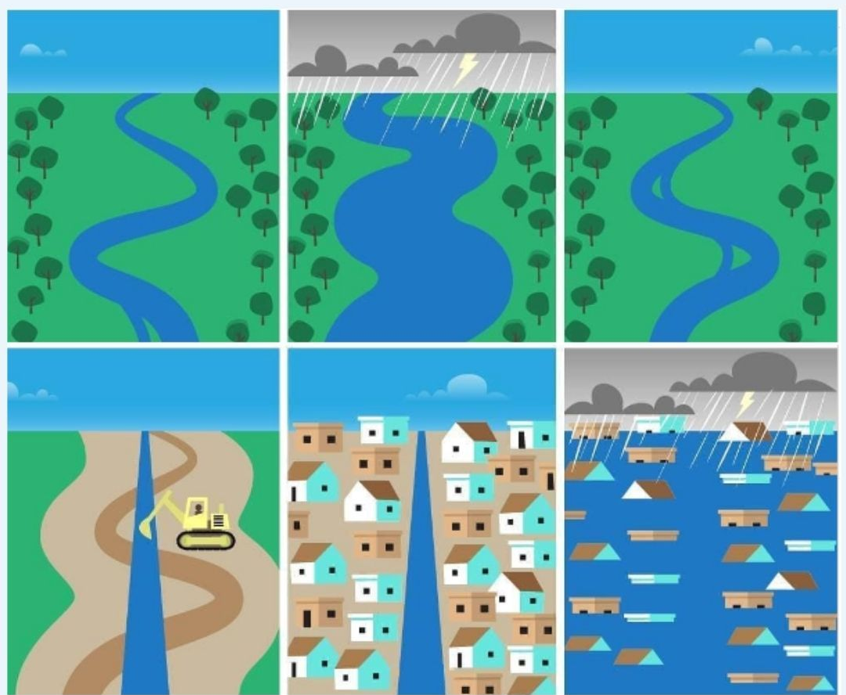
Figure 5: Schematic of flood plains urbanisation and the related FLOOD (Source : arvoreagua).

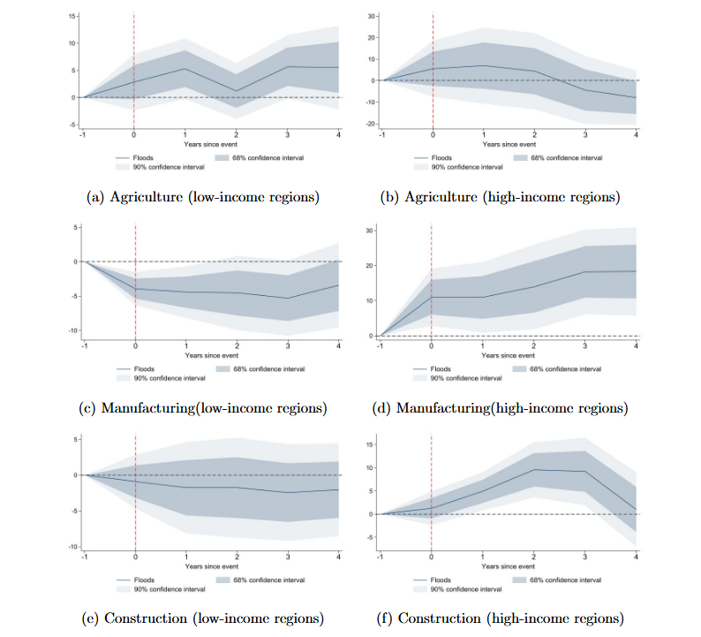
Figure 6: FLOOD impact in terms of Gross value added as a function of years after the event for different activities and income regions in the eu (SOURCE: ECB, 2025).

existing frameworks

integrated flood management (imf) plan mf
Due to the intense urbanisation and environmental footprint of flood works, in the last decades a paradigm shift from “flood control” towards “flood management” was needed (UNESCO, 2006). Flood management consists in accepting that floods as part of river’s natural life and as such it can only be dealt in terms of an Integrated Flood Management (IFM) plan. Thus, in the last decades, the management strategy is globally shifting from a re-active to a pro-active flood management strategy, from balancing flood risk to sustainable development and from ad-hoc flood control to integrated flood management.
The concept of Integrated Flood Management has been developed by the Associated Programme on Flood Management (APFM). Initiated in 2001 by the World Meteorological Organization (WMO) and the Global Water Partnership (GWP), APFM aims to promote the concept of Integrated Flood Management globally (World Meteorological Organization & Global Water Partnership, 2004).

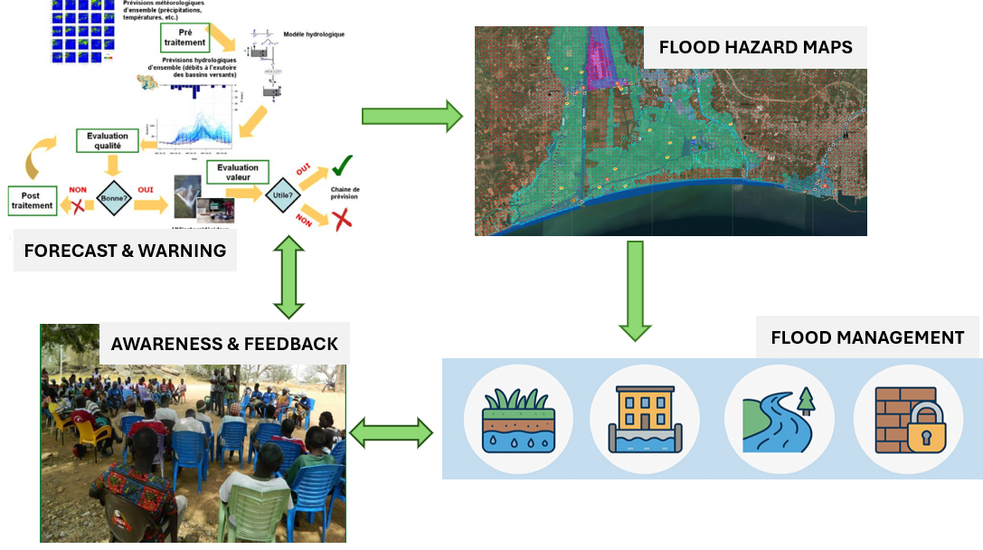
Figure 7: Intergrated FLOOD MANAGEMENT SCHEMATIC (INSPIRED BY WMO, 2025).

A central feature of IFM is the river basin perspective. Floods are basin-wide phenomena influenced by upstream–downstream interactions, land-use patterns, hydrological processes and hydraulic infrastructure. Measures implemented in one part of a basin may alter flood peaks, timing or volumes elsewhere. Therefore, IFM promotes planning and decision-making at the river basin scale, ensuring coherence between local actions and basin-wide objectives and aligning flood management with broader water resources planning.
In addition, IFM recognizes that hydrological systems are dynamic and subject to variability and change. Climate change, land-use transformations and socio-economic development can modify flood regimes and increase uncertainty. Consequently, IFM promotes adaptive management strategies that are flexible and capable of adjusting to evolving conditions. Under conditions of non-stationarity, reliance solely on historical records may be insufficient and scenario-based planning becomes increasingly important.

Furthermore, IFM key components consist in:
- Risk Assessment and Mapping, which help to identify vulnerable areas, evaluate potential impacts and guide the development of targeted risk mitigation measures.
- Land Use Planning, which considers the different hydrological characteristics of land cover that can reduce vulnerability to flooding, like zoning, urban planning and natural floodplains preservation.
- Infrastructure Development, which includes conventional measures used for flood control, play an important role in IFM by reducing flood impact. However, their ecological footprint is taken into account.
- Nature-based Solutions, which are recognized by the IFM for the ecosystems capacity in regulating water flow and reducing the impacts of floods.
- Early Warning Systems, which are an essential component of IFM in order to reduce the risk by allowing stakeholders to prepare for a flood event and to reduce or mitigate its impact.
- Community-based management, as the engagement of local communities help increase local community acceptance of measures, even measures’ effectiveness.
- Managing Residual Risks through contingency planning and emergency response as well as recovery plans.

In summary, the Integrated Flood Management aims at maximizing the net benefits linked to social development close to river plains, while minimizing life and property loss from flooding (Figure 7). More specifically, it consists in:
  - adopting a basin approach to flood management;
  - bringing a multidisciplinary approach in flood management.
  - reducing vulnerability and risks due to flooding;
  - enabling community involvement; and
  - preserving ecosystems.

The Associated Programme on Flood Management (APFM)
The Associated Programme on Flood Management (APFM) supports countries in implementing Integrated Flood Management (IFM) within the framework of Integrated Water Resources Management (IWRM). APFM aims to maximize benefits from the use of floodplains while minimizing loss of life and environmental impact. APFM offers tools, publications, and a HelpDesk that assists countries in developing flood management strategies, pilot projects, and fostering regional collaboration.
The APFM through the concept of IFM attempt to streamline the multi-facets of flood management issues into the decision-making of policy makers, flood managers and various other groups involved in the development planning process in river basins. The objectives of APFM are to (Associated Program on Flood Management, 2020):
- establish the principles of Integrated Flood Management;
- help assimilate principles of Integrated Flood Management within the overall Integrated Water Resources Management;
- develop capacities in the countries to integrate flood management into sustainable development processes;
- provide a platform for a common strategic vision on integrated flood management issues, and to promote the implementation of effective policies and strategies worldwide.

EU Flood-Risk Planning Framework (EU Floods Directive, 2007/60/EC)
The EU Floods Directive (2007/60/EC) is a European legislative framework adopted in 2007 establishing a coordinated approach for the assessment and management of flood risks across the European Union. It was introduced in recognition of the fact that floods can cause loss of life, displacement of populations, environmental degradation, damage to cultural heritage and significant economic losses. However it acknowledges at the same time that floods are a natural phenomenon that cannot be completely prevented; while human activities and climate change may increase both the probability of flood occurrence and the magnitude of their adverse consequences.
The Directive aims to establish a comprehensive framework for reducing the adverse consequences of flooding for human health, the environment, cultural heritage and economic activity. It requires each EU member states to assess flood risks in river basins and coastal areas, identify areas exposed to potentially significant flood risks, prepare flood hazard and risk maps and develop coordinated Flood Risk Management Plans (FRMPs) at river basin district level (Directive 2007/60/EC, 2007).

Flood Risk Management Plans (FRMPs)
Each EU member state must establish Flood Risk Management Plans coordinated at the level of river basin districts or coastal areas. These plans set objectives for flood risk management and focus on three core pillars:
- Prevention: avoiding construction and inappropriate land use in flood-prone areas and promoting sustainable land-use practices,
- Protection: structural and non-structural measures aimed at reducing the likelihood and/or impact of floods,
- Preparedness: improving public awareness, emergency planning, flood forecasting and early warning systems.
The plans must take into account the specific characteristics of each river basin or sub-basin and may include measures such as natural water retention, floodplains restoration or controlled flooding acceptance in designated areas. They serve as the main strategic planning and reporting instrument of each Member State to the European Commission (Directive 2007/60/EC, 2007). These plans are updated every six years.

As part of the FRMPS, areas at potentially significant flood risk are identified. Specifically, each member states must prepare flood hazard maps and flood risk maps. Flood Hazard Maps must indicate the extent of flooding, water depth and flow velocity. The maps must cover three scenarios:
- low probability floods (extreme events),
- medium probability floods (typically of a return period of 100 years),
- high probability floods, where appropriate.
On the other hand, Flood Risk Maps depict the potential adverse consequences associated with the aforementioned flood scenarios, such as:
- the number of inhabitants potentially affected;
- the economic activity in the affected area;
- accidental pollution during floods,
- protected areas and other environmentally sensitive sites.
- Any additional information considered useful, for example areas with high sediment transport.

Coordination with the Water Framework Directive
Flood hazard maps and Flood Risk Management Plans must be coordinated with the Water Framework Directive (2000/60/EC). Both Directives operate at the river basin district scale and follow aligned six-year planning cycles. Their implementation is supported by the Common Implementation Strategy (CIS), which promotes harmonised application across Member States and integration of water policy with other EU policy areas such as agriculture, transport, climate adaptation, research and regional development.
Overall, Directive 2007/60/EC represents a shift from a purely defence-oriented approach to a comprehensive, risk-based and basin-scale flood management framework. It strengthens cooperation among member states, promotes evidence-based planning through hazard and risk mapping, and integrates flood risk management into broader environmental and spatial planning policies within the European Union (Directive 2007/60/EC, 2007).

exploration of flood MANAGEMENT approaches
In international literature and applications, different types of flood management approaches exist. They can be divided into three separate categories: Conventional (grey) measures, Natural Based Retention Measures and non-structural approaches. They will be further analysed in the following paragraphs.

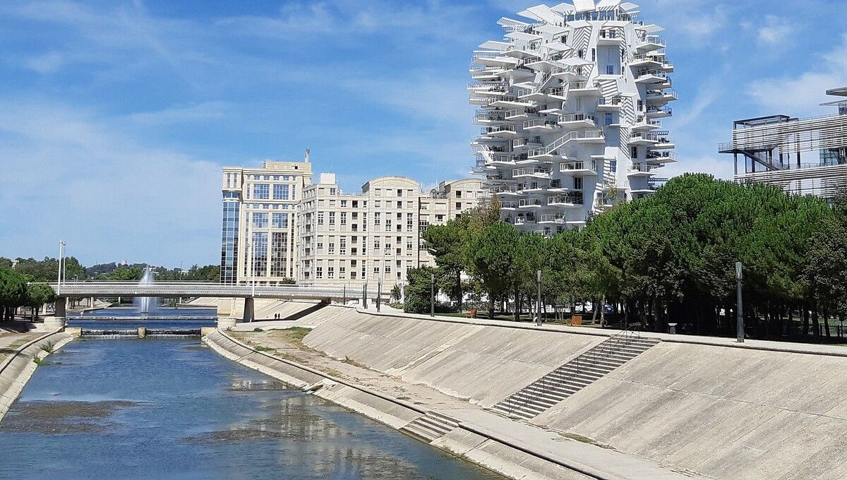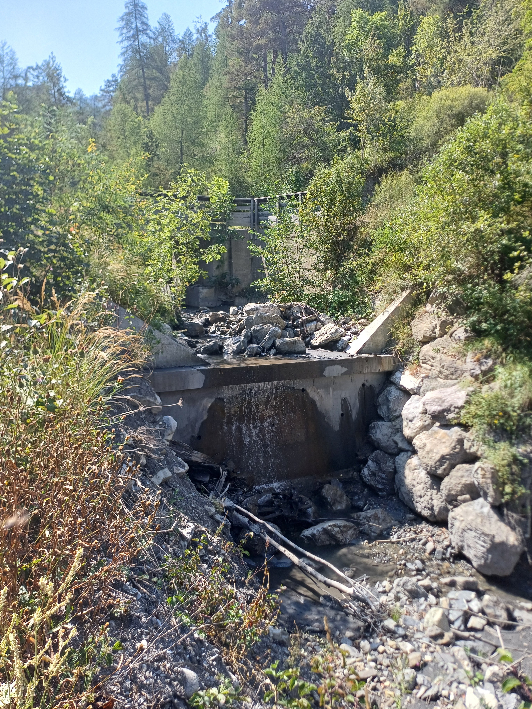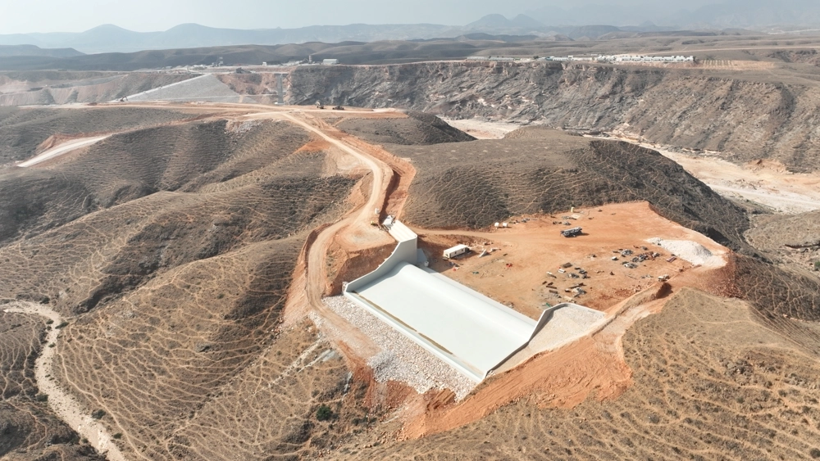
- (b) ( c )
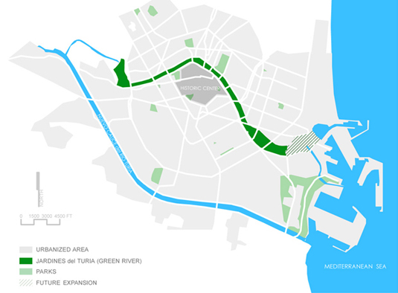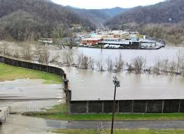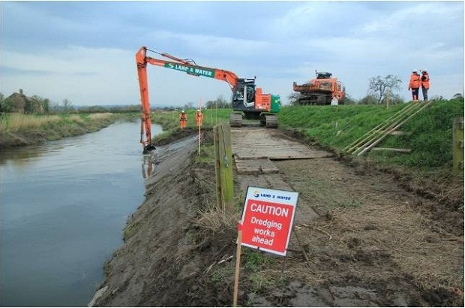
(d) ( e ) ( f )
Figure 8: STRUCTURAL FLOOD PROTECTION APPROACHES: (a) embarkements on the lez river- france (source: france bleu), (b) retention structure (source: I. ZALACHORI), (c) Adawnib Flood Protection Dam-salalah oman (source: ntf), (D) tHE PLAN SUR PROJECT IN VALENCIA (source: metropolismag), (e) floodwall in Williamson, Mingo County, WV (source: Hatfield Construction, LLC) and (f) dredging of River Parrett (source: uk Environment Agency).

CONVENTIONAL (GREY) APPROACHES

large scale works
For many centuries human societies relied on physical interventions near river flood plains to redirect, route or store flooding. These approaches can be mainly divided into two types of interventions: large scale and residential ones. Some of the most commonly used conventional approaches are:
- Levees and embankments (Figure 8a), which are usually raised barriers along rivers. Levees can be permanent barriers (e.g. soil, concrete) or temporary (e.g. modular barriers).
- Dams (Figure 8 b&c), which are used to store excess water during heavy rainfall. Dams provide a highly efficient way to protect from flooding. However, their environmental impact is significant.
- Diversions and bypass channels (Figure 8d), which are used to redirect flood away from populated areas. Diversion channels mitigate the impacts of a flood by offering an alternative route for excess water. Normally, diversion channels are built around major cities and towns to mitigate the effects of flooding in communities and urban centres (e.g. the Plan Sur in Valencia, the New Danube in Vienna, or the Red River Diversion Channel in Manitoba).
- Flood walls and seawalls (Figure 8e), which are concrete, steel or other type material structures that are protecting urban areas or coastlines. Though they are expensive and have significant ecological footprint, they are highly effective.
- Dredging (Figure 8f) is a technique consisting in removing sediment in order to increase channel capacity. Often environmental concerns are linked to dredging significant quantities.

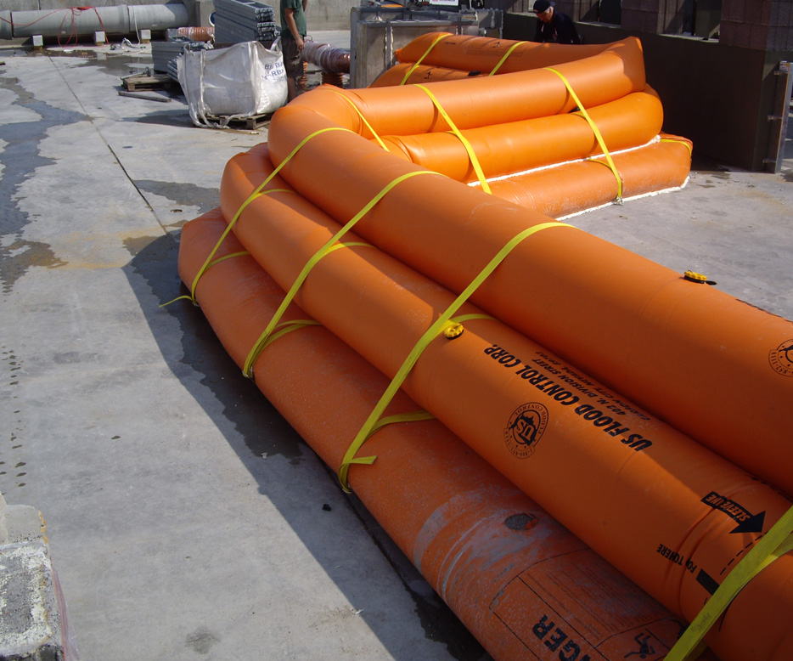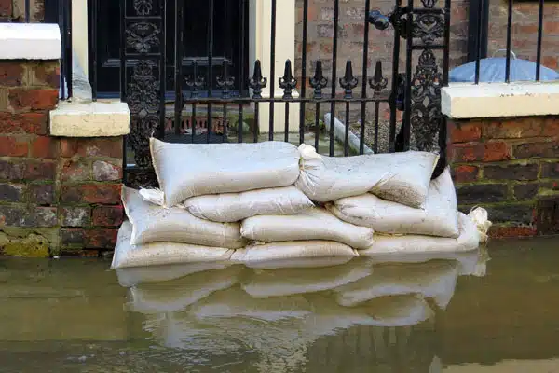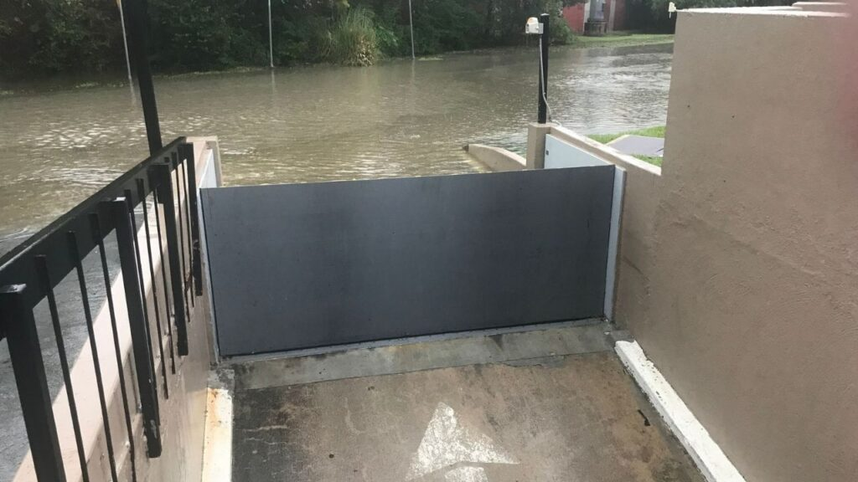
- (b) ( c)
Figure 9: residential & industrial FLOOD PROTECTION APPROACHES: (a) flood barriers (source: https://usfloodcontrol.com), (b) flood barrier (source: vrs) and (c) flood gates (source: floodbreak.com).

residential flood protection measures
Property flood protection measures can reduce the impact caused by floods. These measures aim to prevent or reduce the amount of water entering a property. They can be permanent or temporary and can be include:
- Flood doors and windows, prevent water entering a property. They offer permanent protection when a flood is expected. Flood windows are fitted to low lying windows where flood levels can reach a significant depth.
- Flood barriers can be fitted to external doorways, driveways and gardens and on garage doors, to prevent water entering your property. According to UK guidelines, it is recommended that they are not fitted higher than 600mm in order to prevent structural damage to walls. Flood barriers can also be temporary measures, like sandbags.
- Concrete floors with damp proof membranes are used in properties which are at risk from groundwater rising. Internal and external tanking can also be fitted in basements which are affected by flooding.
- Water resistant mortar applied to walls in order to close any cracks or holes in brickwork with a waterproof silicone sealant. Water resistant renders can also be applied to external walls and water-resistant coatings can be sprayed or painted onto brickwork.
- Non-return valves fitted to pipes will prevent backflow from toilets, sinks, drains and manholes when drains and sewers become overwhelmed with flood water. Prior to a flood, ground level toilets can also be fitted with a toilet pan seal in addition to or instead of a non-return valve.
- Smart airbricks and airbrick covers provide vent and air brick protection. Self closing air bricks allow ventilation but automatically close when flood water enters them. Alternatively, air brick covers can be placed over airbricks prior to a flood event.

benefits & limitations
As described previously, conventional flood protection measures have been used for decades as physical flood barriers. The reason is their immediate flood benefits, such as immediate flood protection of critical infrastructures and dense urban areas. However, their environmental footprint together with their lack flexibility under changing climate extremes consist their main limitations. In the following table (Table 1) a brief summary of the main benefits and limitations of conventional (grey) infrastructure is depicted.
Table 1: Conventional flood protection works benefits and limitations.
Benefits | Limitations
- Provide immediate flood protection  - Reduce flood peaks  - Effective for moderate to low frequency flood events  - Stabilize riverbanks and prevent erosion in targeted areas  - Protect critical infrastructure & specific habitats from inundation (e.g., urban parks)  - Protect lives, property, and economic activity  - Provide clear, visible risk-reduction benefits  - Often politically popular due to immediate results  - Mature engineering methods with predictable performance  - Standardized design guidelines and regulatory frameworks  - Suitable for dense urban areas with limited space | - Often shift flood risk downstream  - Can fail catastrophically when design thresholds are exceeded  - Disrupt natural sediment transport  - Loss of floodplain connectivity  - Increase long-term geomorphic instability  - Degrade river and floodplain ecosystems  - Reduce habitat diversity  - Eliminate natural wetland and riparian functions  - Increase pollutant concentrations  - Reduce natural filtration and self-purification processes  - Rigid structures lack flexibility under changing climate extremes  - Require costly upgrades as flood magnitudes increase  - Encourage development in high-risk zones (“levee effect”)  - High construction and maintenance costs  - Require continuous inspection  - Complex permitting and environmental compliance

NATURAL WATER RETENTION MEASURES
Nature-based solutions (NbS) emerged mid-2000s by the International Union for Conservation of Nature (IUCN) and the European Commission (EC) as an effective combination of measures to addressing climate and disaster risks). It is an umbrella term covering a range of ecosystem-based sustainable development approaches targeting different societal and environmental challenges.
According to the IUCN (2020) definition, NbS are “actions to protect, sustainably manage, and restore natural or modified ecosystems that address societal challenges effectively and adaptively, simultaneously providing human well-being and biodiversity benefits.” Natural Water Retention Measures (NWRM) are part of the NbS umbrella. They are multi-functional interventions widely applied in climate adaptation, flood mitigation, drought management and water-quality improvement, using natural means and processes by mimicking natural hydrological processes (EU, 2014). They are considered a form of green infrastructure within EU environmental policy.

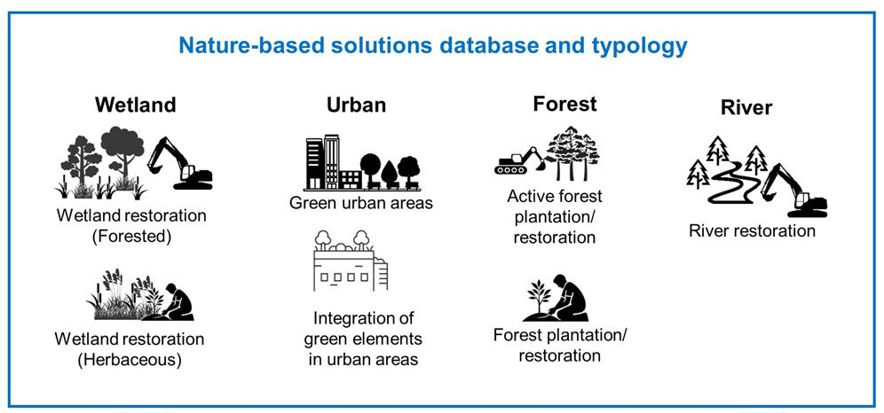

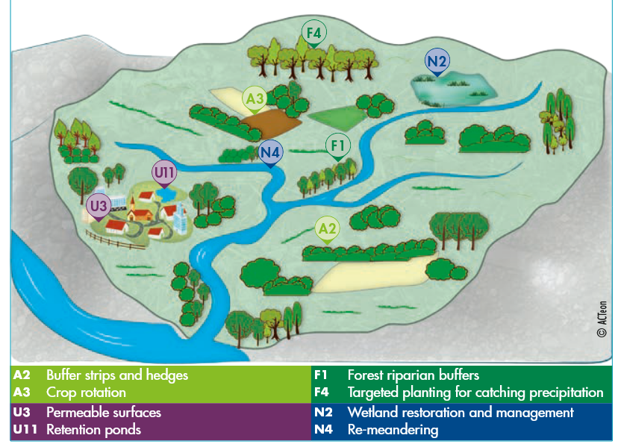
(b)
Figure 10: DIFFERENT APPLICATIONS OF Natural Water Retention Measures IN A CATCHMENT SCALE (a) source: eu guide on nwrm, 2014 (b) Source: Gonzalez-Garcia et al., 2025
Table 2: NWRM CATEGORIES AND EXAMPLES.

The Natural Water Retention Measures (NWRM) aim mainly at:
- increasing water storage and aquifer water retention
- reducing flood peaks by slowing and spreading runoff
- mitigating drought impacts by enhancing infiltration and soil moisture
- restoring natural river and wetland functions
- supporting climate adaptation and reduces costs from extreme events.
- improving water quality through natural filtration and sediment retention
- restoring ecosystems and biodiversity
- stabilizing landscapes and reduce erosion
- improving potential for recreation and life quality.
Natural Water Retention Measures (NWRM) can be divided into five main measure categories: Hydro- morphological, Agricultural, Forestry, Wetland and Urban. These categories are depicted schematically in Figure 10, while some typical examples are provided in Table 2. Further analysis of these measures is presented in the following paragraphs.

Category | Examples | Purpose
Hydro- morphological | Meander reconnection, floodplain restoration | Reduce peak flood, increase storage capacity
Agricultural | Cover crops, buffer strips, contour farming | Increase infiltration, reduce runoff and erosion
Forestry | Reforestation, afforestation, deadwood retention | Enhance soil moisture, stabilize slopes
Wetland measures | Wetland creation/restoration, peatland rewetting | Store water, improve water quality
Urban measures | Green roofs, permeable pavements, rain gardens | Reduce stormwater runoff, enhance infiltration

hydromorphological measures
Hydro-morphological measures aim in restoring natural river dynamics and reconnecting water bodies with the landscape. Through proper zoning and land management, they stand as an effective and sustainable flood control method. Some examples of hydro-morphological measures are:
- Floodplain restoration consists in reconnecting river to their natural floodplains, and it serves as a natural flood management through providing space for water storage (Figure 11 & Figure 12). Different techniques are available to this purpose, like levee/ dike / weir or dam removal, re-opening side channels and over-flow sills or bank stabilization. Floodplain restoration also includes sediment management through removing sediment and restoring natural deposition processes. The main benefits of floodplain restoration consist in:
- Flood peak reduction through flow speed reduction, flood waves attenuation and water storage,
- habitats/ biodiversity restoration,
- water quality improvement by trapping sediment and reducing nutrient loads,
- carbon sequestration enhancement.
Floodplain restoration is suited for rural or semi-natural areas with space for river migration, river corridors with manageable urban constraints, areas with degraded wetlands. In areas where full restoration is not possible, restoring small or fragmented patches of floodplains might be a solution.
- River meandering / re-meandering refers to the restoration of natural hydrological, morphological, and ecological functions to degraded river systems. River meandering can be achieved through reconnecting old, cut-off meanders or excavating new, sinuous channels and reintroducing sinuosity (curves) into historically straightened or channelized rivers. This process, often called "rewiggling," slows water flow, reduces flood risk, improves water quality and creates diverse habitats.
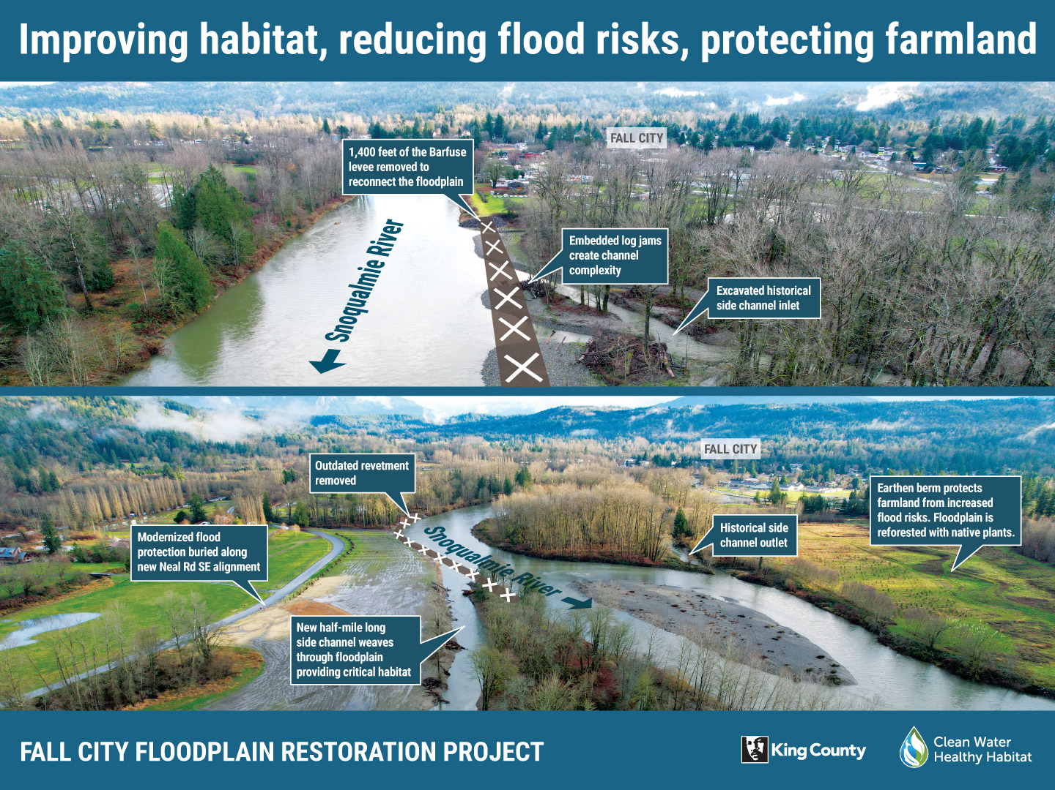
Figure 11: FLOODPLAIN RESTORATION IN KINGS COUNTY, UK (source: KING COUNTY, 2023).
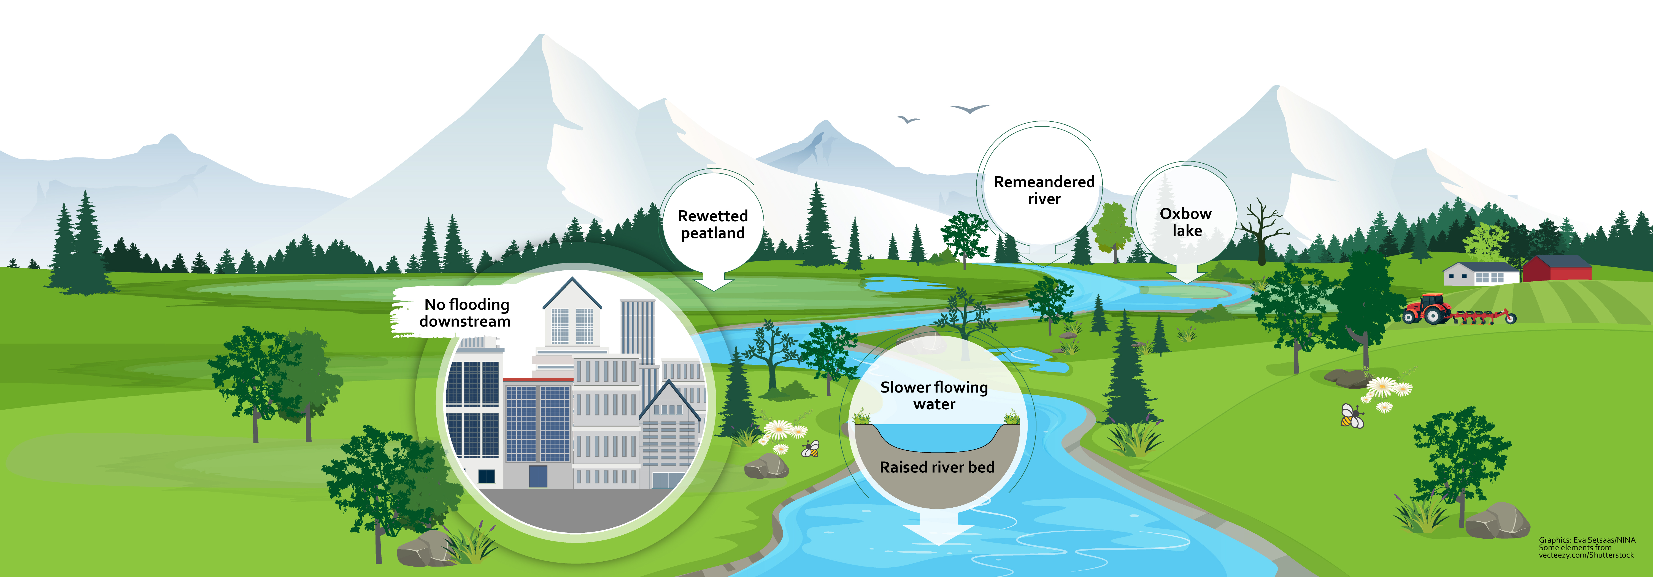
Figure 12: FLOODPLAIN RESTORATION IN KINGS COUNTY, UK (source: EVA SETSAAS, NINA).
- Embankment removal includes involves lowering, breaching, or completely removing natural or artificial banks to restore natural habitats, reduce flood risk, or improve ecological connectivity. Typical application consists in the removing coastal dikes to restore marshes or the setting back river embankments to create natural floodplains. Embankment removal projects can be achieved through:
  - full removal consisting in complete removal of the earthwork to restore the original, natural ground level
  - breaching, consists in creating gaps in the embankment to allow water to flow through, often used in managed realignment of coastlines.
  - lowing embankments, by reducing the height of the embankment, allowing for a hybrid approach where some, but not all, floodwaters pass over.
  - set-back of embankments by removing the existing embankment near the river and constructing a new one further away to create a wider, safer floodplain
It should be mentioned that often pre-work assessments are required to avoid increasing flood risks elsewhere with 5-20 year, or even longer, restoration timelines for ecological equilibrium.
- Side-channel reconnection is a river-restoration technique where old, abandoned or artificially disconnected secondary channels are re-linked to the main river. This floodplain reconnection technique consists in constructing or reopening side channels for restoring natural river–floodplain dynamics. Side channel reconnection is suitable for low slopes, where space is available between river and infrastructure. Side-channel reconnection can be achieved by:
- excavating or re-opening historic channels,
- breaching or setting back levees,
- installing or upgrading culverts,
- creating new side channels.
- Sediment management ensures that restored systems maintain their ecological and hydrological functions without excessive maintenance. Sediment management aims to restore natural processes, by allowing seasonal floods to transport sediment, removing barriers that trap sediment or re-meandering channels to restore natural sorting. Efficient sediment management includes:
- designing self-flushing inlets and outlets,
- sediment bypassing or augmentation,
- strategic embankment breaching,
- controlled erosion zones,
- vegetation-based sediment control.

As described previously, hydro-morphological NWR measures aim at a sustainable flood control method through natural river dynamics restoration. Their main benefit is flood attenuation and flood peaks reduction in combination with biodiversity enhancement and ecosystem resilience. However, their land acquisition requirements and the stakeholder acceptance is among their main limitations. Table 3 presents a summary of the hydro-morphological NWRMs benefits and limitations.
Table 3 : comparative summary of benefits and limitations of hydromorphological
Benefits | Limitations
• Restores natural flow variability  • Reduces long-term flood protection and maintenance costs  • Improves flood attenuation and reduces flood peaks  • Enhances groundwater recharge  • Increases drought resilience  • Re-establishes sediment transport balance  • Reduces bank erosion  • Promotes natural meandering  • Creates self-maintaining river forms  • Restores diverse habitats (wetlands, riparian zones, oxbows)  • Improves ecological connectivity  • Supports fish migration and life-cycle processes  • Enhances biodiversity and ecosystem resilience  • Retains nutrients (N, P)  • Improves downstream ecological water quality  • Reduces pollutant loads through natural filtration  • Stores carbon in wetland soils and riparian vegetation  • Provides cooling via evapotranspiration  • Enhances landscape climate resilience  • Creates recreation and eco-tourism opportunities  • Supports flood-compatible agriculture  • Lower long-term costs than grey infrastructure  • Flexible and adaptable to changing conditions | • Requires space for lateral expansion  • Possibility of local flooding increase on adjacent land  • Effectiveness reduced in heavily regulated rivers (dams, diversions)  • Sediment imbalance can cause aggradation or incision  • May require initial sediment management or monitoring  • Ecological recovery may take years or decades  • Sensitive species may not return without catchment-scale improvements  • Risk of invasive species colonization  • Nutrient-rich soils may release pollutants if hydrology is unstable  • Water quality benefits depend on sufficient inundation frequency  • Drought periods may reduce wetland function  • Climate-driven hydrological shifts may alter performance  • Land acquisition or compensation may be required  • Conflicts with existing land uses (agriculture, development)  • Requires strong governance and stakeholder acceptance  • Requires detailed hydrological and geomorphological assessment  • Benefits may take time to materialize  • Uncertainty in outcomes if catchment pressures persist  • High initial CAPEX  • Permitting and environmental approvals can be lengthy

WETLAND & AQUATIC ECOSYSTEM measures
Wetland and aquatic ecosystem NWR measures focus on restoring or creating wetlands, peatlands, and other water-rich ecosystems (Figure 13). They contribute to store large volumes of water, reduce flow peaks, improve water quality and support biodiversity. Some typical examples include:
  - Wetland creation or restoration consists in building new wetlands in strategic areas (floodplains, depressions, agricultural margins) or rehabilitating degraded natural wetlands (marshes, riparian wetlands, coastal wetlands). This helps in increasing water retention capacity, attenuate flood peak, sediment trapping, water quality improvement.
  - Peatland rewetting consists in rehydrating drained peatlands by blocking ditches and raising water tables. According to Greifswald Mire Centre (2021), drained peatlands represent only 3 % of the EU’s agricultural land and rewetting them would avoid up to 25 % of the greenhouse gas emissions from total EU agriculture.
  - Artificial wetlands are engineered, shallow-water ecosystems designed to mimic natural wetlands. By utilizing plants, soils and microorganisms artificial wetlands improve water quality by filtering pollutants, removing nutrients, and restoring habitats. They typically feature an inlet zone (sedimentation basin), a shallow densely planted macrophyte zone and a high-flow bypass channel. Different types of artificial wetlands exist like: surface, subsurface or hybrid flow wetlands.
  - Coastal wetland restoration (salt marshes, lagoons). Coastal wetland restoration consists at re-establishing natural functions of wetlands that have been degraded by natural processes and human activities and that are also threatened by sea level rise. Coastal wetlands are saltwater and brackish water wetlands located in coastal areas and they also include shallow water ecosystems permanently or periodically inundated and intertidal habitats. The restoration of coastal wetlands is increasingly considered as a measure to absorb storm surge waters and attenuate flooding. Coastal wetlands provide natural defence against coastal flooding and storm surges. They dissipate wave energy and reduce erosion by helping to stabilise shore sediments. Their major benefit is the preservation of ecosystem and biodiversity.
Wetland and aquatic ecosystem NWR measures are most effective in:
- floodplains where large areas of land are available,
- coastal lagoons and deltas,
- opstream reservoir catchments where sediment trapping and flow regulation is required,
- agricultural plains with significant nutrient runoff,
- urban area needing stormwater buffering.
Wetland and aquatic ecosystem measures are not suitable for very steep slopes and highly urbanized areas.

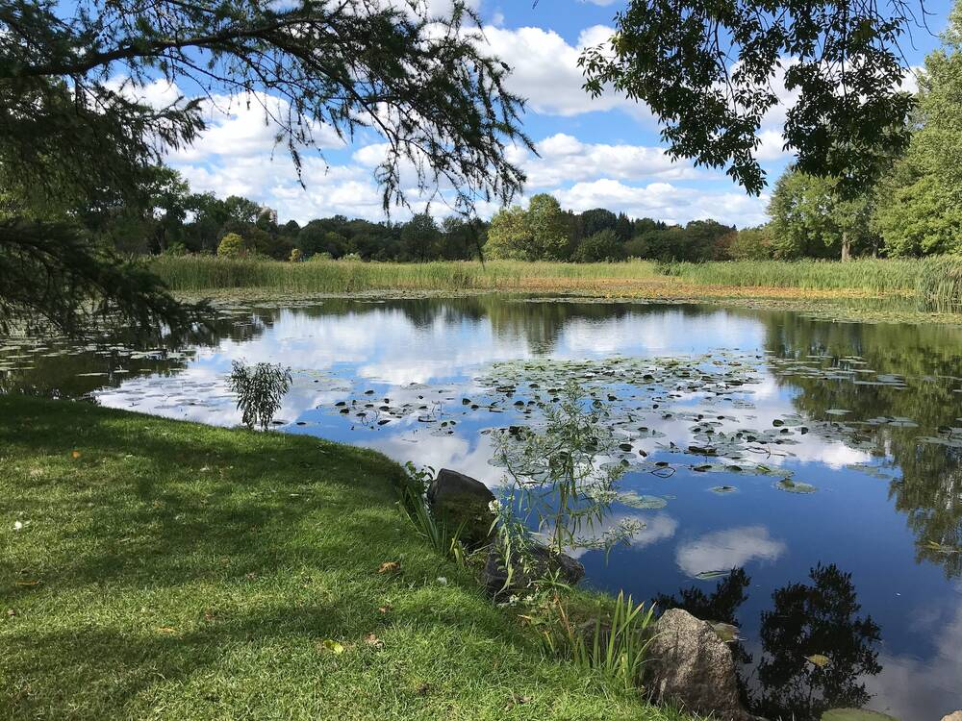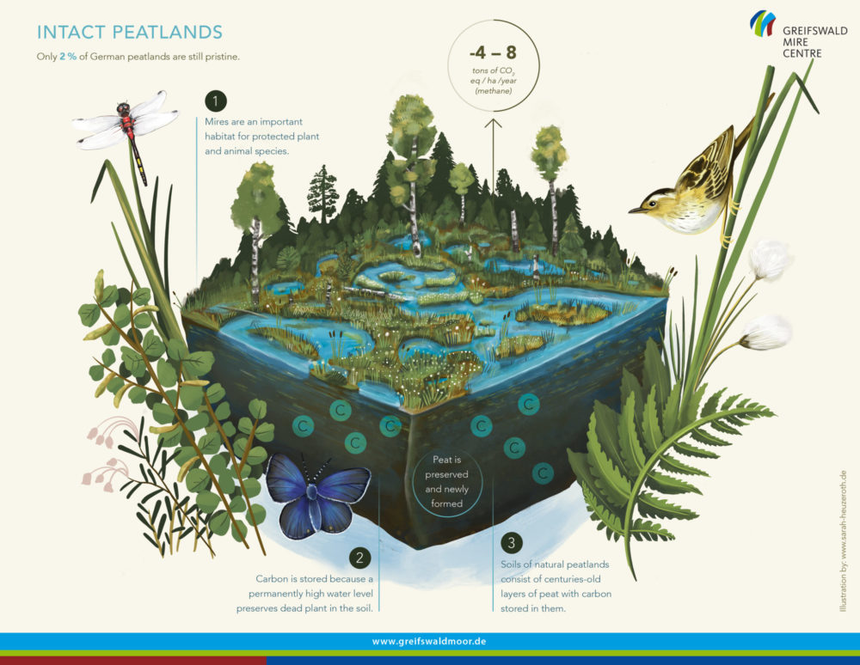
- (b)
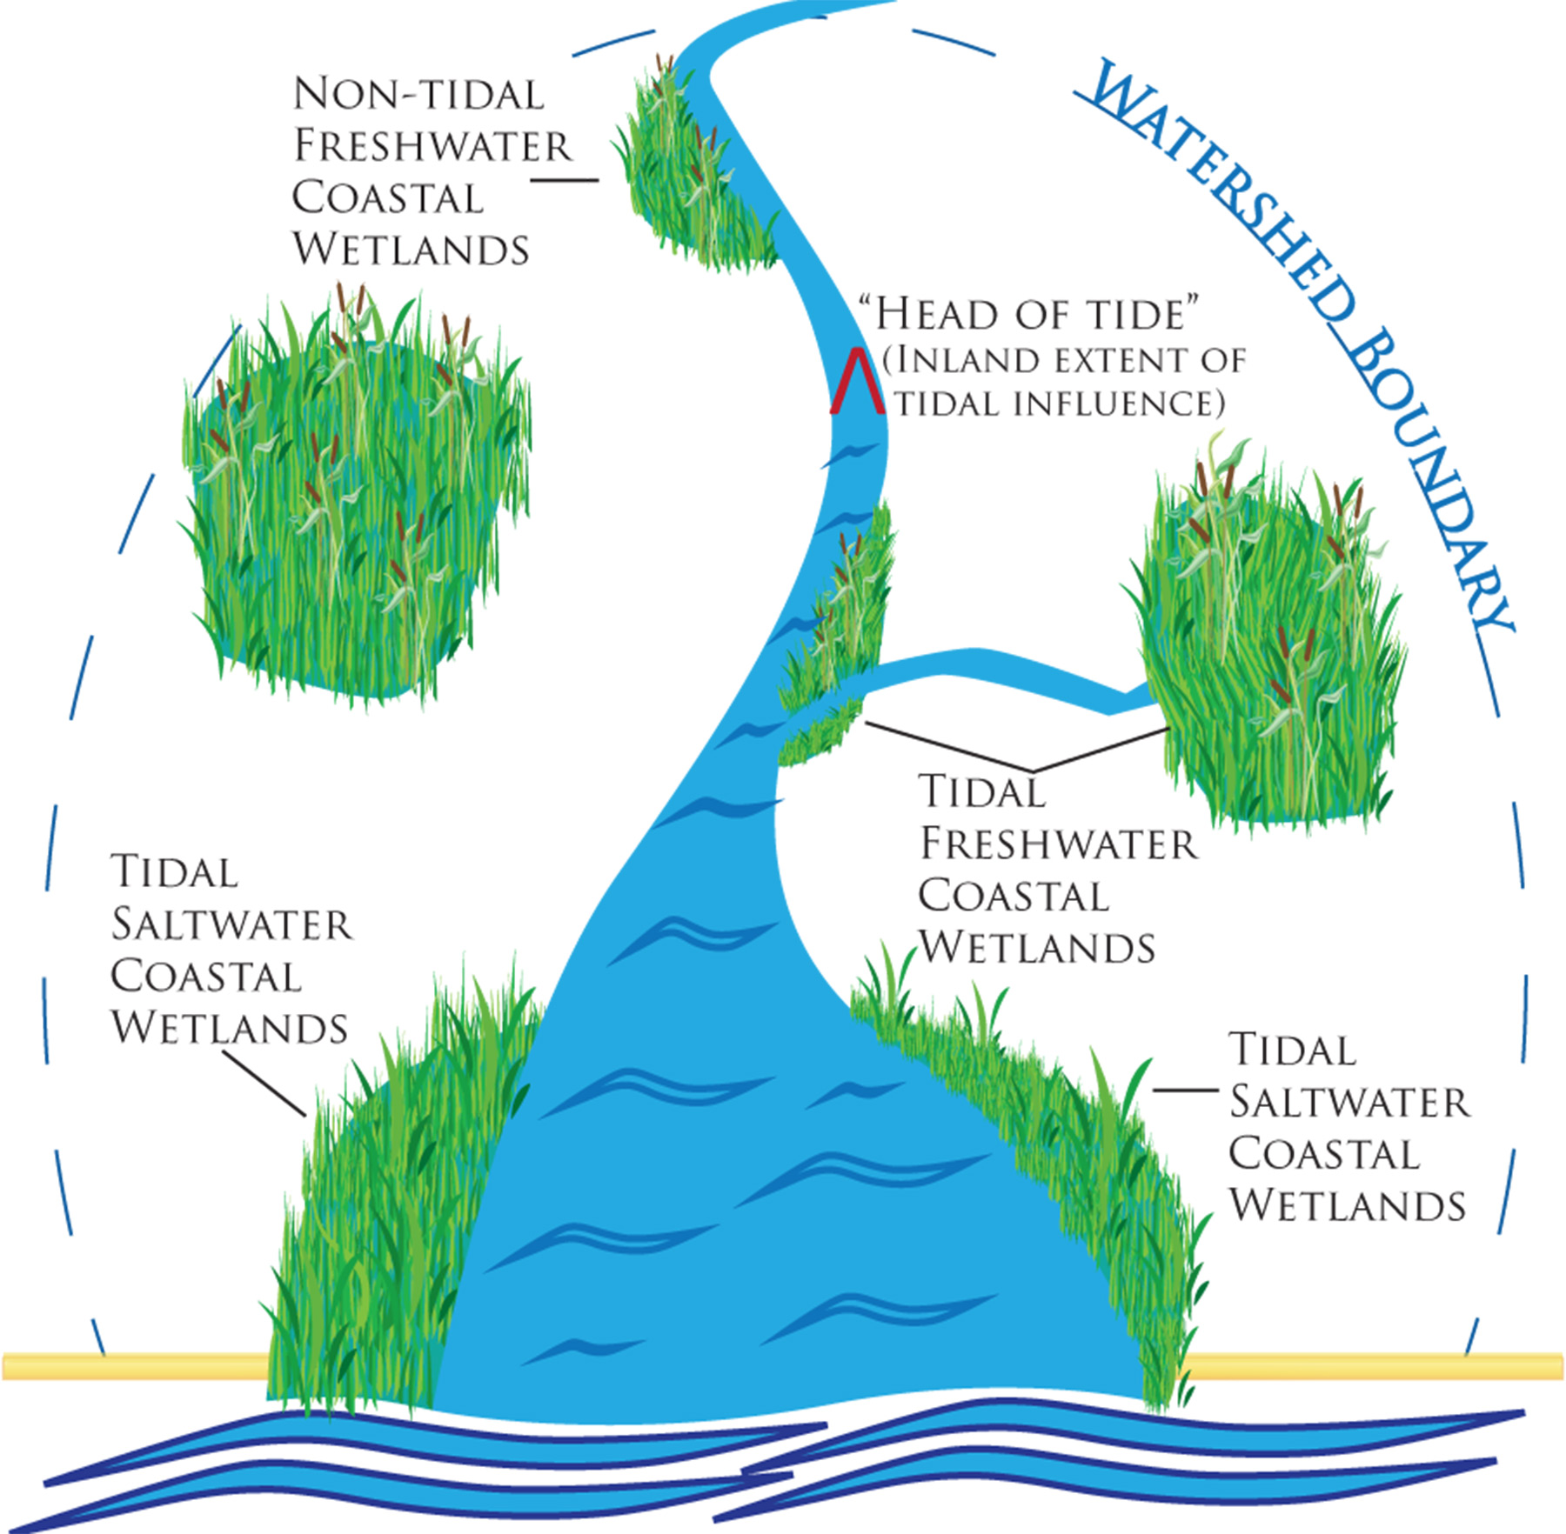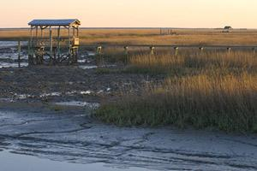
(c ) (d)
Figure 13: (a) wetland (source: Harriet Mackie, 2018), (b) Peatland rewetting (source: wetlands international, 2021), (C) and (d) coastal wetlands (source: epa)

As described previously, wetland and aquatic NWR measures aim at a sustainable flood control method through the restoration or creation of wetland or peatland. Their main benefit is flood attenuation and flood peaks reduction in combination with groundwater recharge, biodiversity enhancement and ecosystem resilience. However, their land acquisition/ compensation requirements, the high initial investment cost and the long-time frame for full ecological maturity are among their main limitations.

In the following table (Table 4) a brief summary of the main benefits and limitations of the wetland and aquatic eco-system NWRMs is depicted.

Table 4: comparative summary of benefits and limitations of wetlands & AQUaTIC nwr measures
Benefits of Wetland NWRMs | Limitations of Wetland NWRMs
- Increase water retention  - Attenuate peak flows and reduce downstream flood risk  - Improve infiltration and groundwater recharge  - Restore natural floodplain processes  - Improve sediment deposition  - Stabilize riverbanks and reduce erosion  - Reconnect rivers with their floodplains  - Create or restore high-value habitats  - Support species richness and ecological corridors  - Improve ecological resilience  - Provide breeding and feeding grounds for species  - Strong nutrient retention (N, P)  - Filter pesticides and contaminants from runoff  - Enhance natural self-purification processes  - Provide cooling effects and microclimate regulation  - Enhance drought resilience through storage and baseflow support  - Peatlands offer major carbon sequestration benefits  - Provide recreation, education, and cultural value  - Enhance landscape aesthetics and property value  - Deliver long-term ecosystem services (flood protection, water purification)  - Well-established restoration and construction methods  - Flexible design options (constructed wetlands, floodplain reconnection, ponds)  - Scalable from small ponds to large floodplain systems  - Low construction and operating costs. | - Land acquisition or compensation often required  - Storage capacity limited by available land and topography  - Require sufficient inflow and hydrological connectivity  - Sensitive to drought under climate change  - Slow hydrological response time after restoration  - Difficult to implement in heavily modified or confined channels  - Sediment accumulation may require periodic management or removal  - Landform recovery can take years to decades  - Full ecological maturity takes time  - Smaller wetlands offer limited biodiversity gains  - Ecological benefits depend on hydrological stability  - Risk of eutrophication if overloaded  - Pollutant retention can create long-term legacy loads  - Methane emissions possible in rewetted peatlands  - Competing land uses (agriculture, development)  - Benefits diffuse and long-term, while costs are upfront  - Stakeholder resistance possible in rural/agricultural areas  - High initial CAPEX for large wetlands  - Requires long-term monitoring and maintenance  - Engineering complexity in modified catchments  - Permitting and environmental approvals can be lengthy

agricultural measures
Agricultural natural water retention measures are land management practices applied within agricultural landscapes that aim to enhance the natural capacity of soils, vegetation, and field structures to retain water, reduce runoff and improve the overall hydrological functioning of farmland.

These practices combine water management with simultaneously improving soil health, reducing erosion and limiting the transport of nutrients and pollutants to water bodies. Water management is accomplished through sustainable agricultural production, by slowing, storing and infiltrating water.

The main categories of agricultural NWR measures are presented in Figure 14 and include:
- no-till or low-till agriculture that consists in leaving a significant amount of crop residue on the field (at least 30%), which helps reduce erosion and runoff, improve soil structure, and increase infiltration. It involves minimal soil disturbance, making it a more sustainable alternative to conventional tillage. The soil is not turned over, which helps maintain its structural integrity.
- contour farming and tillage, consisting in ploughing and planting across the slope to reduce erosion through slower runoff velocity and promote infiltration.
- Riparian buffer strips are permanent, specialized vegetation, shrubs or trees—planted between agricultural land and water bodies (like streams, lakes, or drainage ditches). By preserving a relatively undisturbed area adjacent to a water body, riparian buffers can serve a number of functions related to water quality and flow moderation. Riparian buffers help reduce flood speak and decrease sediment inputs. They reduce water pollution by filtering nutrients and pesticides from runoff, while stabilizing banks and preventing erosion. These areas can also provide an ecosystem for wildlife and another source of income for local communities (for example through agriculture). Buffer strips include:
- Riparian forest buffers which are natural or re-stablished buffers can help filter farm runoff, while roots stabilize the banks of streams, rivers, lakes and ponds to prevent erosion.
- Windbreaks can shelter crops and animals from wind, snow, etc. They are also called shelterbelts, hedgerows, vegetated environmental buffers or living snow fences.
- agroforestry is the integration of trees and shrubs into crop farming systems to create sustainable land-use systems. Agroforestry enhances biodiversity, soil fertility, reduces erosion, improves water retention and captures carbon. It includes:
- intercropping, which is the type of system where trees and crops are not in defined rows and alleys.
- forest farming, also called multi-story cropping, includes growing herbal, botanical or decorative crops under a forest canopy that provides ideal shade levels.
- silvopasture combines trees with livestock and forage on one piece of land. The trees may provide timber, fruit, fodder or nuts as well as shade and shelter for livestock and their forages, reducing stress on the animals from the hot summer sun or the cold winter winds.
- improved soil structure and organic matter, which consists in increasing organic matter (via compost/manure) by boosting soil's ability to retain water.
- controlled traffic farming, which consists in confining machinery to permanent, non-cropped traffic lanes to prevent widespread soil compaction and enhance infiltration.

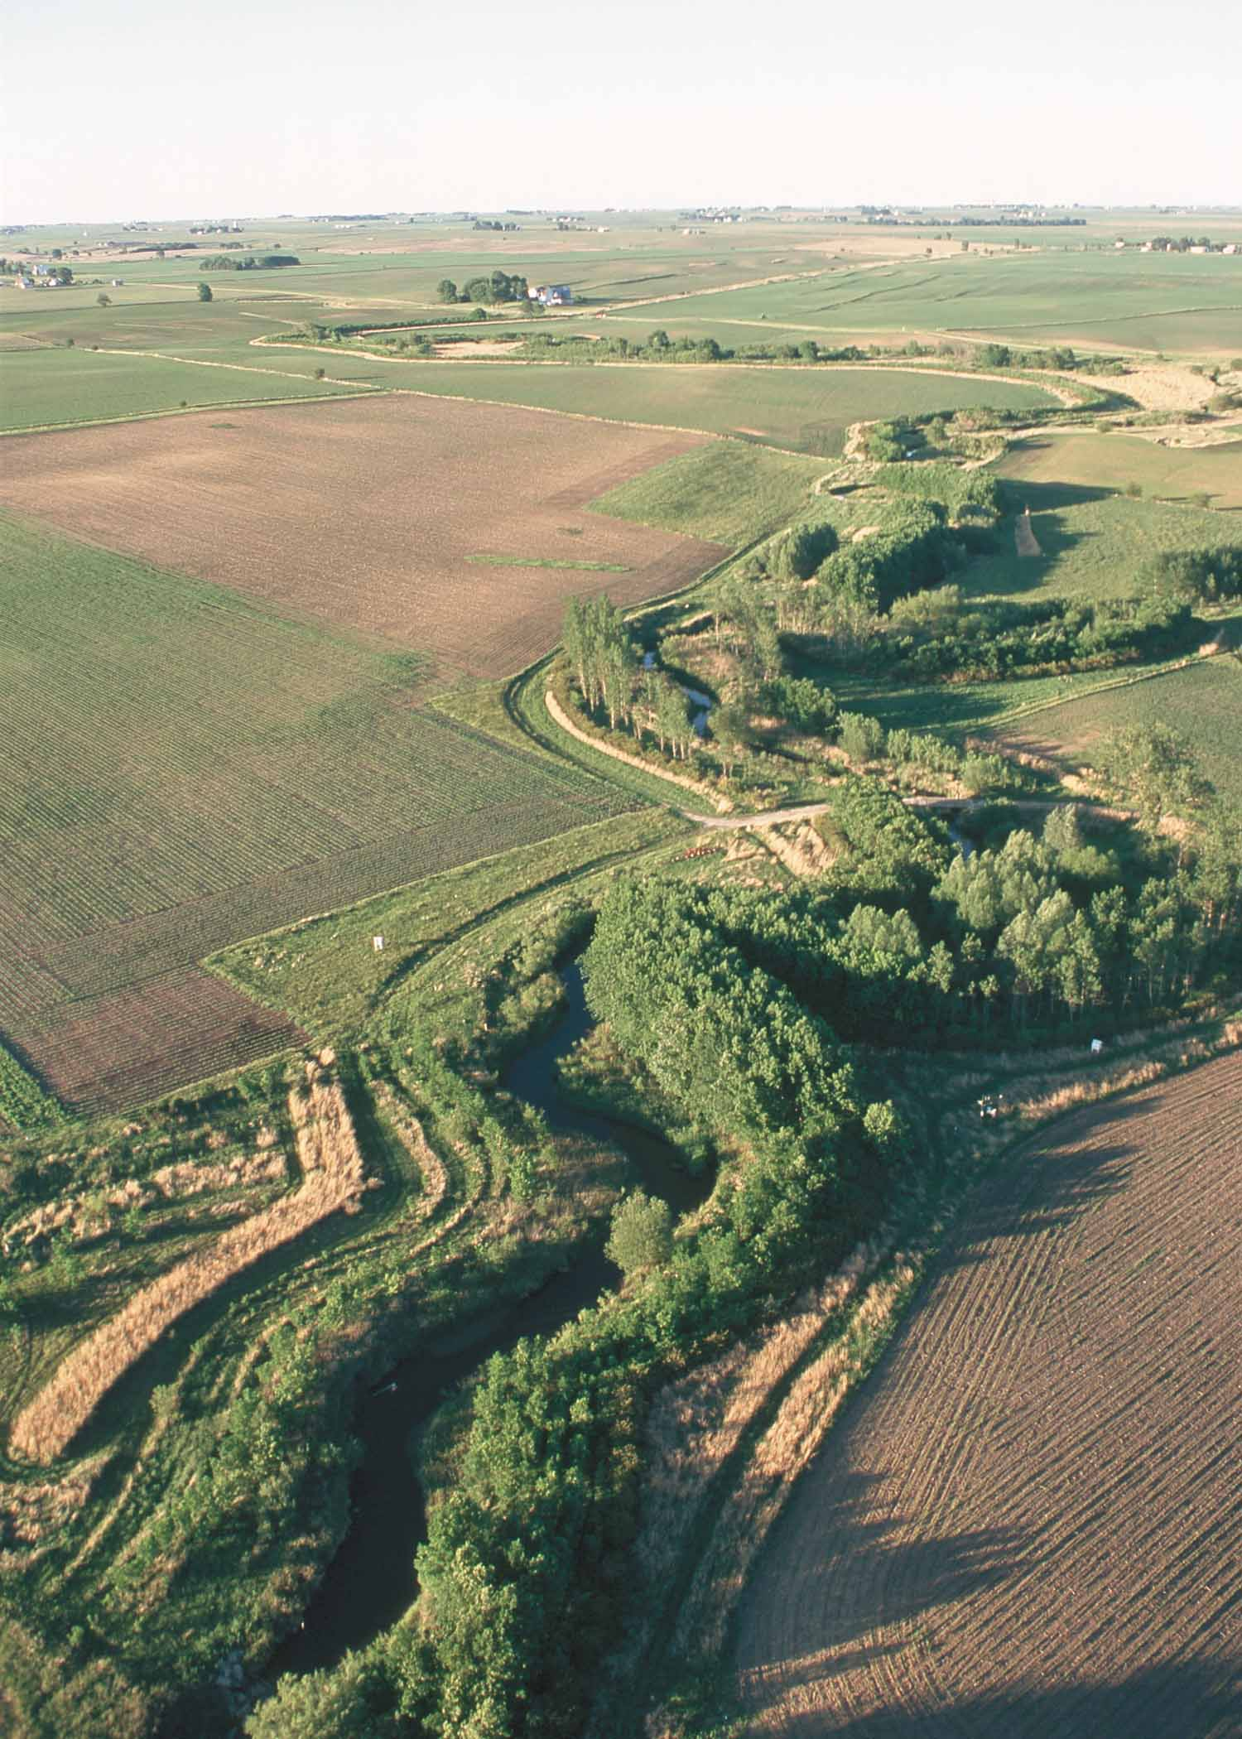
  - (b)
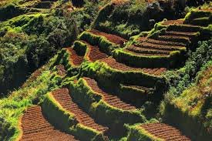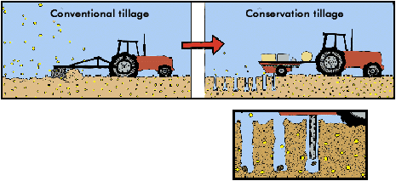
(c ) (d)
Figure 14: agricultural nwrmS (a) riparial buffer zones(source: USDA), (b) agroforestry (source: USDA), ( c) CONTOUR FARMING, (D) Ridge-till farming system (source: w. fills, 2011).
As described previously, agricultural NWR measures are a sustainable agricultural land management practices applied aiming at water management, while improving soil quality and limit nutrients and pollutants transport. Their main benefit is the groundwater recharge, the soil health improvement, the biodiversity enhancement and the ecosystem resilience. Furthermore, these measures are low-cost (compared to grey infrastructure) and can be adaptable in different regions. However, agricultural NWRM require farmer acceptance, as well as behaviour change. Their effectiveness is dependent on available training, monitoring and maintenance.

In the following table (Table 5) a brief summary of the main benefits and limitations of agricultural NWRMs is depicted.
Table 5: comparative summary of benefits and limitations of agricultural nwr measures
Benefits of Agricultural NWRMs | Limitations of Agricultural NWRMs
- Increase infiltration and soil moisture retention  - Improve groundwater recharge through soil structure enhancement  - Reduce surface runoff and peak flows at field and sub-catchment scale  - Reduce soil erosion and stabilize slopes  - Reduce gully formation through grassed waterways and contour farming  - Enhance on-farm biodiversity (pollinators, birds, beneficial insects)  - Create ecological corridors (hedgerows, field margins)  - Increase habitat heterogeneity  - Support soil biodiversity through reduced tillage and cover crops  - Reduce nutrient runoff (N, P) through filtration and reduce fertilizer needs  - Trap sediments and pesticides in buffer strips  - Reduce turbidity and pollutant loads entering water bodies  - Improve drought resilience  - Reduce heat stress through vegetation cover  - Agroforestry provides microclimate regulation and carbon sequestration  - Low-cost compared to grey infrastructure measures  - Improve farm productivity through healthier soils  - Enhance landscape aesthetics and ecosystem services  - Scalable and adaptable to different farm types  - Can be combined into an integrated farm management system | - Hydrological impact is limited locally rather than at catchment-scale  - Benefits are limited in medium to low frequency storms  - Effectiveness highly site-specific, depends on soil type, slope, etc  - Requires consistent farmer adoption across landscape  - Requires maintenance to prevent degradation (e.g., siltation of ditches)  - Some measures (e.g., hedgerows) require space and long establishment time  - Biodiversity gains depend on management  - Pesticide use can impact benefits  - Small-scale measures may not create landscape-level connectivity  - Effectiveness varies with buffer width, vegetation and maintenance  - Nutrient saturation of buffers over time  - Controlled drainage may increase nitrate leaching if mismanaged  - Benefits depend on long-term adoption and consistent management  - Some measures have high water requirement needs, which is scarce in Mediterranean climates  - Climate extremes can reduce vegetation effectiveness  - Carbon benefits vary widely by practice  - Require farmer acceptance and behaviour change  - Cost of land taken out of production  - Benefits long-term, while costs are immediate  - Some measures reduce short-term yields (e.g., reduced tillage in early years)  - Require training, monitoring, and consistent maintenance  - Some measures (agroforestry, hedgerows) require long establishment periods  - Controlled drainage and retention ditches need technical design and oversight

Forestry measures
Forestry NWR Measures use forest ecosystems and forest-management practices to regulate water retention, reduce runoff, stabilize soils and enhance infiltration (Figure 15). They are especially useful in steep, erosion-prone, fire-affected catchments. The most typical examples of forestry NWR measures include:
  - Afforestation / reforestation that consists in planting trees on degraded or bare land, reforesting burned or eroded slopes and increasing canopy cover to slow rainfall impact.
  - Forest road management that includes constructing cross drains and culverts, limiting road embankment compaction and closing unnecessary roads.
  - Deadwood retention consists of leaving logs, branches and root systems and installing engineered log jams.
  - Continuous cover forestry woodland management approach that consists in avoiding clear-cutting, maintaining permanent canopy and root systems and promoting mixed-age, mixed species stands. It involves selectively thinning trees to create a diverse forest structure, thereby producing timber while retaining canopy cover. It
  - Understory and vegetation management involves maintaining shrub layers, avoiding over-clearing and promoting native drought-tolerant species.
  - Fuel breaks designed to follow contour lines, mosaic landscape patterns and post fire erosion control. This approach reduces fire-risk, prevents catastrophic post-fire runoff and soil erosion, while it maintains long-term water regulation.
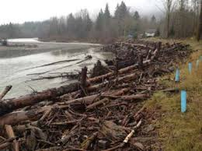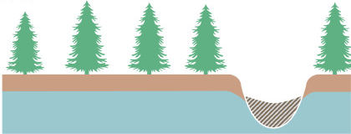
(a) (b)
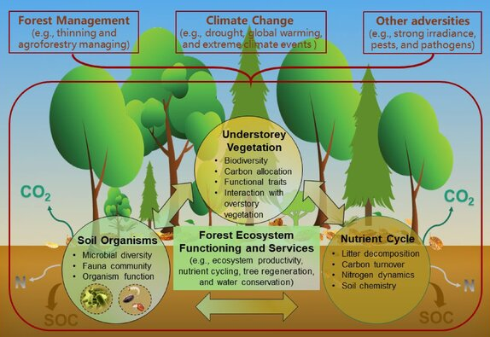
(c ) (d)
Figure 15: (a) engineerd log jams (source: abbe, 2018), (b) Continuous cover forestry (source: Hjalmar et Hasselquist, 2023), (c) Fuel Breaks (source: techlinenews) and (d) understory vegetation (source: deng et al., 2023).
As described previously, forestry NWR measures are through forest-management practices aim to regulate water retention, stabilize slopes and enhance infiltration. Their main benefits are slope stabilization, erosion control and restoration of natural purification processes. These measures are scalable from small riparian strips to large catchments and are based on well-established forestry and restoration techniques. However, benefits may require a long respond time from years to decades to mature and depend on long-term management. Furthermore, forests require high water consumption, which consists a limitation in the water scare Mediterranean region.

In the following table (Table 6) a brief summary of the main benefits and limitations of forestry NWRMs is depicted.

Table 6: comparative summary of benefits and limitations of forestry nwr measures
Benefits of Forestry NWRMs | Limitations of Forestry NWRMs
- Strong slope stabilization and erosion control  - Increase infiltration and reduce surface runoff  - Enhance soil water retention through organic matter  - Reduce peak flows and stabilize baseflows  - Reduce landslide risk through root reinforcement and reduce gully formation  - Stabilize riverbanks via riparian forests  - Provide high-value habitats and ecological corridors  - Support pollinators, birds, mammals, etc  - Enhance landscape connectivity  - Reduce sediment and nutrient runoff  - Filter pollutants through and reduce pesticide transport  - Enhance natural purification processes  - Increase carbon sequestration  - Reduce heat stress and buffer climate extremes  - Improve resilience to drought  - Provide recreation, tourism, and cultural value  - Support timber and non-timber forest products  - Enhance landscape aesthetics and rural development  - Well-established forestry and restoration techniques  - Scalable from small riparian strips to large catchments  - Compatible with integrated watershed management  - Can be combined with fire-resilient and climate-smart forestry | - Young plantations have limited hydrological effect and benefits depend on root maturity  - High evapotranspiration can reduce downstream flows  - Wildfire risk can reverse hydrological benefits  - Steep terrain limits accessibility for interventions  - Post-fire erosion can be severe  - Monoculture plantations offer limited biodiversity  - Poorly planned afforestation can harm open-habitat species  - Invasive species risk if non-native trees are used  - Biodiversity gains depend on long-term management  - Effectiveness varies with buffer width and forest type  - Steep slopes require careful management to avoid runoff pulses  - High fire risk under climate change threatens long-term benefits  - Water consumption of forests can reduce downstream availability  - Drought stress can reduce forest health and resilience  - Long establishment time before benefits materialize  - Opportunity cost of land (agriculture vs. forest)  - Conflicts with grazing or local land uses  - Management costs for thinning, fire prevention, and monitoring  - Requires long-term management and monitoring  - Sensitive to species selection and planting design  - Fire prevention and fuel management are technically demanding

URBAN measures
Urbanization is accelerating in recent decades. It is estimated that by 2050, nearly 70% of the world’s population will live in cities. This expansion increases pressure on natural systems and on engineered infrastructure, especially in a climate change context.
For this reason, flood risk management in urban areas has increasingly moved beyond traditional engineering solutions, focusing instead on urban resilience frameworks and blue-green infrastructure (BGI) to ensure sustainable development. BGI refers to the integration of natural systems (green) and water management (blue) into urban spaces to sustainably manage stormwater while delivering multiple co-benefits.

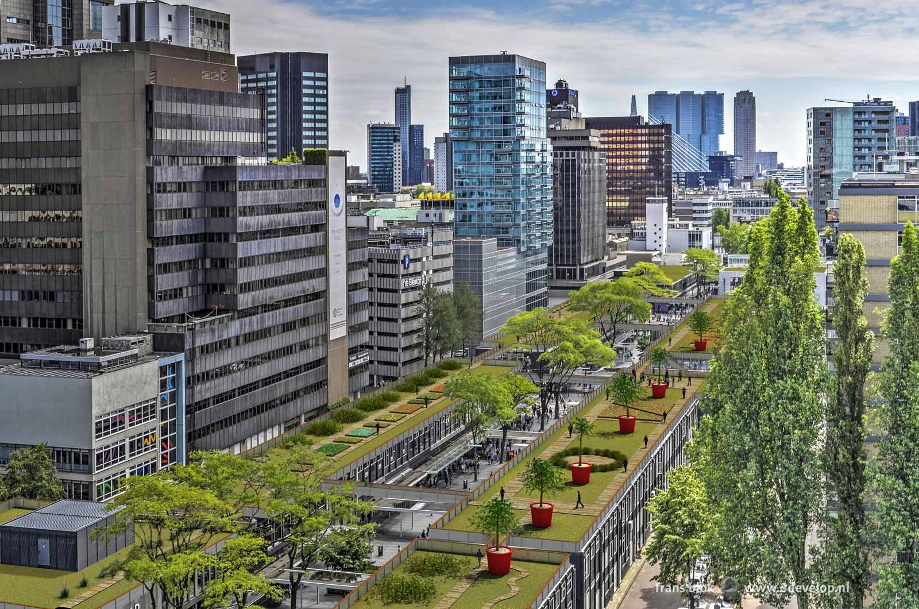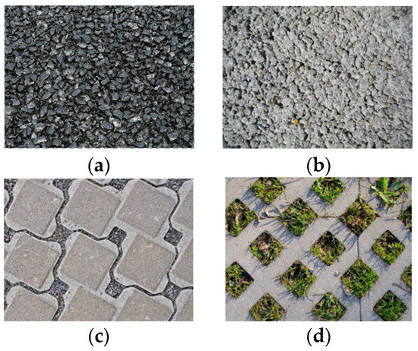
  - (b)
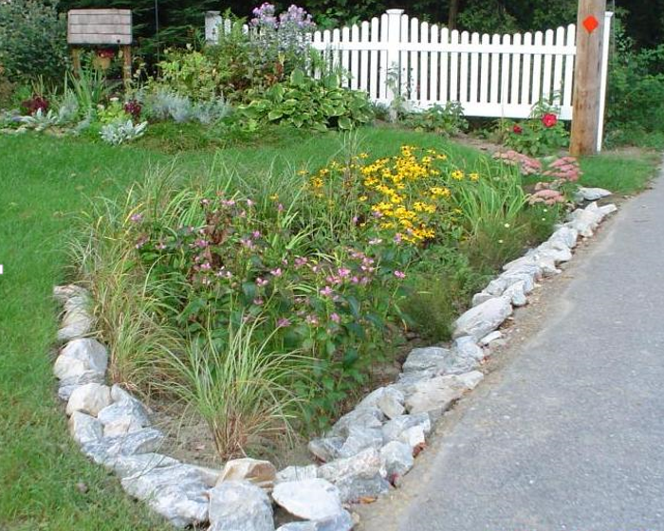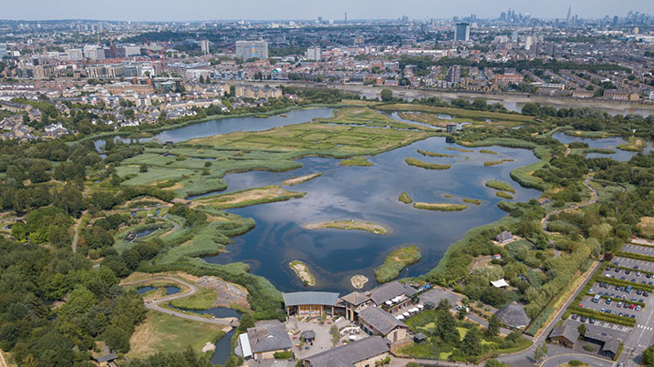
( c ) (d)
Figure 16: (a) high line baan (rotterdam), (b) permeable pavements (source: ciriminna et al., 2022) wetlands international, 2021), (C) rain garden (source: massachusetts clean water) and (d) WWT London Wetland Centre
Urban natural based solutions are multi-functional measures that aim at reducing stormwater peaks, increasing infiltration and improving microclimate and urban resilience (Figure 16). Some typical examples of urban NWR are presented in Table 7 and include:
  - Green roofs, which consist in creating a roofing surface that allows vegetation to grow and water to drain through. Green roofs aim at reducing building energy demand and mitigate heat islands. The core principle is that rainwater is absorbed through the plants (low grasses, perennial plants, sedums and even shrubs) and the soil and drainage layer. Underneath the drainage layer a waterproofing membrane is applied.
  - Permeable pavements, which are durable, eco-friendly surfacing material (e.g. porous asphalt, concrete, and interlocking pavers). They are designed to allow stormwater to infiltrate through the surface into underlying soil. In this way runoff is reduced, pollutants are filtered and groundwater table is recharged. Different type of permeable pavements exist, like porous asphalt or concrete, interlocking pavers, concrete or brick units, grid systems and resin-bound gravel.
  - Rain gardens / bioretention cells, which are shallow depressions filled with sandy soil, topped with a thick layer of mulch and planted with dense vegetation.
Stormwater runoff flows into the bioretention area, percolates through the soil (which acts as a filter) and eventually drains into the groundwater. Often, they are coupled with an overflow outlet to prevent flooding during larger storm events. In area where soils have low permeability, a perforated underdrain can be incorporated to route water into a storm drain system. Bioretention areas can provide excellent pollutant removal for the "first flush" of stormwater runoff as suspended solids, metals, and nutrients are removed.
  - Urban wetlands, which are natural or artificial water rich areas, like marshes, lakes, swamps, mangroves within or surrounding a city. They enhance urban resilience by reducing runoff volume and peak flow rates, lowering temperatures via evaporation, creating habitats for biodiversity, filtering pollutant through soil layers and providing recreational green spaces.
  - Swales or infiltration trenches, which are engineered channels that are often used alongside roads or landscaped areas. Swales are shallow, vegetated, open channels, while infiltration trenches are rock-filled trenches. These sustainable drainage systems (SuDS) provide underground storage, reduce flooding and improve water quality and enhance groundwater recharge. Swales and infiltration trenches are often used together. In this case a swale provides a sediment removal pre-treatment before directing water into an infiltration trench.
  - Urban forests, which are networks of trees—from small, dispersed trees to dense woodlands - within cities and surrounding areas, encompassing street trees, parks, gardens, and private, public, or peri-urban woodlands. Their main function includes reducing urban heat islands, managing stormwater, improving air quality and enhancing biodiversity.
  - River restoration in urban environments, which consists in daylighting streams, through uncovering, restoring and bringing to the surface waterways (creeks, rivers, or storm drains) that were previously buried (for example in pipes, culverts, etc). They reconnect waterways with the landscape, restore natural habitats, improve water quality and increase biodiversity. Furthermore, through stream daylighting flash flooding risks are reduced by providing natural, high-capacity channels rather than restricted and often aging culverts.

Table 7: summary URBAN NWRM CATEGORIES
NWRM Category | Examples | Primary Function
Green Roofs | Extensive roofs | Retention, cooling
Permeable Surfaces | Parking, sidewalks | Infiltration
Rain Gardens & Bioswales | Curbside gardens | Runoff reduction
Urban Wetlands | Retention ponds | Water purification
River Restoration | Open channels | Flood mitigation
Urban Forests | Tree-lined avenues | Cooling, air quality

As described, urban NWR Measures are nature-based solutions integrated into cities’ water management and aiming at improving stormwater management, groundwater table recharge, water quality, climate and economic resilience, biodiversity and social cohesion. Urban NWRMs contribute to improve urban microclimates and vegetation diversity and reduce drainage a combined sewer overflow. However, maintenance and site suitability are among their main limitations. Urban NWR measures requires regular maintenance (for example to prevent clogging of pores with debris), while some urban NWRMs have limited lifespan. Furthermore, space constrains often apply, especially in densely urban areas and thus a careful design is required.

In the following table (Table 8) a brief summary of the main benefits and limitations of urban NWRMs is depicted.

Table 8: comparative summary of benefits and limitations of urban nwr measures
Benefits of Urban NWRMs | Limitations of Urban NWRMs
- Reduce stormwater runoff volume and peak flows  - Increase infiltration and local groundwater recharge  - Reduce combined sewer overflow (CSO) events  - Reduce erosion in urban channels  - Stabilize soils in parks, green corridors, etc  - Increase ecological connectivity through green corridors  - Improve urban microclimates and vegetation diversity  - Strong pollutant removal through filtering runoff through soils and vegetation  - Improve water quality  - Reduce urban heat island effects and increase resilience to heatwaves (green roofs, trees)  - Support drought adaptation via rainwater harvesting  - Improve urban liveability  - Improve public space quality  - Provide recreational and educational benefits  - Reduce long-term stormwater management costs  - Scalable and compatible with existing infrastructure  - Wide range of mature design guidelines  - Can be integrated into redevelopment and new construction | - Limited space in dense urban areas  - Effectiveness reduced during low frequency (extreme rainfall) events  - Soil contamination limits infiltration options  - Requires extended implementation to achieve catchment-scale impact  - Minimal influence on large-scale geomorphic processes  - Sediment accumulation in bioretention and swales requires periodic removal  - High disturbance from urban activity  - Pollution and heat stress limit ecological potential  - Biodiversity gains depend heavily on design and maintenance  - Pollutant accumulation in soils requires periodic replacement  - Effectiveness limited under extreme climate scenarios  - Heatwaves can stress vegetation (e.g. in green roofs)  - Some measures have limited lifespan (e.g., permeable pavements)  - High upfront costs for installation  - Requires public acceptance and behaviour change  - Maintenance responsibilities often unclear  - Benefits diffuse, while costs are localized  - Requires regular maintenance to avoid clogging and failure  - Space constraints require careful design  - Performance highly site-specific (soil, slope, drainage networks)

non structural type MEASURES
Part of the Integrated Flood Management Plans are the non-structural type measures, which consist of policies, planning tools, management practices and behavioural or institutional measures. The focus of the non-structural measure is changing the way land, water and risk are managed, rather than altering the landscape through built structures (Table 9).
Table 9: INDICATIVE COMPARISON between structural and non-structural nwrmS.
Structural Measures (Grey or NWRMs) | Non-Structural NWRMs
Physical interventions (levees, dam, wetlands, ponds, green roofs) | Policies, planning, management, behaviour
Direct hydrological impact | Indirect hydrological impact via governance
Require land and construction | Require institutional capacity
Immediate local effect | Broad, catchment-scale influence
Higher CAPEX | Lower CAPEX, higher coordination needs

Non-structural strategies reduce exposure, improve preparedness and manage risk through reduction of exposure and vulnerability to floods and droughts, improvement in land-use planning, promoting sustainable water/soil management, strengthening long-term catchment resilience and encouraging behavioural change in communities. In particular, non-structural strategies include:
- Land-use planning and zoning, which prevents construction in high-risk flood zones and encourages development in safer areas. It comprises:
- floodplain zoning,
- setback zones along rivers,
- protection of wetlands, riparian zones, and natural retention areas,
- integration of NWRMs into spatial and urban planning,
- restrictions on soil sealing.
- Policy & Economic Instruments, which are non-structural NWRMs that influence how land and water are managed by shaping incentives, regulations and governance frameworks. They aim to unlock, accelerate and sustain the implementation of structural NWRMs across landscapes. More specifically, they include:
- regulation of land and water use,
- financial incentives (or disincentive) for sustainable land management,
- water pricing and demand management,
- insurance and financial instruments to spread flood insurance risk and support recovery,
- aligning agricultural and environmental policies,
- shifting behaviour and long-term management practices.
- Operational & Water Management Tools, which include management plans, hydrologic models and sensors to predict flood peaks and issue alerts. These systems are critical for evacuation and emergency response. More specifically these tools include:
- flood and drought early warning systems through, such as smart technology-enhanced systems for monitoring and response or smart flood sensors and real-time monitoring that track water levels and send alerts when thresholds are reached). These tools intergrade into urban flood-management systems,
- drought management plans,
- water allocation and abstraction planning,
- management plans (like River Basin Management Plans, Flood Risk Management Plans, Urban Master Plans) that provide long-term vision and cross sector coordination.
- emergency response protocols.
- Behavioural & Capacity-Building Measures, which include tools that enhance social norms, knowledge and institutional capacity. They help increase acceptance and long-term stewardship, reduce resistance to land-use changes and build capacity for implementation and maintenance through:
- community preparedness and education through public awareness campaigns, evacuation drills, and local response plans,
- community-based flood and drought preparedness,
- training programs for local authorities and stakeholders,
- knowledge transfer and participatory planning with local communities.

The non-structural measures are low cost, scalable measures that can be implanted by a wide range of institutions from local communities to national river basin authorities. However, they consist mostly of long-term actions and they are dependent on institutional capacity and stakeholder cooperation. These measures complement both conventional and NWR measures by creating the regulatory, social and operational conditions that allow natural processes to function effectively.

SELECTION CRITERIA – measures perfomance

evaluation criteria
From all of the above, it is clear that there is not one unique practice “fit for all”, nor one approach is considered as the universally efficient for flood management. Therefore, it is crucial to choose practices that suit each hydro-climatic, geographical and socio-economic area. In order to do that, the definition of a list of different evaluation criteria is critical. An indicative list is presented hereafter:
- Hydrological performance in terms of:
- Runoff reduction, which evaluates the measures’ capacity to slow, store or infiltrate water during flood events.
- Flood attenuation, which evaluates the level of peak flow reduction, lag time delay and hydrograph flattening.
- Groundwater recharge, which evaluates the infiltration potential, soil permeability and connection to aquifers.
- Evaporation/ evapotranspiration dynamics, which quantifies potential evaporation losses.
- Geomorphology in terms of:
- Erosion control, which consists in the efficiency of each measure to reduce soil erosion.
- Slope and bank stabilization, which evaluate the measure ability to retain soil instabilities.
- Ecological value as summarized through:
- Biodiversity enhancement, which can be evaluated through the restoration of diverse habitats (wetland, oxbows, etc), the improved ecological connectivity, the support in species migration, the enhancement of species richness and the ecosystem resilience, etc
- Climate resilience, which can be evaluated through a measure capacity to buffer floods, droughts, heatwaves and extreme rainfall.
- Carbon sequestration, which is evaluated through the extend of areas reforested, riparian buffers restored and wetland recreated.
- Reduced urban heat island, which are quantified though the ability of a measure to buffer climate extremes via microclimate cooling.
- Cultural and recreational landscape aesthetics, which are evaluated by the public’s perception of their surroundings.
- Water quality as achieved via:
- Enhancement of natural purification processes, which is evaluated through the amount of runoff filtered through soils and vegetation,
- Pollutant removal, which are quantified through water quality downstream or at the outlet.
- Sediment trapping, which can be evaluated through the reduction in sediment quantity downstream.
- Improved soil nutrient cycling, which can be evaluated through the reduced amount of nutrient runoff, the subsequent reduced fertilizer needs and the improved soil quality.
- Technical feasibility which can be evaluated through different parameters:
- Site suitability, which depends on accessibility, hydro-climate conditions, slope, geological types, etc.
- Space availability, which depends on land footprint and competing land uses.
- Engineering complexity, which depends on special, geological, structural constrains or the availability of potential specialized materials required.
- Scalability and replicability, which comprises the potential to expand across sub-catchments.
- Location in the catchment, meaning upstream or downstream of a catchment.
- Cumulative effects, which evaluates the synergy of different measures (for example combination NWRMs with grey infrastructure or non-structural measures).
- Personnel Availability (contractors, engineers, etc) with adequate now-how.
- Cost and governance which should comprise:
- Cost–benefit analysis, which comprises of a thorough techno-economical evaluation taking under consideration potential co-benefits, upfront costs, etc.
- Life span and robustness, which should be included the techno-economical evaluation of different measures and materials (for example material resistance to climate extremes, etc).
- Maintenance requirements, in terms of frequency, cost and technical skill needed.
- Land ownership and permissions should be included as often land acquisition and permitting procedures can be time consuming.
- Stakeholder acceptance, which include the time and effort required to present and discuss the measures benefits to different shareholders (for example via workshops, etc).
- Policy alignment, which includes coordination between National Legislation or Guidelines, Basin or National Water Framework Directive and Floods Directives, Local Landuse/ spatial Masterplans.
- Risk and uncertainty should evaluate technical approaches’ performance on:
- Climate change sensitivity and specifically its performance under extreme temperatures and intense precipitations, etc.
- Failure mode risk, such as blockage, overtopping, vegetation die-off, sediment overload.
- Monitoring feasibility, in order to track hydrological, water quality, ecological performance.

CONVENTIONAL (GREY) MEASURES
As presented in §0 for the past centuries, states and cities, in order to prevent the loss of life and flood damages, have planned physical interventions near river flood plains to redirect, route or store flooding, like levees, dams, floodwalls and barriers, drainage networks, etc. These measures are evaluated based on the criteria defined in §6.1, and their main benefits and limitations are depicted in Table 10.

Table 10: Conventional flood protection works benefits and limitations.
Criterion | Benefits | Limitations
Hydrological performance | - Good performance to event of all frequencies.  - Rapid response during extreme events.  - High capacity to control and store flood volumes.  - Solid engineering practice designed with reliable technical standards. | - Risk of transferring flood risk downstream.  -Not necessarily a catchment-wide measure.  - Can fail catastrophically if overtopped or breached.  - Limited adaptability to non-stationary climate extremes.
Geomorphology | - Stabilization of channels and banks in targeted locations.  - Reduces local erosion where structures are placed. | - Disrupts natural sediment transport and channel dynamics.  - Can cause downstream incision or aggradation.  - Constrains river mobility and floodplain natural processes.
Ecological value | - May create localized habitats (e.g., reservoir margins) but usually incidental. | - Fragmentation of habitats and interruption of ecological connectivity.  - Loss of floodplain wetlands and riparian zones.  - Reduced river biodiversity.
Water quality | - Controlled flows can reduce turbidity in specific reaches.  - Reservoirs may allow sediment settling. | - Reduced natural filtration and nutrient cycling due to floodplain disconnection.  - Increased pollutant concentration downstream during low flows.
Technical feasibility | - Mature engineering solutions with well-established design standards.  - Predictable construction timelines.  - Suitable for densely populated areas requiring high protection levels. | - Requires specialized engineering,  - Potentially complex permitting.  - Aging infrastructure and maintenance gaps are potentially a risk.
Cost and governance | - Protecting of high-value assets and justify investment through avoided damages.  - Often eligible for national funding due to clear risk-reduction metrics. | - High capital and long-term maintenance costs.  - Creates long-term financial liabilities for authorities.  - Can trigger equity issues (protection for some, increased risk for others).
Risk and uncertainty | - Provides a sense of security and clear design thresholds (e.g., 1-in-100-year protection). | - Over-reliance on structures reduces preparedness.  - Less adaptable to climate change and events beyond design limits.  - Failure consequences are often severe and sudden.

Based on Table 10 conventional flood protection measures excel in their hydrological performance due to their capacity to restrain both high and low frequency flood events. Furthermore, their performance excels in areas where people and infrastructure are densely concentrated.

However, their limitations lie in ecological disruption, geomorphological alteration and the risk related to their failure, especially when climate extremes exceed design assumptions. The construction cost is elevated, while maintenance cost can be significant and has to be included in the project OPEX.

In Table 11 provides a detailed synthesis for different types of conventional measures based on the defined evaluation criteria. To help create a comparison between different measures, a qualitative performance score is added using the following scale:
- High, equivalent to high performance to a particular criterion,
- Moderate, equivalent to moderate performance to a particular criterion,
- Low, equivalent to low performance to a particular criterion.
From this analysis some key conclusions are apparent:
- Levees and floodwalls offer strong local protection but create systemic downstream risks and ecological losses.
- Dams provide the most powerful hydrological control, but they introduce the largest geomorphic and ecological disruptions.
- Diversion channels reduce peak flows without significant intervention in the main river corridor, but they require space and a thorough shareholder consultation.

Table 11: Detailed perfomance per different conventional flood protection measure sub-category.
Measure | Hydrological performance | Geomorphology | Ecological value | Water quality | Technical feasibility | Cost & governance | Risk & uncertainty
Levees / Embankments | High  Strong protection against large floods; but do not reduce total flood volume. | Moderate  Constrain river mobility; may increase downstream erosion; disconnect floodplains. | Low  eliminate riparian and floodplain habitats. | Low  Eliminates  natural bank;  Reduce natural filtration. | High Well-established design practices; feasible in many terrains; require continuous maintenance. | Moderate  Moderate to high CAPEX; long-term OPEX; governance challenges due to residual risk downstream. | Moderate  Consequences of failure; overtopping risk increases with climate extremes.
Floodwalls | High  High local protection for urban areas; effective for intense floods. | Moderate  Severely restrict channel–floodplain interaction; increase flow velocity. | Low  create hard, impermeable boundaries with no habitat value. | Low  Eliminates  natural bank;  Reduce natural filtration. | High  Technically straightforward but require precise engineering; suitable for constrained urban spaces. | Moderate  High cost per metre; strong governance requirements for inspection and emergency planning. | Moderate  High failure consequences.
Dams / Reservoirs | High  Very high flood-storage capacity and can provide multi-purpose benefits. | Low  Trap sediment; cause downstream sediment starvation; alter natural flow regimes. | Moderate  Major environmental footprint. | Low  Risk of eutrophication, thermal stratification, low oxygen; altered nutrient cycles. | Moderate  Complex engineering; long construction times; require suitable geology. | Low  Very high CAPEX; long-term liabilities; land acquisition issues. | Low  Potential catastrophic failure; sensitive to sedimentation and climate-driven hydrological shifts.
Diversion Channels / Bypasses | High  Reduce peak flows by redirecting water; effective for extreme events with appropriate design. | Moderate  Modify local geomorphology; may cause erosion at inlet/outlet zones. | High  Low to moderate depending on design; vegetated bypasses can offer some habitat. | High  Can improve quality by reducing pollutant loads in main channel. | High  Technically feasible; require space and careful hydraulic design. | Low  Moderate to high cost; land acquisition; requires coordination across different jurisdictions. | Moderate  Moderate failure risk; performance depends on maintenance and sediment management.

nwrms
As described in §5.2, Natural Water Retention Measures (NWRM) are nature-based multi-functional interventions widely used in climate adaptation, flood mitigation, drought management and water-quality improvement. These measures are evaluated based on the criteria defined in §6.1, and their main benefits and limitations are depicted in Table 12.

Table 12: comparative summary of benefits and limitations of nwr measures
Criterion | Benefits | Limitations
Hydrological performance | Enhance infiltration, slow runoff, increase storage in soils and floodplains; reduce peak flows; support baseflows during dry periods. | Performance depends on rainfall intensity, soil conditions and spatial scale; slower response compared to grey measures; limited capacity during extreme events.
Geomorphology | Restore natural channel dynamics, reconnect floodplains, stabilize banks through vegetation, promote sediment deposition. | May require space for river mobility; effectiveness reduced in highly constrained areas.
Ecological value | Create or restore habitats, increase biodiversity, improve ecological connectivity, support riparian and wetland ecosystems. | Benefits may take years to mature; sensitive to poor maintenance or invasive species; limited ecological gains in highly urbanized settings.
Water quality | Improve filtration, reduce nutrient loads, trap sediments, enhance natural biogeochemical processes. | Effectiveness varies seasonally; risk of nutrient release from wetlands under anoxic conditions; may require careful design to avoid stagnation.
Technical feasibility | Simple, nature-based techniques; adaptable to many landscapes; low reliance on heavy engineering; easier to integrate with land management. | Require suitable soils, slopes and hydro-climatic conditions; performance sensitive to vegetation establishment; may be difficult in dense urban areas without space.
Cost and governance | Generally low CAPEX and OPEX; provide multiple co-benefits (recreation, climate resilience, biodiversity); align well with international directives and green-infrastructure strategies. | Require coordination across landowners and specialized maintenance;  benefits are long-term, governance complexity when measures span over multiple jurisdictions.
Risk and uncertainty | Fail gradually rather than catastrophically; resilient to climate extremes when implemented at scale. | Low performance during extremes event; benefits accumulate slowly; monitoring and benefit quantification can be challenging.

Based on Table 12 Natural Water Retention Measures provide multi-benefits across different criteria, such as hydrological performance, ecological value, water quality, etc. Their long-term resilience and cost-effectiveness are eminent advantages in the choice of a flood protection approach.

However, the potential requirements in land acquisition and stakeholder cooperation that are often associated with NWRMs are among their main limitations as they can increase significantly their implementation time. Furthermore, NWRMs ‘performance are highly depended on climate conditions (for example rainfall intensity), while benefits accumulate slowly and may take years to mature. During the operation phase a robust maintenance protocol should be set from the beginning. It is critical for the success of NWRM to obtain the alignment of local, social and institutional bodies.

In Table 13 a detailed synthesis for different NWRM sub-categories is presented based on the defined evaluation criteria. To help create a comparison between different measures, a qualitative performance score is added using the following scale:
- High, equivalent to high performance to a particular criterion,
- Moderate, equivalent to moderate performance to a particular criterion,
- Low, equivalent to low performance to a particular criterion.

From this analysis some key conclusions are apparent:
- Hydromorphological and wetland measures deliver the strongest system-wide hydrological and ecological benefits with respect to NWRMs, but require space and governance coordination.
- Forestry and agricultural measures excel in distributed retention and erosion control, offering high feasibility and low cost.
- Urban NWRMs are essential for low frequency flood mitigation and soil infiltration in urban environments. Their footprint is important for the improvement of urban environment, increasing the available green space and water quality in cities. Their effectiveness has limited geomorphologic influence, but might require regular maintenance (for example to avoid clogging).

Table 13: Detailed perfomance per different NWR measure sub-category.
NWRM Category | Hydrological performance | Geomorphology | Ecological value | Water quality | Technical feasibility | Cost & governance | Risk & uncertainty
Hydromorphological measures | High  Strong at slowing flows, increasing storage, reconnecting floodplains and reducing peak discharge; cumulative catchment benefits. | Moderate  Restore natural sediment transport, channel mobility and bank stability; reduce erosion. | High  Restoration riparian habitats, improve connectivity, support diverse species. | High  Improve filtration, reduce pollutants. | Moderate  Require space and geomorphological suitability; engineering design-sensitive. | Moderate  Moderate cost;  complex governance due to land acquisition and multi-stakeholder coordination. | High  Low structural failure risk; performance depends on space availability and long-term maintenance.
Forestry measures | Moderate  Increase infiltration, reduce runoff, enhance soil moisture retention; effective for small–medium events. | High  Stabilize slopes, reduce erosion, increase soil organic matter; improve hillslope processes. | High  Enhance habitat connectivity, support biodiversity. | High  Strong nutrient and sediment retention; improve shading and thermal regimes. | High  High feasibility in mountainous areas; limited in urban or agricultural plains. | High  Low to moderate cost; long-term governance needed for land-use change. | High  Low risk; Performance varies with species selection, wildfire risk and climate extremes.
Wetland & aquatic ecosystem measures | High  High storage capacity; attenuate peak flows; support baseflow regulation. | Moderate  Promote sediment deposition, reconnect floodplain processes. | High  Wetlands enhance biodiversity. | High  Excellent pollutant removal, sediment trapping. | Moderate  require suitable hydroclimatic and geomorphological conditions; sensitive to design and vegetation. | Moderate  Moderate cost; Maintenances costs should be included; strong policy support and governance needed. | Moderate Moderate risk Sensitive to drought.
Agricultural measures | Moderate  Reduce runoff, increase infiltration, slow overland flow; effective at small-scale retention. | High  Reduce soil erosion, improve soil structure, enhance sediment retention. | Moderate  Improves field connectivity. | High  Reduce nutrient runoff; improve soil filtration;  reduce pesticides need. | High  High feasibility; easy integration with farm practices; require farmer cooperation. | High  Low cost; governance depends on incentives, CAP schemes, and farmer uptake. | High  performance varies with maintenance, crop cycles and extreme rainfall.
Urban NWRMs | Moderate  Reduce runoff volume and peak flows; increase infiltration; effective for frequent storms. | High  Limited geomorphological impact, reduce erosion in urban channels by moderating flashy flows. | Moderate: create microhabitats, increase urban green space. | High  Improve stormwater quality by filtering sediments and pollutants. | High  High feasibility in new developments; retrofitting can be challenging; space constraints apply. | Moderate  Moderate to high cost; governance involves municipalities, utilities and private owners. | High  Low structural risk; performance sensitive to clogging, maintenance, and drought stress.

NON-STRUCTURAL MEASURES
As discussed in §0, non-structural measures include policies, planning tools, institutional actions and behavioural strategies that reduce flood risk without relying on physical engineering works (grey or green). These measures may include land-use planning, zoning, early-warning systems, insurance schemes, emergency preparedness, public awareness campaigns and flood-risk mapping.

Their focus is identifying vulnerabilities, managing exposure, creating policies and modifying/establishing legislation. Even though these measures are often complementary with conventional and NWRMs, their effectiveness lies in setting the groundwork for all other measures. To this end, Table 14 provides a comparison of non-structural flood-risk management measures performance based on the defined evaluation.
Table 14: comparative summary of benefits and limitations of non-STRUCTURAL measures
Criterion | Benefits | Limitations
Hydrological performance | Reduce exposure by steering development away from flood-prone areas; lower overall damages without altering hydrology; enable adaptive responses during events through forecasting and warnings. | Do not directly reduce runoff or peak flows; rely on behavioural change and compliance; effectiveness limited when extreme events exceed preparedness capacity.
Geomorphology | Preserve natural river mobility by preventing hard infrastructure; maintain floodplain functions through zoning, setback policies, etc. | Cannot restore degraded geomorphology; require complementary physical measures to address erosion or channel instability.
Ecological value | Protect and expand natural habitats by restricting development in sensitive areas; support long-term ecological restoration through land-use planning. | Ecological gains are indirect and slow; benefits depend on enforcement and land-use compliance; limited impact in already urbanized areas.
Water quality | Reduce pollution risk by controlling land uses near water bodies; improve stormwater quality through behavioural and regulatory measures. | Do not directly treat or filter water; rely on voluntary or regulatory compliance; limited effect during extreme runoff events.
Technical feasibility | Strong Feasibility as it relies on planning tools, regulations, digital systems and community engagement; adaptable to different contexts; scalable across regions. | Require strong institutional capacity, data quality, and continuous updates; early-warning systems need reliable monitoring networks; implementation varies across jurisdictions.
Cost and governance | Generally low capital cost; cost-effective for reducing damages; support long-term resilience; align with existing directives and integrated flood-risk management. | Governance-intensive as it requires coordination across agencies, municipalities and landowners; political resistance possible when restricting development; long-term enforcement needed.
Risk and uncertainty | Reduce systemic risk by lowering exposure; flexible and adaptive under climate change; avoid catastrophic structural failures. | Effectiveness uncertain if public awareness is low or compliance weak; behavioural responses unpredictable; extreme events may overwhelm preparedness measures.

Based on this Table non-structural measures provide indirectly significant benefits both in the reduction of future damages (people or/and assets) and the preservation of natural floodplains via:
- the management of exposure through land-use and spatial planning (zoning, building code, etc).
- the preparedness improvement and response planning through early-warning systems, emergency plans, evacuation protocols and public awareness campaigns,
- an effective governance and agency coordination,
- the establishment of specialized frameworks,
- financial incentives (or disincentives) for sustainable land management.

Non-structural measures often provide the highest cost-effectiveness to reduce flood risk, especially in areas where structural works or NWRMs are impractical, too expensive or environmentally damaging. They are essential for climate-change adaptation, because they can be updated and adjusted for different climate scenarios and thus changing the baseline risk of a catchment.

However, the non-structural measures can’t be considered as a “stand alone” flood management approach, but it is complementary to both NWRMs and conventional (grey) measures.

conclusions
From the comparison presented in the previous paragraphas the following main conclusions can be drawn:
- Conventional flood protection measures are most effective for high-magnitude, low-frequency events and especially adequate for areas when spatial constrains are significant. They are most suitable where immediate, high-capacity protection is needed (for example in dense urban areas with limited space, etc).
- Natural Water Retention Measures (NWRMs) are effective in reducing runoff and water storage, in improving soil stability and landscape restoration. They excel in catchment-scale resilience, multi-benefit outcomes and climate adaptation, but require land, time and coordination. They are strongest when combined with conventional and non-structural measures.
- Non-structural measures aim at long-term flood risk reduction through updating existing policies, improving governance capacity building and public awareness. They are essential for risk management, exposure reduction and climate change adaptation, but cannot replace physical measures, like NWRMs and grey infrastructure.

Table 15 presents a comparative table presenting the performance of Conventional (Grey) Flood Protection Approaches with the five NWRM sub-categories (Hydromorphological/Wetland, Agricultural, Forestry, Urban), as well as the non-structural measures based on the defined evaluation criteria. To help create with the comparison, a qualitative performance score is added using the following scale:
- High, equivalent to high performance to a particular criterion,
- Moderate, equivalent to moderate performance to a particular criterion,
- Low, equivalent to low performance to a particular criterion.

Table 15: comparative summary between differentl flood management approches.
Criterion | Conventional measures | Hydromorphological / Wetland NWRMs | Agricultural NWRMs | Forestry NWRMs | Urban NWRMs | Non-structural measures
Hydrological performance | High | High | Low | Low | Moderate | Low
Geomorphology | Low | High | High | High | Moderate | Low
Ecological value | Low | High | Moderate | High | Moderate | Low
Water quality | Moderate | High | High | High | High | Low
Technical feasibility | High | Moderate | High | Moderate | Moderate | High
Cost & governance | Low | Moderate | Moderate | Moderate | Moderate | High
Risk & uncertainty | High | Moderate | Moderate | Moderate | Moderate | Low

As depicted in Table 15, the best approach is rarely the one with the highest individual score—it’s the one that fills a functional gap in a catchment. For example, a measure with moderate hydrological performance but high feasibility and strong stakeholder acceptance may outperform a technically superior but socially unviable option.

Furthermor, it is clear that an effective flood protection approach emerges from the adequate combination of conventional and natural water retention measures with the necessary support of the non-structural measures. This integrated approach is critical as climate change intensifies flood frequency and severity, as it combines:
- Conventional measures (Grey infrastructure) for critical protection, especially in high-risk areas.
- NWRMs for retention and infiltration increase and ecological restoration benefits
- Non-structural measures for long-term risk reduction in terms of exposure, casualties and economic losses.
Moreover, this hybrid combination of conventional measures with NWRMs and Non-structural measures reduces the flood load on grey infrastructure. This can result in:
- an extended lifespan of dams, levees, drainage systems, etc when in operation phase, or
- re-dimensioning of grey infrastructures and improvement of their environmental footprint,
- in less fatalities and/ or economic losses from major flood event through zoning, improved public awareness and implementation with early warning systems.

To this end, different combination approaches (hybrid schemes) towards an integrated flood management are presented in Table 16. Each hybrid scheme is adapted for a different context as presented and analysed hereafter.

Table 16: DIFFERENT COMBINATIONS OF FLOOD MANAGEMENT APPROACHES (HYBRID SCHEMES).
Context | Grey Infrastructure | NWRM & Non Structural | Justification
Hybrid Scheme 1:  Cities and flash-flood-prone towns | Protect dense urban areas with high asset value (levees, floodwalls, pumping stations) | Urban NWRMs & Non-Structural Measures | - Grey infrastructure protects critical assets; green reduces load  - Green roofs, permeable pavements, swales reduce stormwater entering the system, reduce overload  - Zoning + early warning systems reduces exposure
Hybrid Scheme 2:  Large river basins, floodplain systems, upstream mountainous catchments | Reduce downstream flood peaks from large catchments (dams, retention basins) | Wetland & Forestry NWRMs & Non-Structural Measures | - Wetlands store water and slow hydrographs  - Forests increase infiltration, stabilize slopes and reduce sediment production  - Grey infrastructure handle residual peaks
Hybrid Scheme 3:  Rural plains, mixed farming landscapes, terraces | Protect agricultural land and rural infrastructure (embankments, drainage channels) | Agricultural NWRMs & Non-Structural Measures | - Contour farming, buffers and agroforestry reduce runoff  - Prevent development in high-risk zones  - Grey infrastructure protects key transport/irrigation assets
Hybrid Scheme 4:  Mountainous catchments |  | Forestry NWRMs & Agricultural NWRMs & Non-Structural Measures | - Forest cover reduces slope runoff  - Terracing and contour farming slow overland flow  - Grey infrastructure trap debris and attenuate peaks
Hybrid Scheme 5:  Peri-urban zones, industrial areas, transport corridors | Protect critical infrastructure (levees, floodwalls, pumping stations) | Wetland NWRMs & Urban NWRMs & Non-Structural Measures | - Wetlands buffer peak flows before they reach infrastructure  - Urban NWRMs reduces local runoff  - Grey infrastructure ensures structural protection
Hybrid Scheme 6:  Coastal deltas, estuaries, lagoons | Reduce coastal flood and storm surge impacts (sea walls, breakwaters) | Wetland NWRMs (coastal marshes) & Non-Structural Measures | - Marshes dissipate wave energy  - Zoning prevents risky development  - Grey infrastructure protects essential assets
Hybrid Scheme 7:  Old cities with combined sewer systems | Address combined sewer overflow (CSO) problems (improve drainage network) | Urban NWRMs & Wetland NWRMs & Non-Structural Measures | - Urban NWRMs reduces inflow to sewers  - Constructed wetlands treat overflow  - Grey infrastructure storage tanks handle residual peaks
Hybrid Scheme 8:  Hydrological basins with strong seasonal variability | Mitigate drought while managing flood risk (reservoirs, etc) | Agricultural & Forestry & Wetland NWRMs & Non-Structural Measures | - Soil moisture retention, forest shading, and wetland storage increase resilience  - Grey infrastructure/ reservoirs provide backup supply

Review of software for flood-adaptation design
“All models are wrong, but some are useful”
George E. P. Box, 1979

Why use models?
The meaning of the above epigraph is that no model describes reality perfectly. Even if a model is precise, again it differs from reality conceptually as the model is a representation of reality, not the physical reality per se (Koutsoyiannis, 2025).
The optimal model is the one that yields outputs close to reality while using the fewest variables and minimal conditions. This is called a parsimonious model. The concept of parsimony was understood a long time ago and expressed by the famous Ockham’s razor: “Plurality must not be posited without necessity” (William of Ockham, Ordinatio). In simple words: too many parameters are a problem.
There are many reasons why we need to model the processes of hydrology and water resources in general. The main reason is the limitations of hydrological measurement techniques. We have, in fact, only a limited range of measurement techniques and a limited range of measurements in space and time.
Therefore, extrapolating from available measurements in both space and time is essential, particularly in cases of ungauged catchments or in future scenarios, in order to assess the likely impacts of hydrological change. Models provide a means of quantitative extrapolation or prediction that is helpful in decision making.
The ultimate goal is to improve decision making, whether that be in water resources planning, flood protection, mitigation of contamination, licensing of abstractions or other areas. Given the increasing water resources demand throughout the world, improved decision making in a context of changing climate requires improved models (Beven, 2012).

Modelling Tools Used in Practice
In practice, flood adaptation planning rarely relies on one single model. Instead, a modelling chain is typically implemented, combining hydrological, hydraulic and risk-analysis tools. A simplified modeling chain in Mediterranean context includes:
- Hydrological models for rainfall analysis (historical records, IDF curves, design storms/streamflows), rainfall–runoff modelling (event-based or continuous),
- Hydraulic models for hydraulic routing and floodplain simulation (1D, 2D or coupled), flood hazard mapping (depth, velocity, extent), exposure and risk assessment (infrastructure, population, land use), adaptation measures design (detention basins, NBS, levees) and scenario comparison (current vs future climate or land-use conditions)
- Flood Awareness Systems for operational flood, early-warning, risk management and crisi response.
The choice of model at each part of the chain depends on data availability, spatial scale, modeler’s experience, regulatory requirements and institutional capacity.

Hydrological Models

Hydrological Model Types
A hydrological model is a simplification of the water cycle (e.g. surface water, groundwater, etc) that helps understand, predict and manage water resources. Different types of models exhibit distinct capacities and limitations. Therefore, their classification is essential in order to identify their suitability for specific water resources management applications (Figure 17).
Hydrological systems consist of multiple processes that are represented through the interaction of different parameters.
One classification of hydrological models refers is based on their capacity to represent spatial parameter variability within a hydrological basin (spatial discretization). Thus the models are divided into: lumped, semi-distributed and fully distributed models.
The lumped model has only one constant set of parameters for the whole area of application. The distributed model has several identical cells that adopt different parameter values. Finally, the semi-distributed model has cells that are not necessarily the same size and shape with each other. The user can assign different parameter values to each cell.
Another classification of hydrological models is based on their process representation:
- Empirical models are based on observed data and statistical relationships between inputs and outputs (regression equations, unit hydrographs)
- Conceptual models simplify complex hydrological processes using conceptual storage elements (reservoirs) and flow pathways (linear or nonlinear equations)
- Physically based models are using governing equations of fluid mechanics and conservation laws (mass, momentum, energy) by solving partial differential equations.
A third classification is based on temporal scale:
- Event-based models simulate individual storm events with short time steps (minutes to hours) focusing on peak flows and hydrographs. Input is usually derived through extreme value analysis.
- Continuous models simulate hydrological processes over extended periods (months to years) capturing long-term water balance and low flows. Input is usually historical or synthetic time-series.
Finally, the last category of hydrological models is related to model uncertainty (Chow et al., 1988):
- Deterministic models describe a hydrological system through fixed equations and parameters, producing a single output for a given set of inputs and initial conditions
- Stochastic models explicitly account for the inherent randomness of hydrological processes by representing inputs, parameters or system dynamics as random variables or processes, thereby generating probabilistic outputs and enabling the assessment of uncertainty, variability, and risk in hydrological responses.

Figure 17: Types of hydrological models (Dwarakish & Ganasri, 2015)
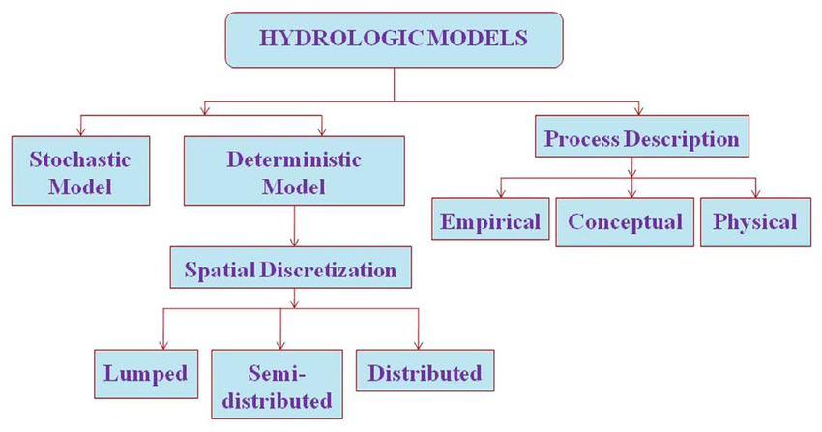

commonly used hydrological models
A recent overview of hydrological modelling approaches and capabilities by Beven (2025) states that no single model structure is universally applicable. The reason behind this is that model performance depends strongly on modeling purpose, project scale, data availability and the nature of the decision problem. For this reason, the user should keep in mind that:
- model complexity should be aligned with the information content of available data and the intended application rather than maximized by default.
- model evaluation should therefore focus on robustness, transparency and fitness for purpose rather than on single performance metrics.
- hydrological models differ fundamentally in how they represent processes, ranging from highly simplified abstractions to explicit numerical solutions of governing equations.
- increased process detail does not necessarily lead to improved predictive skill, particularly when data are limited or uncertain.
- many models combine elements of different modelling philosophies, resulting in hybrid approaches that blur traditional distinctions between conceptual, physically based, and empirical models.
- uncertainty arises not only from parameter estimation and input data, but also from structural choices embedded in model formulation.
- advances in data availability, computation and machine learning have expanded modelling capabilities, but they also introduce new challenges related to interpretability, transferability, and extrapolation beyond observed conditions.
- overall, hydrological models should be viewed as conditional analytical tools that support understanding and decision-making under uncertainty, rather than as definitive representations of hydrological reality.
Hereafter we present, in a descriptive way, some of the internationally available hydrological models commonly used in the Mediterranean context:
- NAM model, which is a lumped conceptual hydrological model used to simulate rainfall-runoff processes. It simulates the hydrological cycle using the average value of different parameters for the whole watershed. NAM model has four storage layers: (i) snow (ii) surface (iii) lower zone and (iv) underground and simulates three flows processes: (i) overland flow (QOF), interflow (QIF) and underground flow (QBF). The NAM model can either be applied independently in a catchment or by dividing a large basin into small sub-basins (Kumar et al., 2019). It’s part of the DHI MIKE Hydro Basin package.
The NAM hydrological model is widely used across Mediterranean basins because it performs well under data-scarce and highly seasonal conditions. Its structure—four conceptual reservoirs representing surface, root zone, interflow, and groundwater—matches many Mediterranean hydrological processes. Its performance depends heavily on calibration. Mediterranean studies show that NAM can achieve high calibration and validation performance (Pereira et al., 2016).
It is less suitable for areas with sharp elevation gradients or prone to localized convective storms or highly heterogeneous geology. High-altitude Mediterranean basins require careful calibration of NAM’s snow module.
- HBV model, which is widely among the most standard lumped conceptual model globally (HEPEX). It has been used extensively in more than 95 countries, references in 1400 publications and in almost 50 PhD theses. Its structure is similar to NAM, as it uses routine reservoirs for snow, soil moisture, and runoff response. It’s more suitable for regions with significant snowfall or mountainous terrain, though it is highly versatile across all climates.
The HBV model is widely used in Mediterranean basins because its conceptual structure, low data requirements and robustness under climate variability match the hydrological behavior of semi-arid and seasonally dry catchments. For example, in Greece and Morocco, the HBV model simulated daily flows to analyze high-flow trends under climate change. It successfully detected decreasing flood trends in Greece, and increasing trends in Morocco, demonstrating its ability to capture regional hydrological contrasts (Bouadila et al., 2020).
However, HBV’s lumped structure cannot fully represent spatial complexities. Furthermore, HBV’s performance depends heavily on calibration quality. In Mediterranean basins with short or noisy datasets, parameter uncertainty can be high.
- GR4J/GR5J/GR6J model, which is a parsimonious daily rainfall–runoff model with four/ five/ six parameters. It is developed as part of a suite of lumped hydrological models, the Génie Rural (GR) hydrological models by IRSTEA (France). They are lumped models that can be applied at various time steps, ranging from hourly to annual. Their conceptual parameters must be calibrated against streamflow observations. In low- flow environments, the GR6J is often preferred (Coron et al., 2017).
They are widely used in the Mediterranean catchments, especially in catchments with limited data availability. Their applications include daily streamflow simulation in small–medium basins and climate change impact studies among other.
The main advantage of the GR models is that they require very little input data and can be calibrated even with short datasets.
Their limited representation of groundwater processes along with the fact that they cannot capture strong spatial rainfall variability (typical of convective Mediterranean storms) is among the main limitations.
- HYMOD, which is a simple conceptual hydrological model, originally created as a parsimonious 5-parameter model designed to function on a daily scale. The model consists of a variety of different functions for excess generation (interception, storage tension storage, free storage), percolation and streamflow routing. Thus, it can describe different hydrological behaviors of a watershed system.
It requires limited data variables to carry out simulations: precipitation (mm) and potential evapotranspiration (mm) (Boyle, 2000). Another advantage is its robustness across diverse climates.
The model has been evaluated globally, including in regions with Mediterranean-type climates, and its parameter regionalization has been shown to be feasible and reasonably robust (Bastola, 2022).
However, its limited representation of complex processes and its sensitivity to parameter regionalization are among its main limitations. Studies have shown that parameter regionalization can lead to performance losses up to of 10–15% when applied to ungauged basins, which is the case in many Mediterranean regions with sparse gauging networks.
- TOPMODEL, which is a rainfall-runoff model that has its origins in recognition of the dynamic nature of runoff back in the 1960s and 1970s. It was one of the very first models to make explicit use of topographic data in the model formulation, well before digital terrain or elevation maps started to be made available. TOPMODEL reflects the way that the catchment topography would shape runoff generation in a structurally, parametrically and computationally parsimonious model (Beven et al., 2021).
TOPMODEL is adapted for areas with limited data (such as certain Mediterranean catchments), small to medium catchments (10-500km2), areas with moderate slopes and where saturation excess processes dominate. It’s less adapted for urbanized areas or large catchments or high-altitude Mediterranean basins or karst systems.
TOPMODEL has been used extensively across Greece, Italy, Spain, Portugal, Morocco, Algeria, Tunisia and Turkey in order to simulate flash floods, climate change impact, etc.
- SWAT, which is a spatially distributed watershed-scale hydrological model. Hydrological processes such as infiltration, surface runoff, evapotranspiration, and groundwater flow are simulated on a daily time step. It is mainly used to simulate water and related environmental processes. Both surface water and groundwater are represented.
The model is often applied to examine how changes in land use or water management affect water availability and water quality. Climate variability is also commonly considered.
It has been applied on a wide range of spatial scales. The model integrates hydrological processes with sediment transport and nutrient dynamics. Management practices are included explicitly, which allows scenario-based analysis.
The SWAT model is one of the most widely used eco-hydrological models in Mediterranean regions, especially in Greece, Italy, and Spain (Aloui et al., 2023). Its ability to simulate water quantity, water quality, land-use change and climate-change impacts makes it a central tool for Mediterranean water-resource research.
The model performs well under seasonal climates, intense short duration storms and complex land-use mosaics (agriculture, forests, shrublands). Furthermore, the model simulates well sediment and erosion conditions.
- WEAP, which is a water resources planning model that links water supply and demand with water quantity and quality considerations. Environmental constraints are explicitly represented. On the demand side, it represents water use patterns, efficiencies, reuse, pricing, hydropower demand, and allocation rules. On the supply side, it includes streamflow, groundwater, reservoirs and water transfers. WEAP is used to examine alternative strategies for water development and management.
WEAP is one of the most widely used integrated water-resources planning models in the Mediterranean region. In Morocco, for example, WEAP was used in order to simulate future water balance scenarios at Haouz plain under climate change scenarios.
WEAP allows different water needs (irrigation, water supply, etc.) to be simulated together, which is essential in water-scarce Mediterranean catchments. The model supports the allocation of water quality, groundwater–surface water interaction and policy scenarios in a unified structure.
However, it has limited ability to simulate extreme flash floods (very common in the Mediterranean basin) and complicate groundwater processes. Furthermore, it is data-intensive and often calibration is very demanding in data (hydrological, demand, operational rules, etc).
- MIKE HYDRO Basin is a river basin modelling tool designed for integrated water-resources management. The model simulates water allocation over time based on availability and system rules. Reservoir operations and water transfers can be modelled directly. Scenario analysis is used to test changes in infrastructure, demand, operation and climate. Results are provided as maps, time series, and summary indicators, which allow clear comparison between scenarios.
It is suitable for a basin-scale, multi-sector water-resource planning, especially in regions with water scarcity, strong seasonal variability, climate-change pressures and agricultural dominance. However, it is less suitable in very small catchment (<20–30 km²) and high-resolution flood modelling.
MIKE HYDRO Basin has been extensively used in Mediterranean basins.
- HEC-HMS is designed to simulate precipitation-runoff processes of a watershed and is applicable in a wide range of geographic areas. This includes large river basin water supply and flood hydrology, as well as small urban or natural watershed runoff. It calculates rainfall-runoff, snowmelt and baseflow for water management and flood forecasting.
HEC-HMS is widely used in Mediterranean basins because it can simulate event-based and continuous rainfall–runoff processes, handle flash-flood dynamics. The model can operate with limited data, which matches the hydrological realities of semi-arid and seasonally dry Mediterranean catchments. Recent applications in Spain and Greece show that HEC-HMS performs well in semi-arid basins with high climatic variability, scarce precipitation and high evapotranspiration, and can accurately reproduce flow regime changes for water-management purposes (Wang et al., 2016).

HEC-HMS is ideal to simulate flash floods, event-based hydrology and a watershed response under climate variability. However, it is less suitable for simulating complicated groundwater and sub-hourly urban flooding. Model performance is sensitive to rainfall input quality and calibration is challenging.
- LISFLOOD is a distributed hydrological and water-resources model. It simulates the entire water cycle from rainfall to river flow, including surface and subsurface processes. The model can run from small catchments to global scale and is developed for water policy support and climate impact studies.
It is widely applied across Europe and the Mediterranean basin for flood forecasting, drought monitoring, climate-change impact studies and integrated water-resources assessments. It is also the core model behind Copernicus Emergency Management Service flood and drought systems, such as the European Flood Awareness System (EFAS) and the Global Flood Awareness System (GloFAS).
Lisfood is ideal to model large-scale catchments for climate-change scenarios, flood/ drought forecasting, land-use and policy analysis and water resource assessment. However, it is less suitable for very small basins (<10–20 km²), coastal flooding and high-resolution urban flood modelling. Furthermore, it is computationally intensive and sensitive to rainfall input quality.

In the following table (Table 17) a comparative summary of the different hydrological models, presenting their strengths and limitations, as well as their ideal application. Based on the above, in a mediterranean context:
- HBV, NAM, GR and SWAT Models excel in simulation of seasonal climates (wet–dry seasonality), as handle soil-moisture memory and evapotranspiration well.
- HEC-HMS and LISFLOOD are the strongest choices when simulating flash-floods, with HEC-HMS preferred for small basins, while LISFLOOD is more suited for large distributed systems.
- MIKE HYDRO Basin and WEAP dominate when simulating water-allocation and drought planning, because they can simulate demands, priorities, reservoirs and policies.
- LISFLOOD, SWAT, HBV, NAM, and GR are commonly used in climate-change impact studies, due to their stability under long-term scenario runs.
- Most models struggle simulating complex geological systems. SWAT, HBV, and NAM require careful calibration, while TOPMODEL and HYMOD are generally unsuitable.

Table 17 : hydrological model comparison
Model | Type | Strengths in Mediterranean Basins | Key Limitations | Ideal application
LISFLOOD | Fully distributed, process-based | Captures spatial rainfall gradients, flood/drought forecasting, climate-change impacts | Computationally heavy; limited karst representation | Flood forecasting, climate impact studies, basin-scale hydrology
HEC-HMS | Event-based & continuous rainfall–runoff | Excellent for flash floods, flexible loss/routing methods, works with limited data | Weak groundwater representation; sensitive to rainfall quality | Flash-flood modelling, storm events, semi-distributed hydrology
SWAT | Semi-distributed eco-hydrological | Simulating land-use, agriculture, sediment, climate scenarios | High parameterization; weaker for karst; rainfall-input sensitive | Agriculture, erosion, climate scenarios, water-quality modelling
MIKE HYDRO Basin | Integrated water-resources allocation | Simulating multi-sector allocation, reservoir operations, climate & policy scenarios | Not for flash floods; simplified groundwater unless coupled | Water allocation, reservoir planning, drought management
HBV | Conceptual rainfall–runoff | Strong seasonal simulation, low data needs, good for climate scenarios | Limited spatial detail; weak for karst; simple snow module | Climate-change studies, water-availability, seasonal hydrology
GR4J/5J/6J | Parsimonious conceptual | Very low data needs, robust calibration, GR6J strong for low flows | Lumped; limited flash-flood realism; no spatial detail | Daily runoff, drought analysis, ungauged basins
WEAP | Integrated water-resources planning | Demand–supply modelling, policy scenarios, irrigation & urban planning | Not a hydrological model; weak for floods; simplified hydrology | Allocation, drought planning, climate & socioeconomic scenarios
TOPMODEL | Conceptual, topography-based | Good for saturation-excess runoff, threshold behaviour, small steep basins | Poor for infiltration-excess floods; unsuitable for karst | Seasonal runoff, soil-moisture mapping, small mountainous basins
HYMOD | Parsimonious conceptual | Very low data needs, good for scenario ensembles, simple structure | Weak low-flow simulation; limited groundwater; lumped | Ungauged basins, sensitivity analysis, simple runoff modelling
NAM (MIKE NAM) | Conceptual rainfall–runoff | Strong seasonal performance, good for land-use/climate impacts, integrates with MIKE | Limited spatial detail; calibration sensitive; not ideal for karst | Continuous runoff, reservoir inflows, climate/land-use impacts

Hydraulic models
A hydraulic model is a representation of water’s movement through a natural or artificial system. The model simulates flow behavior in terms of velocity, depth, pressure, energy losses and interactions with structures under different conditions. It is an essential tool for engineers and planners in order to understand, predict and optimize required interventions.

hydraulic model classification
There are two main ways of representing a fluid’s movement: mathematical or physical.
Mathematical models simulate water using equations, like continuity equation (mass conservation), momentum equation (often Saint-Venant equations for open channels), energy equations or turbulence models (in advanced CFD).
Mathematical model complexity varies according to their dimensionality (1D, 2D and 3D), meaning the amount of directions simulation will take into account. Specifically:
- 1D Models: they are the most commonly used models in the Mediterrean basin. They simulate flow along a single dimension (typically the longitudinal direction of a river, channel, or pipe). Flow properties (depth, velocity) vary only along the main flow direction, not across width or depth. This type of model is best suited for long rivers, pipe networks and flood routing. However, these models can’t simulate lateral flow patterns, complex flow around structures and floodplain flow distribution.
- 2D Models: they simulate flow in two dimensions (x–y). In this simulation water depth varies vertically (y-direction), while velocity varies only in the horizontal plane (x-direction). 2D-Models solves depth-averaged shallow water equations, captures lateral spreading flow separation, but they are more computationally demanding than 1D. These models are suited for floodplain or urban inundation mapping, simulating flow around islands/ bridges/levee or coastal and estuarine hydrodynamics. However, 2D models doesn’t simulate well vertical velocity gradients and vertical stratification.
- 3D Models: they simulate flow in all three spatial dimensions (x–y–z). Velocity varies in all directions, and vertical processes are explicitly simulated. They solve full 3D Navier–Stokes equations (RANS, LES, or DNS depending on turbulence model), captures vertical stratification and turbulence. 3D models are ideal for simulating detailed flow around structures (spillways, gates, turbines), vertical stratification, as well as mixing zones, intakes or outfalls. However they require high quality input data and they are very computationally intensive models.
On the other side, physical models are scaled down, real-world replicas of water systems built in laboratories. Their main advantage is that they can capture complex flow patterns, simulate more reliable turbulence, sediment transport and structure–flow interactions. They are mainly used in the design of structures like spillways, dams, energy dissipation, harbors, etc.

commonly used mathemtical hydraulic models
In international literature, there is a plethora of mathematical hydraulic models applied in flood simulation application. Typical examples of this type of models are HEC-RAS, SWMM, MIKE HYDRO / MIKE 11, TUFLOW, TELEMAC and OpenFOAM (CFD)

- HEC-RAS contains the following river analysis components for: (1) one dimensional steady flow water surface profile computations; (2) one-dimensional and/or two-dimensional unsteady flow simulation; (3) Quasi unsteady or fully unsteady flow movable boundary sediment transport computations (1D and 2D); and (4) one dimensional water quality analysis. All four components use a common geometric data representation and common geometric and hydraulic computation routines. It’s run time duration are reasonable.
This model is suited for river hydraulics, floodplain mapping, levee breach and dam break. It’s ideal for regulatory studies (EU Flood Directive, FEMA). However, it is less suitable for reservoirs with complex circulation or sediment transport.
HEC-RAS is the most commonly used hydraulic model in the Mediterranean basin for flash flood simulation (Itali, Turkey, Spain, Greece, Jordan, etc), urban flooding (Athens, Barcelona, Izmir, etc), river-coast interaction (Egypt, Spain, Greece, Italy, etc), dam break studies (Turkey, Greece, Italy, Spain, etc), infrastructure design and reservoir flood routing (Greece, Spain, Turkey, etc).
- MIKE-HYDRO is an integrated water modeling platform for simulating catchments, rivers and water resource systems. It provides a unified environment for hydrology, hydraulics and basin management. MIKE HYDRO (catchment + river), MIKE 21 (2D) and MIKE 3 (3D) are widely used because they can simulate hydrodynamics, waves, water quality, sediment and stratification in a fully integrated way.
MIKE HYDRO simulates 1D river hydraulics, flood routing, water demand and allocation and climate change scenarios.
MIKE 21 is a two-dimensional (2D) hydrodynamic modelling system for simulating free-surface flows in rivers, lakes, reservoirs, etc. It is ideal for systems where horizontal flow patterns dominate and simulates floodplain inundation, sediment transport and water quality (ECO Lab
MIKE 3 is a three-dimensional (3D) hydrodynamic modelling system for environments where vertical processes are essential, as it simulates vertical mixing, turbulence and vertical stratification. It’s suitable for water quality and eutrophication modelling, deep reservoir hydrodynamics, coastal and estuarine circulation. It is one of the most advanced operational tools for reservoirs, lakes, estuaries, and coastal waters.
It is widely used in basins across the Mediterranean region for Integrated River Basin Management (Spain, Turkey, Greece, etc), river hydraulics (Italy, Spain, Greece, etc), coastal flooding and surge (Spain, Italy, Turkey, Greece, etc), urban flooding (Genova, Rome, Athens, Barcelona, etc).
- SWMM is a dynamic rainfall–runoff and urban drainage model developed by the U.S. Environmental Protection Agency (EPA). It is one of the most widely used tools worldwide for urban hydrology, stormwater management and sewer system modelling. It can simulate jointly hydrology, hydraulics and water quality.
SWMM simulates how rainfall becomes runoff and how that runoff moves through pipes, channels, storage units, pumps and treatment systems. It simulates stormwater drainage networks, combined and sanitary sewer systems, water quality in urban runoff, as well as surface flooding.
However, it is not designed for large river basins, requires detailed urban data (pipes, slopes, inverts) and it is computationally heavy for very large networks.
It is widely used by municipalities and regulators in Mediterranean cities (Valencia, Athens, Genoa, Naples, Izmir, etc), because it operates at short time steps (seconds to minutes), making it ideal for flashy Mediterranean storms. Moreover, it is ideal for NWR measures design.
- TUFLOW is a 2D and 1D/2D hydraulic modelling software designed to simulate free-surface flows in rivers, floodplains, urban environments, estuaries, and coastal zones. It is widely used for flood risk assessment, urban drainage, storm tide modelling and complex overland flow. It is known for its robust 2D solver, GIS-centric workflow and high computational efficiency, especially for large-scale floodplain simulations.
TUFLOW is designed to represent complex topography, urban structures and dynamic flood propagation with high stability, through solving 2D shallow water equations (finite-difference or finite-volume), 1D Saint-Venant equations (for channels, pipes, culverts) and Coupled 1D/2D flow for integrated river–floodplain–urban systems.
TUFLOW is ideal for 2D flood modelling, urban hydraulics, highly stable for steep, flashy flows and for coastal and estuarine modelling. However, it requires good-quality terrain data and is less suited for sediment, water quality and deep-water circulation modelling.
TUFLOW is well-suited to Mediterranean hydrology because it can simulate flash floods in steep basins, urban pluvial flooding, river–coast interactions and complex topography and urbanization patterns. Typical examples include flash-flood modelling in Greece (Attica, Crete, Peloponnese), urban flooding in Italy (Liguria, Sicily, Rome), floodplain mapping in Spain (Catalonia, Valencia) and coastal inundation in Turkey (Mediterranean coasts).
- TUFLOW is a 2D and 1D/2D hydraulic modelling software designed to simulate free-surface flows in rivers, floodplains, urban environments, estuaries, and coastal zones. It is widely used for flood risk assessment, urban drainage, storm tide modelling and complex overland flow. It is known for its robust 2D solver, GIS-centric workflow and high computational efficiency, especially for large-scale floodplain simulations.
- TELEMAC is an advanced open-source hydrodynamic modelling system designed for simulating free-surface flows in rivers, lakes, estuaries, coastal zones and floodplains. It is one of the most powerful and flexible hydraulic modelling suites available, widely used in research, consulting and large-scale engineering projects. TELEMAC is widely applied in river hydraulics, floodplain modelling, estuarine and coastal hydrodynamics, sediment transport, tidal flows, storm surge and coastal flooding.
It is ideal for simulating complex geometries and morphodynamics. It is particularly suited for coastal and estuarine hydrodynamics and sediment transport. However, it requires more technical expertise (mesh generation, scripting), it is more computationally demanding and less user-friendly.
Its applications in the Mediterranean basin include sediment transport modelling (Po and Ebro Delta, Italy and Spain), coastal morphology and flooding (Italy, Spain, Greece) and water quality and circulation (France).
- OpenFOAM is a fully open-source Computational Fluid Dynamics (CFD) platform used to simulate 3D fluid flow, turbulence, heat transfer, multiphase processes and complex hydraulic structures. It is one of the most powerful and flexible CFD tools available, widely used in research, engineering and advanced hydraulic design. OpenFOAM solves the full 3D Navier–Stokes equations, making it ideal for high-resolution simulations.
It is ideal for detailed hydraulic, hydro-power and coastal engineering, as it excels in simulating complex 3D hydraulic structures and turbulence modeling. Furthermore, it simulates environmental hydraulics and industrial fluid mechanics. For this reason it is widely used from academic and research community
However, it is suited for not basin-scale hydrology/ hydraulics, as it not designed for long-duration or large-area simulations. It requires high computational resources and steep learning curve.
Its applications in the Mediterranean basin include CFD design of spillways in Greece and Turkey, breakwater overtopping studies in Italy and Spain, intake hydraulics for desalination plants in Cyprus and Israel and wave–structure interaction in the Aegean and Adriatic sea.

In the following table (Table 18) a comparative summary of different hydraulic models, presenting their strengths and limitations, as well as their ideal applications. Based on the above, in a mediterranean context:
- HEC-RAS excel in flash floods, steep torrents and riverine hazard mapping.
- SWMM is ideal for intense convective storms and pluvial flooding in dense cities.
- MIKE HYDRO is suitable for multi-reservoir systems, drought planning and river routing.
- TUFLOW is strong for flash floods, urban inundation and coastal overtopping.
- TELEMAC is excellent for deltas, estuaries, coastal flooding and morphology.
- OPENFOAM is ideal for advanced hydraulic infrastructure design (spillways, gates, breakwaters, intakes, outfalls).
Table 18 : comparison of different hydraulic models
Model | Main Domain | Dimensions | Typical Scale | Cost | User facility | Mediterranean Application Examples
HEC-RAS | Rivers, floodplains, dams | 1D / 2D | Reach–basin | Free | ★★★★☆ | Flash floods in Greece (Attica, Thessaly), Po & Ebro rivers, dam-break studies in Turkey
SWMM | Urban drainage & sewers | 1D pipes + surface ponding | Urban districts | Free | ★★★★☆ | Pluvial flooding in Athens, Barcelona, Rome; CSO analysis in Istanbul
MIKE HYDRO / MIKE 11 | River networks, basin management | 1D | Basin–system | Commercial | ★★★☆☆ | Acheloos & Evinos (Greece), Ebro Basin (Spain), Po Basin (Italy), Seyhan–Ceyhan (Turkey)
TUFLOW | Floodplains, urban flooding, coasts | 1D / 2D | Catchment–city | Commercial | ★★★☆☆ | Urban flooding in Liguria & Sicily, flash floods in Crete, coastal inundation in Spain
TELEMAC | Rivers, coasts, estuaries, morphology | 1D / 2D / 3D | Reach–regional | Free (open-source) | ★★☆☆☆ | Ebro & Po deltas, Venice Lagoon, Izmir Bay, Greek estuaries (Axios–Aliakmonas)
OpenFOAM (CFD) | Detailed 3D hydraulics & structures | 3D | Structure-scale | Free (open-source) | ★☆☆☆☆ | Spillways in Greece & Turkey, breakwaters in Italy & Spain, desalination outfalls in Cyprus

Emerging Digital and AI-Supported Tools
Nowadays there is rapid development of digital technologies for hydrological monitoring, forecasting and risk management. These developments include advances in artificial intelligence (AI), machine learning (ML), cloud computing and digital twin frameworks. Such tools increasingly complement traditional hydrological modelling and observation systems.
Machine learning methods are now widely used to improve forecasting skill, assimilate heterogeneous data sources and extract information from large Earth observation datasets. Applications include rainfall–runoff prediction, flood forecasting, drought monitoring and remote sensing data processing. Deep learning architectures such as recurrent neural networks and transformers have shown promising performance in rainfall–runoff modelling and streamflow prediction when large training datasets are available (Nearing et al., 2024).
At the same time, caution is required when applying purely data-driven methods in hydrology. Many ML models operate as “black boxes” and may not preserve physical consistency or hydrological process understanding. Their performance may degrade when applied outside the range of training data or under uncertainty, which is the norm for hydrological procceses (parsimony issue). For this reason, hybrid approaches are increasingly explored.
Another important development concerns digital twins of the Earth system. Digital twins integrate Earth observation data, numerical models and high-performance computing to create continuously updated digital representations of environmental systems. They aimsto simulate hydrological, climatic and environmental processes at high spatial and temporal resolution and support early warning services. Some operational systems already demonstrate how digital technologies can strengthen flood forecasting.
The following sections briefly present some of the most relevant initiatives.

European Flood Awareness System (EFAS)
The Copernicus Emergency Management Service (CEMS) is part of the Copernicus Program, the European Union’s Earth Observation Program. CEMS is managed directly by the European Commission via the Joint Research Centre. Its flagship in continental flood forecasting system is European Flood Awareness System (EFAS), operating under Copernicus Emergency Management Service (CEMS).
EFAS operates at the European continental scale and provides hydrological and hydraulic forecasts tailored to European river systems. EFAS integrates multiple meteorological ensembles up to 10 days ahead, a calibrated version of LISFLOOD and a suite of hydrological indicators to deliver probabilistic flood forecasts, impact-based warnings and rapid mapping. Its strengths include better spatial resolution, region-specific calibration, and integration with national civil-protection networks. EFAS is particularly effective for large river basins (e.g., Po, Ebro, Danube) and for cross-border flood coordination, but it still struggles with flash-flood dynamics, urban pluvial events, and very small Mediterranean torrents, where local processes dominate.
CEMS supports all actors involved in the management of natural or manmade disasters by providing geospatial data and images for informed decision making. CEMS constantly monitors Europe and the globe for signals of an impending disaster or evidence of one happening in real time. The service immediately notifies national authorities of their findings or can be activated on-demand and offers to provide them with maps, time-series or other relevant information to better manage disaster risk. CEMS products are created using satellite, in-situ (non-space) and model data.
From late 2025, EFAS integrates an AI-enhanced forecasting component (AIFS) developed by ECMWF to improve prediction skill and uncertainty representation in both EFAS and its global counterpart GloFAS.

Destination Earth (DestinE) Digital Twin Initiative
Destination Earth (DestinE) is a major European initiative led by the European Commission with the objective of developing high-precision digital twins of the Earth system. The program aims to integrate climate models, Earth observation data and advanced computing infrastructure to simulate environmental processes and support policy decisions related to climate change and disaster risk.
The DestinE platform combines data from the Copernicus program with advanced numerical models and high-performance computing resources available in Europe. The goal is to create continuously updated digital replicas of the Earth system that allow users to analyze future scenarios, assess climate impacts and explore mitigation and adaptation strategies.
The initiative is implemented through collaboration between several European organizations, including ECMWF, the European Space Agency (ESA), and EUMETSAT. The long-term objective is to provide an open digital infrastructure that can support scientific research, operational forecasting, and evidence-based policy development.

Global flood awareness system
GloFAS is a global operational flood forecasting system that integrates ECMWF numerical weather prediction with the LISFLOOD hydrological model to provide probabilistic medium-range and seasonal streamflow forecasts and flood hazard indicators. It supports early-warning, risk management and humanitarian response across all major river basins worldwide. Its principal strength lies in its global consistency, open accessibility and ability to deliver forecasts in data-scarce or transboundary basins.
However, despite its strategic importance, GloFAS also presents notable limitations. Its coarse spatial resolution and reliance on global datasets restrict its ability to capture local hydrological processes, especially in small, steep Mediterranean catchments where flash floods dominate. Furthermore, GloFAS does not provide 2D hydraulic inundation mapping and forecast skill varies significantly between basins depending on data availability, model calibration, and climatic regime. Consequently, while GloFAS is highly effective as a basin-scale early-warning trigger, it cannot substitute a local, high-resolution hydraulic models such as HEC-RAS, TUFLOW, etc, which are required for detailed floodplain analysis and operational civil-protection planning.

OVERVIEW OF DIFFERENT Forecasting systemS IN eu
The Global Flood Awareness System (GloFAS), the European Flood Awareness System (EFAS), and national flood forecasting systems represent three complementary tiers of hydro-meteorological forecasting, each designed for different spatial scales, data environments, and operational needs.
National forecasting systems—typically operated by hydrological services, meteorological agencies, or civil-protection authorities—offer the highest level of detail and operational relevance. These systems often combine high-resolution numerical weather prediction, locally calibrated hydrological models (e.g., HEC-HMS, MIKE HYDRO Basin, HBV), and 1D/2D hydraulic models (e.g., HEC-RAS, TUFLOW, TELEMAC) to produce site-specific water-level forecasts, inundation maps, and real-time alerts. Their major advantage is the ability to incorporate local data, in-situ measurements, reservoir operations, urban drainage networks, and national emergency protocols. However, national systems can be heterogeneous in quality, dependent on data availability and sometimes lack the ensemble-based uncertainty information provided by GloFAS and EFAS.
In the Mediterranean context, national systems are indispensable for flash-flood early warning, urban pluvial forecasting, and reservoir management, but they benefit significantly from the large-scale boundary conditions and early-warning lead times supplied by EFAS and GloFAS. Overall:
- GloFAS provides global early-warning signals and long-lead probabilistic outlooks.
- EFAS refines these forecasts for Europe, offering improved resolution and regional calibration.
- National systems deliver local, high-precision forecasts and operational decision support.
Their combined use is essential for robust flood risk management, particularly in the hydrologically complex and rapidly responding Mediterranean environment.

Google Flood Forecasting system
Another promising example is the Google Flood Forecasting system, developed by Google Research. It combines large-scale hydrological modelling with machine learning-based inundation mapping to provide real-time river flood forecasts and public warnings in several countries.
The system uses satellite observations, digital elevation data and historical hydrological records to produce forecasts several days ahead. Warnings are distributed through public platforms such as Flood Hub and mobile services. It operates in countries such as India and Bangladesh and continues to expand geographically. This shows that data-driven flood forecasting can operate on a national scale and support real-time public services (Nearing et al., 2024).

MEDITERRANEAN EXAMPLES
The Mediterranean region is characterised hydro-climatically by water scarcity, ephemeral rivers, steep topography and intense, short-duration storms often leading to flash floods. These conditions make retention, infiltration, soil conservation and aquifer recharge especially valuable. To this end, the region has already implemented a wide range of NWRMs.

Furthermore, on the North part of the Mediterranean Basin (Spain, France, Greece, etc) an extended program of non-structural measures is being implemented, driven by three major policy forces:
- EU Water Framework Directive (WFD) — achieving Good Ecological Status and preventing deterioration of rivers.
- Habitats Directive — protecting and restoring habitats and species, especially in Natura 2000 sites.
- EU Floods Directive — reducing flood risk through “slow the flow” and natural flood management.
These frameworks are encouraging countries to adopt ecosystem-based river management in their traditional flood management techniques.

In this chapter representative examples of Natural Water Retention Measures and hybrid flood management measures implementation in the Mediterranean context are presented.

THE LAKE KARLA REHABILITATION PROJECT (GREECE)
The largest environmental project in the Balkans is being implemented by the Region of Thessaly at Lake Karla (Figure 2). Lake Karla (ancient Boibeis) was originally a 180 km² lake in the Thessaly plain. It was completely drained in 1962 when the need for agricultural land was high. The drainage eliminated a unique wetland ecosystem and a traditional fishing culture, but the reclaimed land proved saline and agriculturally unproductive, and the region began experiencing water scarcity, groundwater over-extraction, and ecological degradation.
Thus, the restoration aimed to recreate approximately 50 km² of the former lake—one of the largest wetland restoration efforts in Europe. The project comprised of:
- the construction of a new reservoir to re-establish a permanent lake.
- the diversion of Pinios River flows into the lake to ensure water availability.
- the creation of wetland habitats, reedbeds, and shallow zones for biodiversity.
- the development of water-supply infrastructure to support agriculture and nearby cities.
- the Installation of monitoring systems for water quantity and quality.
The restored lake was officially inaugurated in 2018, ultimately holding more water than originally planned. It is considered a unique project in the Balkans and Europe and has been nominated for an EU-Council Prize

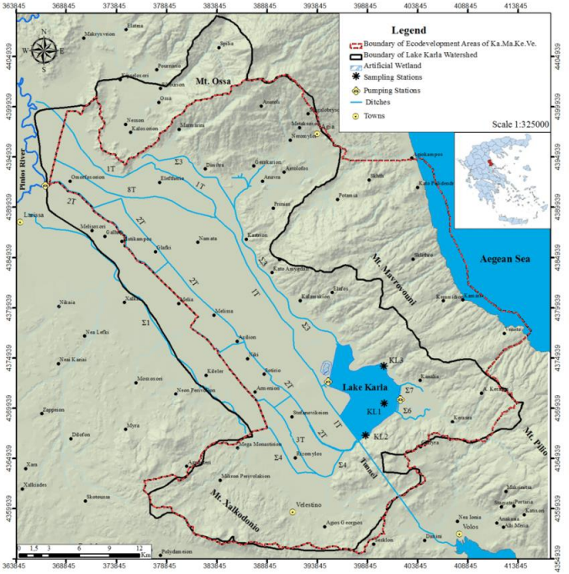
Figure 18: LAKE KARLA LOCATION AND DRAINAGE NETWORKS
Furthemore, this project, of national importance provides, multiple benefits for region of Thessaly, where the Lake is situated. Specifically, the major benefits associated with this project are:
  - flood protection of the low-land areas around the lake and specifically of the city of Volos through the existing tunnel that discharges flood volumes through the tunnel to the streams of the city of Volos.
  - groundwater table recharge by reducing extractions, through irrigation via the lake.
  - Ecosystem restoration and Landscape aesthetics improvement through the lake restoration and the creation of wetlands and ecosystems around it.
  - Water quality improvements through the construction of the dam and a leachates cleaning using natural processes (wetland for leachate cleaning).
  - Pollutant reduction in the Pagasetic Gulf through the effluents’ water storage in lake Karla. Following the creation of the lake, outflow to the Pagasetic Gulf will only take place in the case of extended flooding, when the anti-flooding functioning of the artificial lake is no longer possible.
  - Soil quality improvement through the improvement in the soil’s physical and chemical properties across the broader region.
  - Improved water supply to the broader Volos region, which currently lacks high-quality water, with high-quality subterranean water, through new boring projects.
  - Microclimate change in the region: lower temperatures in the summer, higher temperatures in the winter.
  - Indirect economic benefits for the region through the development of new activities and employment opportunities (such as fisheries, ecotourism) and the reverse of the population shrinkage trend.

Lake Karla is a flagship example of the way a large-scale wetland restoration can address some key Mediterranean challenges, like:
- flash-flood management;
- water scarcity and aquifer depletion;
- ecosystem and landscape degradation;
- climate-change resilience;
- water quality degradation;
Lake Karla restoration is in essence a hybrid NWRM project, as its realization wouldn’t have been possible without the use of conventional (grey) infrastructure (like dam and tunnel). However, restoring natural hydro-morphology can deliver multi-beneficial outcomes that engineered (grey) solutions alone cannot achieve.

Check dam system (MOROCCO)
Morocco’s landscapes combine steep slopes, erodible soils and intense, short-duration rainfall events. This combination prepares the ground for destructive flash floods and massive sediment transport. At the same time rural communities also face chronic water shortages and rely heavily on groundwater.

For this reason, Morocco’s national water strategy includes 150 new hillside dams to strengthen rural resilience and irrigation capacity, as highlighted by the Minister of Equipment and Water. Check dams are small, low-cost structures built across gullies and ephemeral streams. They are inspired from traditional practices used for many centuries and they align perfectly with modern NWRM principles and can be integrated into national water policy. Check dams can result in the:
- slowing down flash-flood;
- trapping sediment and reduce downstream siltation;
- enhancement infiltration and groundwater recharge;
- protecting agricultural terraces and villages;
- creating small upstream pools for local water use.

The developed check-dam systems are one of the most characteristic and long-standing NWRMs in the Mediterranean basin. They are widely used across the country’s semi-arid and mountainous regions to manage flash floods, erosion, and water scarcity—three defining hydrological challenges of the Maghreb.
These small dams are part of a broader effort to secure water supply in drought-prone regions and are consistent with the country’s long-standing use of check-dam systems. They operate jointly with its large-dam network.

These systems are often implemented in networks, where dozens of small structures collectively reduce flood peaks and increase infiltration across an entire sub-catchment. This shows that small-scale retention structures are at the core of Morocco’s water-management strategy.

Moroccan check dams vary widely depending on region and purpose (Figure 3), like:
- Stone masonry check dams in the Rif and Middle Atlas;
- Gabion check dams in semi-arid foothills;
- Earthen or rubble check dams in remote rural areas;
- Hillside reservoirs (small dams) used to store runoff for irrigation;
- Series of micro-dams built along ephemeral streams to create a cascade of retention points.

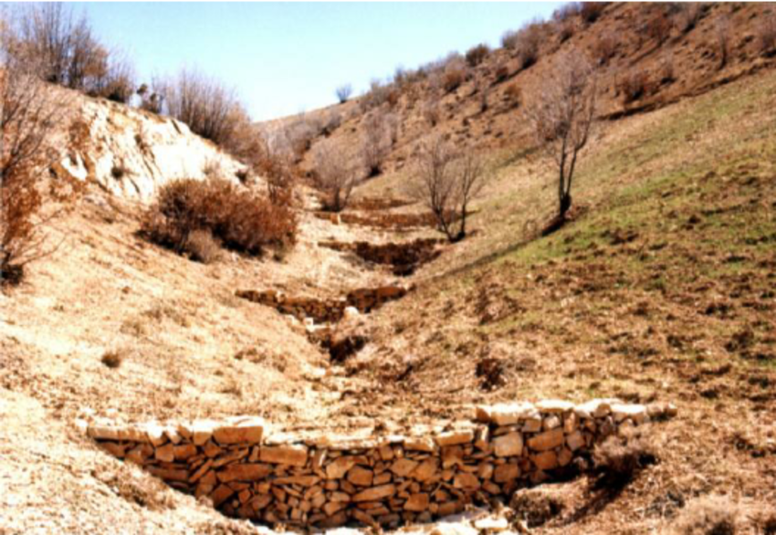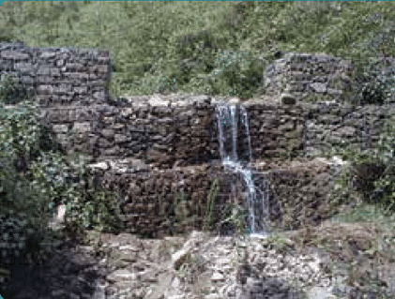
  - (b)
Figure 19: (a) SERIES OF CHECK DAMS (SOURCE: Hassanli & Beecham, 2013), (B)gambion check dam (source: Shrestha et al., 2012).

Similar projects have been implemented in other Mediterranean countries like Cyprus, Lebanon and Greece (Figure 4).

Figure 20: Mansory CHECK DAMS in sifnos island (SOURCE: CARDIMED project with the cooperation of NTUA and implemented by Boulouki team).

infiltration basins (jordan)
Jordan is one of the most water-stressed countries in the world. Rainfall is low, highly variable and concentrated in short, intense events that generate flash floods. At the same time, groundwater is over-exploited and aquifers are declining.

Jordan’s infiltration basins are one of the clearest Eastern Mediterranean examples of Natural Water Retention Measures (Alraggad & Alsharifa, 2010; Al-Kharabsheh, 200). They are formally recognised in the NWRM framework as vegetated depressions designed to store runoff, filter pollutants and recharge aquifers. Normally their volume does not exceed 15.000 m³. The base of the pond needs to be permeable with an infiltration rate varying from 30 m/year for fine texture soils (e.g. sandy loams), 100 m/year for loamy soils and 300 m/year for coarse clean sands. Ideally infiltration rates should exceed evaporation rates.

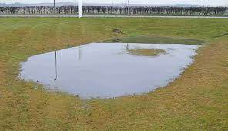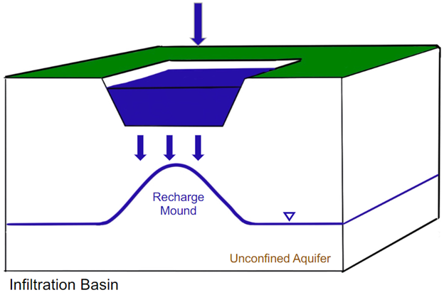
  - (b)
Figure 21: (a) INFILTRATION BASIN EXAMPLE, (B) infiltration basin operation (source: Interstate Technology and Regulatory Council (ITRC).

Often, they are dry most of the year, filling only during storms. They are connected to stormwater drains or runoff channels and are equipped with pre-treatment features (e.g., swales, sediment traps) to prevent groundwater contamination. Infiltration basins aim at:
- capturing stormwater from urban and peri-urban areas;
- allowing water to infiltrate into the soil and recharge aquifers;
- reducing peak flows;
- improving water quality through filtering before water reaches the groundwater.

Infiltration basins are part of its decentralised water-efficiency strategy, which includes:
- Small-scale, community-managed interventions;
- Low-cost measures;
- Use of non-conventional water sources (stormwater, reclaimed water);
- Climate-change adaptation through natural processes.

Jordan’s infiltration basins example illustrate how NWRMs can be adapted to arid and semi-arid climates; mitigate flash-flood conditions; reverse severe groundwater depletion and be suitable for communities with limited financial resources and under land restrictions.

NWRM PROGRAMME (CYPRUS)
Cyprus is characterized by semi-arid climate, high water scarcity, high erosion rates, rapid urbanisation and ephemeral river systems. Cyprus has a 2600 km river network with only 15% perennial, 34% intermittent, and 51% ephemeral. The island’s chronic water scarcity makes the role of water storage and aquifer recharge critical.

For these reasons Cyprus was forced to provide one of the best-documented NWRM programmes in the Mediterranean. Its measures are explicitly listed in the National River Basin Management Plans. In Cyprus, NWRMs are used for aquifer recharge, flood mitigation, erosion control and urban stormwater management. Specifically, some of the NWR measures (Figure 6) applied in the island are:
- Agricultural & Terracing Measures, which originates from the traditional terracing techniques, that are widespread in mountainous regions (e.g., Pitsilia). Terracing helps reducing runoff, increasing infiltration and slope stabilization.
- Retention reservoirs on temporary rivers that are used to store winter flows and recharge aquifers. Typical example is lake Magli, near Nicosia, with an area of about 37 000 m² and perimeter 760 m, which is created from the diversion of part Pediaios river. The storage volume of the pond is grossly estimated to 200,000 m³. The diversion has been made feasible by a small, concrete, diversion dam (maximum height 1m) along the bed of the river. Lake Magli acts both as flood protection to the city of Nicosia and as a recreational lake for the broader area. A similar retention lake example is the Kato Polemidia retention Lake.
- Detention trenches in alluvial riverbeds, like in Paphos (Xeropotamos river). These structures slow down flash flows and enhance infiltration.
- Wetland and lake restoration, over 373 wetlands are identified on the island of Cyprus (58 are natural and 315 are artificial), according to Inventory of the Cyprus Wetlands.
- Check dams and gabion weirs are constructed in series or isolated in various basins of the island (like the Peristerona river on the Mesaoria plain) in order to slow flood peak, reduce erosion, trap sediment and enhance aquifer recharge. Typical example the Orounda check dam (with storage capacity of 25,000 m³). According to Djuma et al. (2017) during its four years of operation, the aquifer has recharged with roughly 30% of the annual streamflow (3.1 million m³ of the 10.4 million m³ year⁻¹ of streamflow).
- Sustainable Urban Drainage Systems (SUDS) are applied in Limassol to manage high-intensity, high frequency storm events, reduce runoff volume, prevent storm drainage system overload and facilitate water reuse. The systems applied include permeable paving, vegetated swales, green roofs and subterranean tanks. Typical example is the permeable pavement that covers Iroon Square in Limassol. The SuDS design aims to the reuse the stormwater that is generated in the square, by collecting and routing the stormwater through channels to an underground storage tank. This tank is equipped with a pump and an overflow outlet towards road downstream.
- Afforestation on artificial terraces is critical in Cyprus in order to combat land degradation. For this reason the Department of Forest aims at expanding forest cover of about 18.7%. To this end the actions taken include planting exotic species in arid areas, restoring cedar habitats in Paphos Forest and volunteer-led initiatives to restore burned areas with native trees. Typical project examples include:
(a) the LIFE-KEDROS project, which consists in restoring 12 hectares of degraded habitat and planting 8 hectares of new cedar habitat in the Paphos Forest.
  - the Plant Micro-Reserves, which consists in the conservation of rare endemic plants (e.g., Centaurea akamantis, Cedrus brevifolia) in Natura 2000 sites.
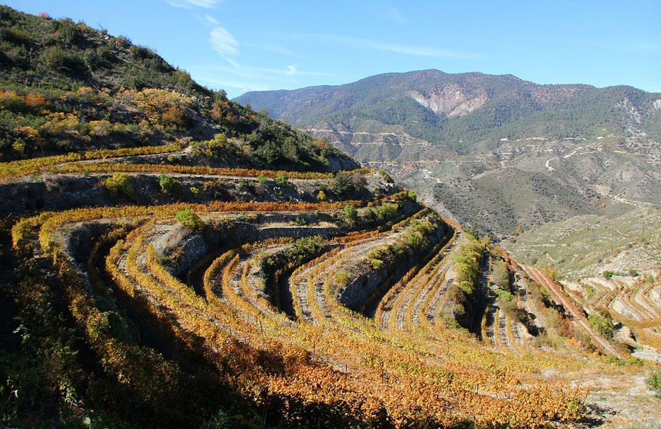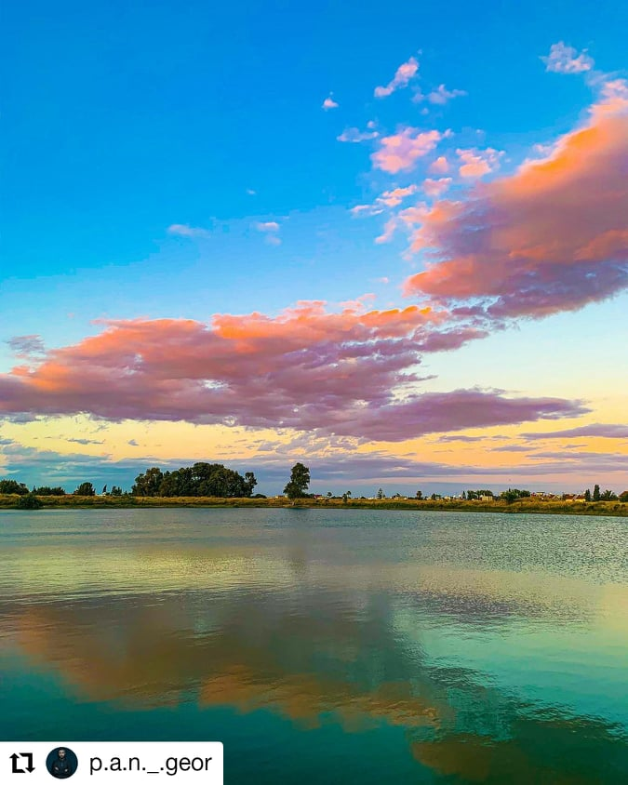
  - (b)
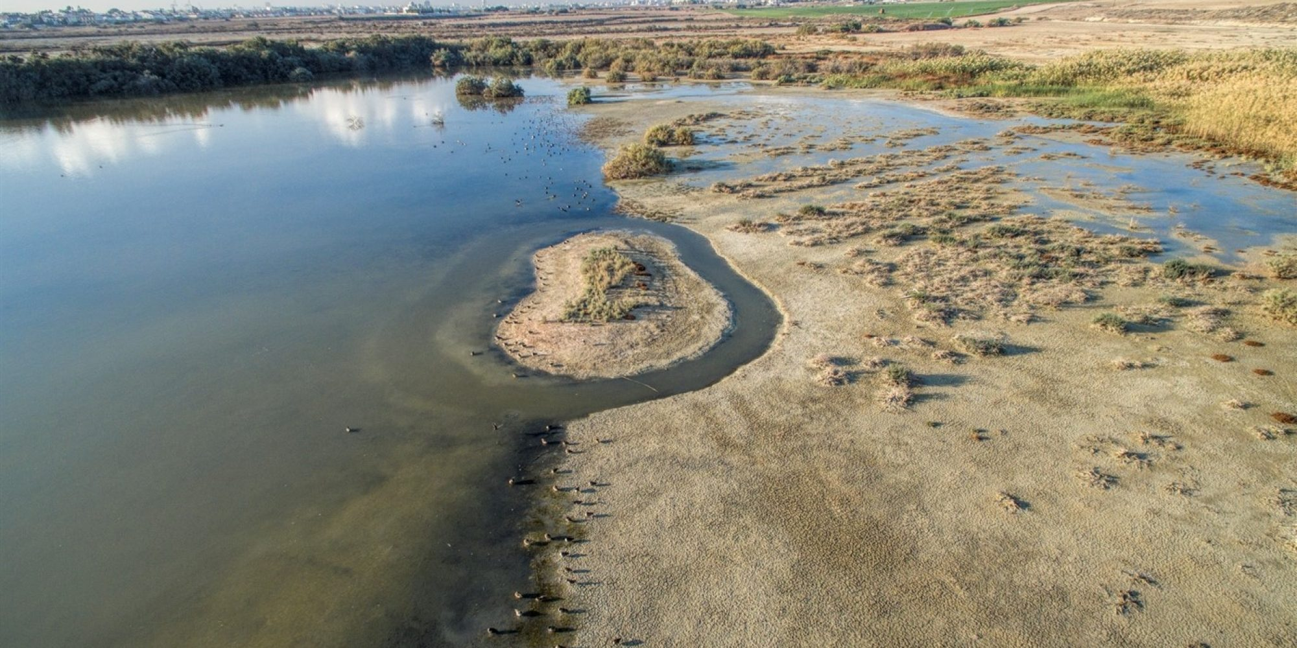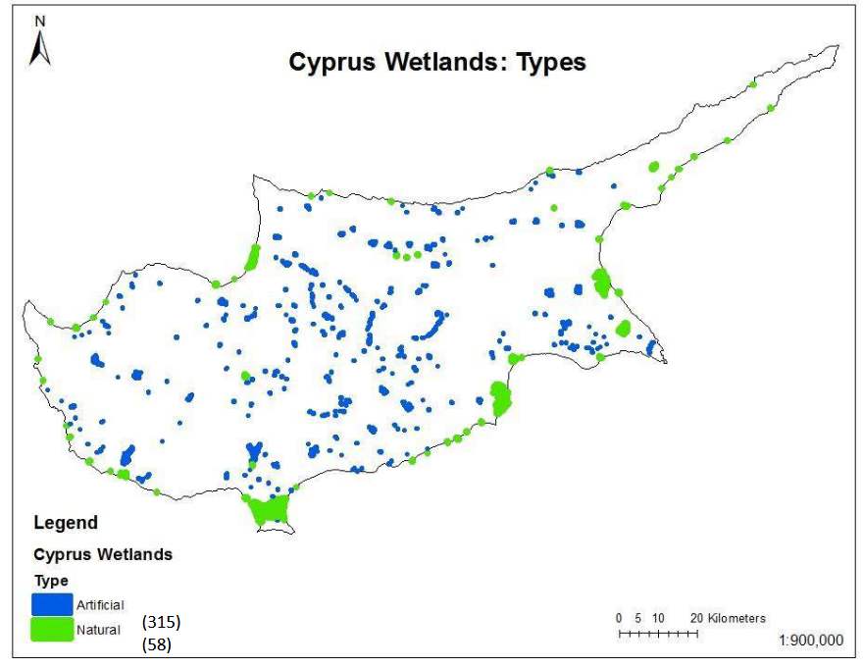
( c ) (d)
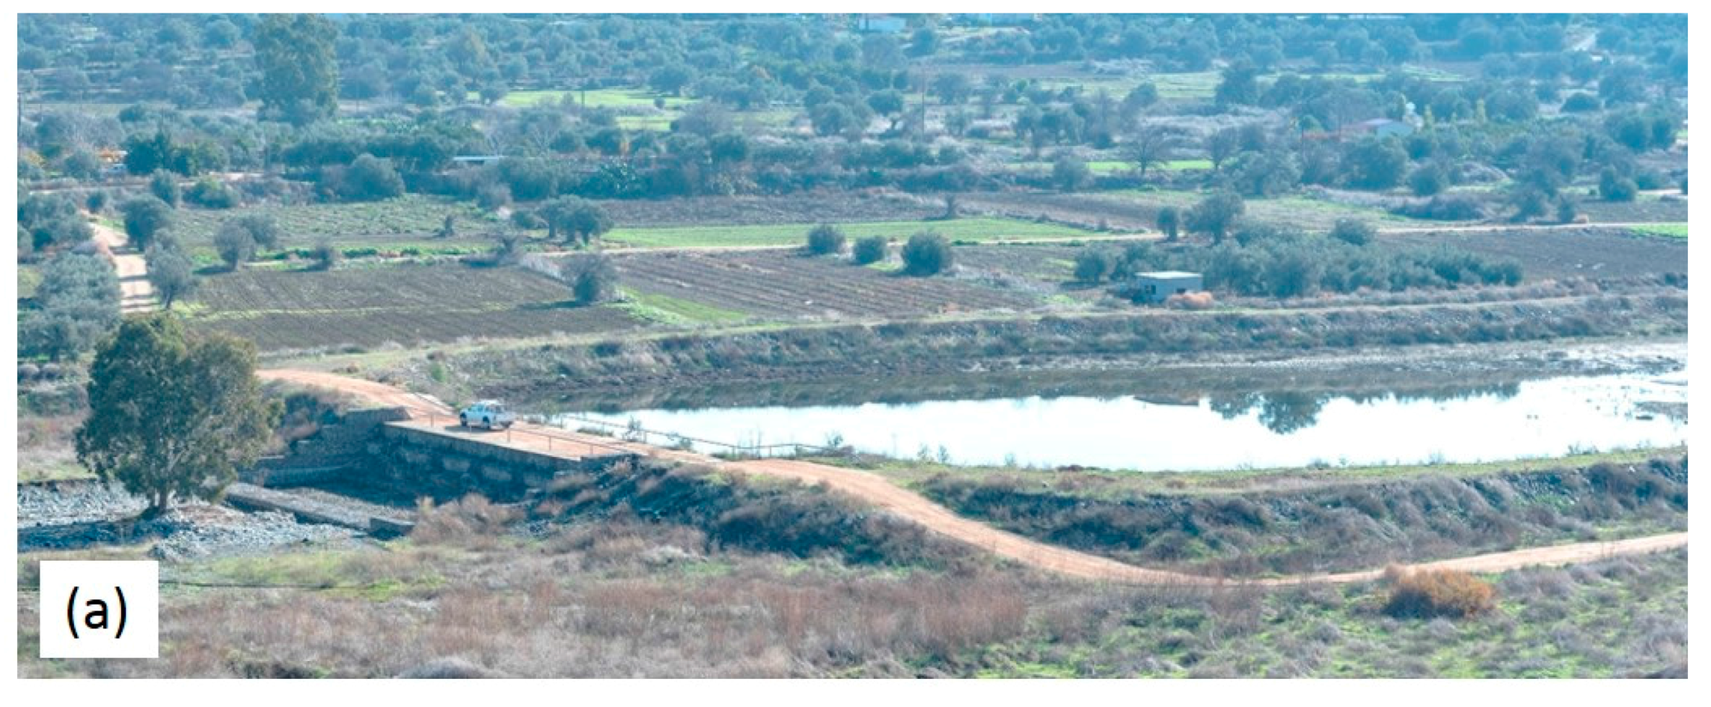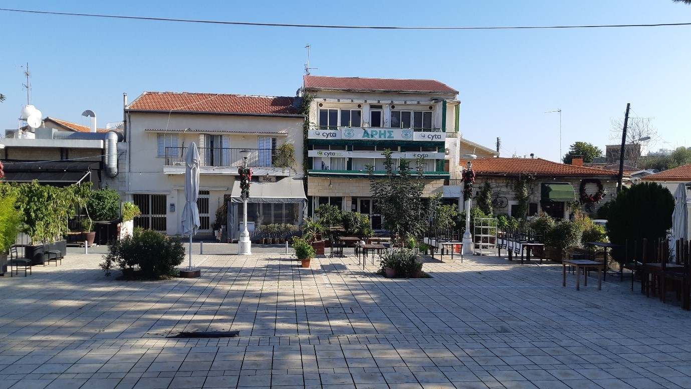
( e ) (f)
Figure 22: (a) pitsilia terracing (source:polygnosi), (B) lake magli, (c) Oroklini Lake (source: Romos Kotsonis), (d) map of wetlands (source: “Inventory of Cyprus Wetlands”), (e) orounda check dam (source: Djuma et al., 2017), (f) permeable pavement implemented in iroon square, limassol (source: iaco ltd).

kerkini lake (greece)
Lake Kerkini is one of Greece’s most important artificial wetlands, created through a large-scale conventional infrastructure project but now functioning as a major ecological hotspot. It represents a model of how a reservoir can evolve into a thriving semi-natural ecosystem.

Lake Kerkini was created in 1932 by constructing embankments along the Strymon River and building a dam near Lithotopos. The aim was to regulate the river, support irrigation and control flooding in the Serres plain. Over time, heavy sediment loads from the Strymon reduced the lake’s capacity, leading to a major redevelopment and construction of a new dam between 1980–1982.
Today, Kerkini is a regulated reservoir whose surface area fluctuates between 54 and 72 km², depending on seasonal inflows. It is fed mainly by the Strymon River and secondarily by the Kerkinitis stream.

Despite being artificial, Lake Kerkini has become one of Europe’s most important wetlands, protected under the Ramsar Convention since 1975. It hosts:
- 227 bird species, including rare and protected species;
- Extensive riparian forests, water-lily zones, and diverse fish populations;
- The largest buffalo population in Greece, grazing in the wet meadows;
- Rich assemblages of amphibians, reptiles, and insects that support the food web.

The lake lies on a major migratory flyway, making it a premier birdwatching destination, especially for species like the Dalmatian Pelican and Pygmy Cormorant.
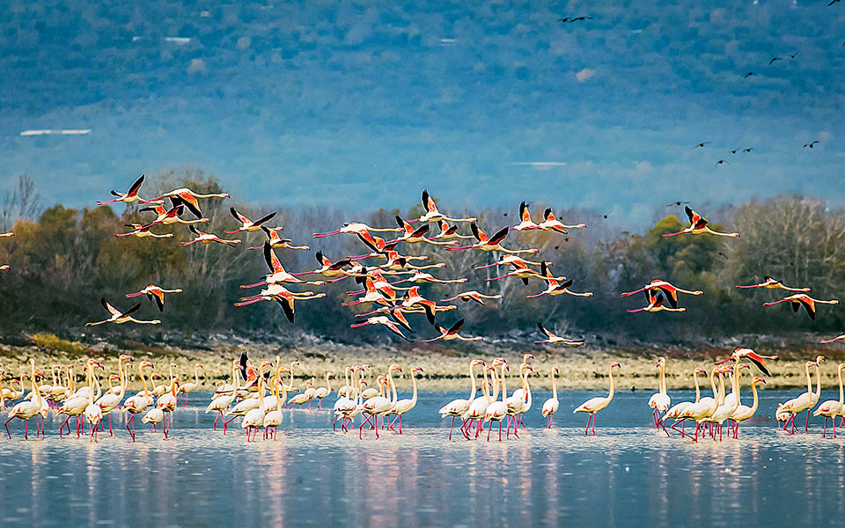
Figure 23: lake kerkini ecosystem (source: © GEO PICTORIAL / GEORGE S BLONSKY).

Kerkini is a rare example of an engineered reservoir that evolved into a high-value natural ecosystem. It demonstrates how a typical conventional (grey) infrastructure, when managed adaptively, can generate:
- flood protection and irrigation benefits;
- biodiversity conservation;
- ecotourism and local economic development;
- a resilient wetland system in a region with variable climatic conditions.

Kerkini Lake can set the example for the transformation of other ageing grey infrastructures, often too expensive to be demolished, into thriving wetland ecosystems.

FLOODPLAIN restoration (Spain)
Spain is often referenced as a pioneer in Mediterranean river restoration. They have implemented Natural Water Retention Measures (NWRMs) in compliance with EU water and biodiversity directives; in order to shift river management toward an ecosystem-based approach. Multiple examples of river restoration, floodplain reconnection and wetland creation, with several emblematic case studies have been realized in Spain. Its case studies demonstrate:
- high hydrological impact in flashy Mediterranean basins;
- strong integration with Natura 2000;
- effective public participation processes;
- clear flood-risk reduction benefits.

A typical example for Spain is the restoration of the Ebro river in “El Ortigoso”, Milagro (Navarra). The project aims at the morphological restoration of the river. The “El Ortigoso” site, located upstream of the confluence of the Ebro and Aragón rivers (Figure 8), has always been a conflictive area during flood episodes, as it is difficult for both rivers to flow together due to land morphological configuration. In these situations, the Aragón river, which provides more flow, prevailed over the Ebro, causing overflows towards the banks.

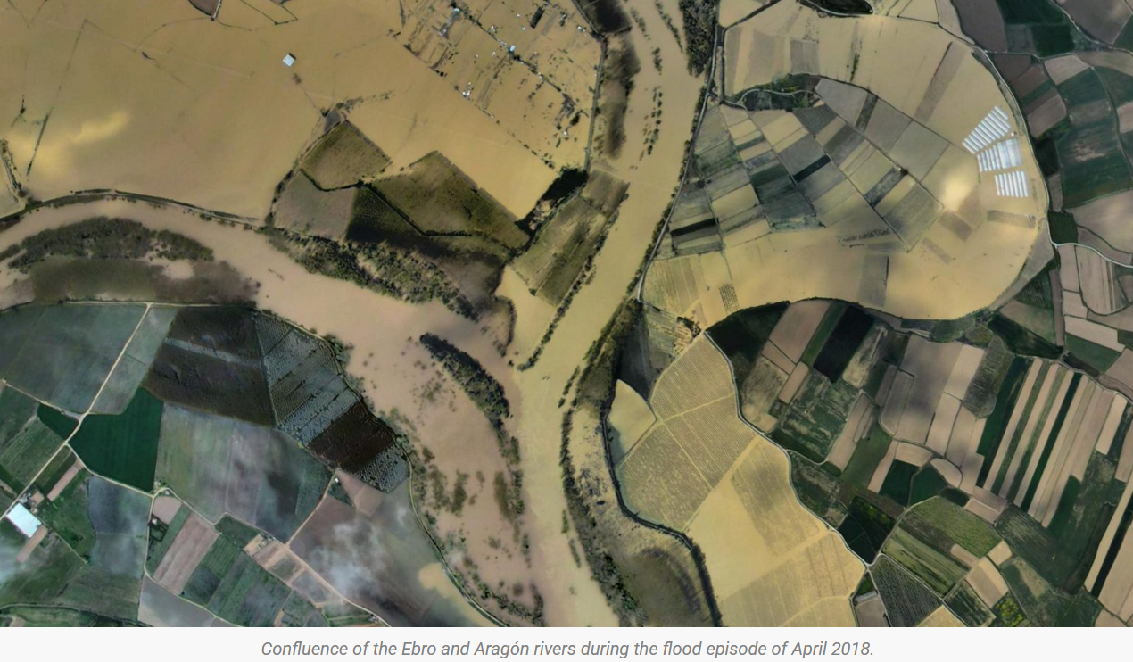
Figure 24: confluence of ebro and aragon river during flood episode (source: ebro resilience).

The main objective of the restoration project is to reduce the damage caused by overflows, together with environmental recovery, contributing to the fulfilment of the environmental objectives of the Ebro Hydrological Plan, in accordance with the Water Framework Directive and in coordination with the Habitats Directive and the programs of the Natura 2000 Network.

The first phase of the project already completed (2023), consists in the removal of 1,790 meters of dykes, placing them back 100 meters away from the river. In this way, a big part of the floodplain is restored (6.4 hectares), providing more space for the two rivers to meet, as well as the restoration of two lost river branches over 400 meters long. The new 800-meter-long dyke has been built based on innovative landscape concepts. Soft and revegetated slopes were used so that the fauna passage is facilitated.

In 2023, the Ebro Hydrographic Confederation (CHE) also began the environmental restoration of the area with more than 12,000 native plants. Vegetation of riparian species typical of this section of the river, such as poplars (Populus alba, Populus nigra), ash trees (Fraxinus angustifolia), willows (Salix alba, Salix purpurea), tamarisk (Tamarix gallica), hawthorns (Crataegus monogyna) and brambles (Rubus ulmifolius) have been planted.

These works carried out in the “El Ortigoso” site represent the first completed action of the Ebro Resilience Strategy in Navarra.

Another earlier example of floodplain restoration in Spain is the Soto de los Tetones (Ebro River, Navarra) completed between 2005-2006 (Figure 9). The floodplain area restored was 110 ha of former rice fields. The objective was to improve environmental conditions in the area, increase water retention and prevent damages caused by floods in the city of Tudela, located downstream.

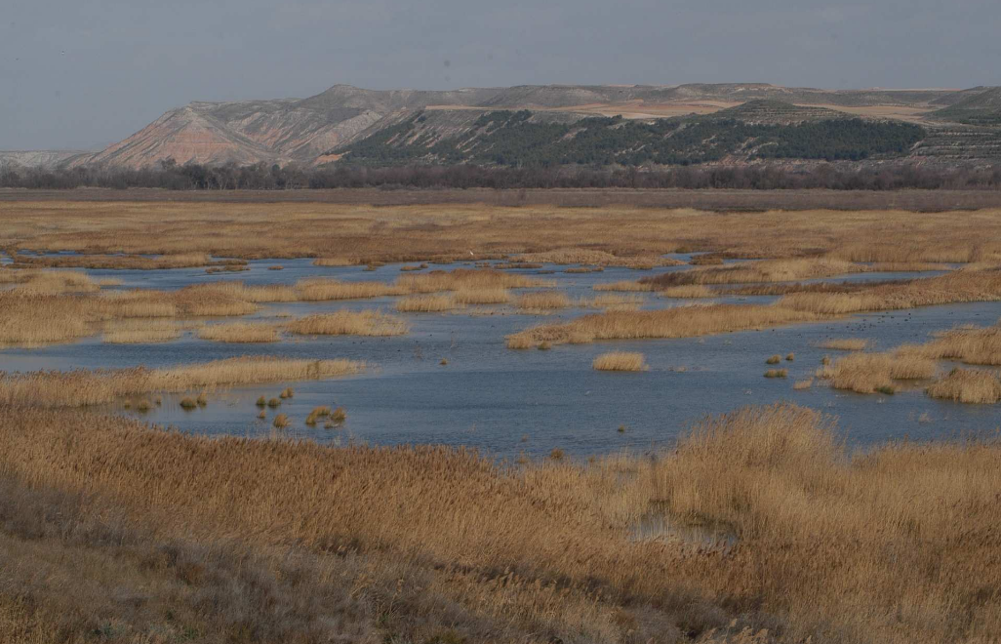
Figure 25: Soto de los Tetones restoration (source: ciref).

Summary
As described, the Mediterranean context is characterized by flash floods, semi-arid climate, water scarcity, high erosion rates, rapid urbanisation, land-use pressures and ephemeral river systems. To tackle these challenges different Nature Water Retention Measures and/ or Hybrid Measures have been already implemented.

As presented above, in a Mediterranean setting, wetland/ floodplain restoration is consistently considered as a very effective NWRM as they:
- reduce flood damage and support summer ecological flows;
- improve the surrounding ecosystem;
- trap sediment and regulate inflows;
- provide aquifer recharge;
- improve water quality through filtration;
- provide storm-surge protection, crucial under sea-level rise (coastal wetlands).

However, in steep, fire-prone slopes areas forestry and agricultural NMWM are most effective, as the improve soil infiltration, reduce surface runoff, decrease sediment loads. Furthermore, forestry NWRM are especially critical after wildfires to prevent post-fire erosion.

In the rapidly growing urban centres, the development of urban NWRMs is locally crucial and can significantly reduce the flood load on drainage networks, while improving the city’s landscape.
In Table 3 a qualitative comparison between different NWRMs sub-categories is presented based on their performance in the Mediterranean context and its major challenges. The comparison is based on scoring scale varying from a very low performance (1/5) to a very high performance (5/5).
Table 19: Qualitative scoring comparison of nwrm categories in the mediterranean context (Scores: 1 = very low performance, 5 = very high performance).
Category | Flood attenuation | Drought | GroundWater  recharge | Erosion control | Biodiversity | Cost | Feasibility
Agricultural | 3 | 4 | 3 | 5 | 3 | 4 | 3
Forestry | 3 | 3 | 3 | 4 | 4 | 3 | 3
Hydromorphological | 5 | 3 | 4 | 3 | 5 | 2 | 2
Wetland & peatland | 4 | 4 | 4 | 3 | 5 | 2 | 2
Urban | 3 | 2 | 2 | 2 | 3 | 3 | 4

références
- Abbe Tim, Hrachovec Mike and Winter Steve, (2018), Engineered Log Jams: Recent Developments in Their Design and Placement, with examples from the Pacific Northwest, U.S.A., Reference Module in Earth Systems and Environmental Sciences, Elsevier, 2018. 30-Oct-18 doi: 10.1016/B978-0-12-409548-9.11031-0.
- Aloui S., Mazzoni A., Elomri A., Aouissi J., Boufekane A., Zghibi A., 2023, A review of Soil and Water Assessment Tool (SWAT) studies of Mediterranean catchments: Applications, feasibility, and future directions // Journal of Environmental Management. Vol. 326. No. Pt B. p. 116799.
- Alraggad, Marwan & Mohammad, Alsharifa Hind. (2010). Managed Aquifer Recharge (MAR) through Surface Infiltration in the Azraq Basin/Jordan. Journal of Water Resource and Protection. 02. 10.4236/jwarp.2010.212125.
- Andrikopoulou, T. (2020). Integrated approach to flood risk assessment – the case of the Pinios River (Diploma thesis). National Technical University of Athens, Institutional Repository. https://dspace.lib.ntua.gr/xmlui/handle/123456789/50529.
- Associated Programme on Flood Management. (2020). Selecting measures and designing strategies for integrated flood management: Guidance document. World Meteorological Organization & Global Water Partnership. https://www.floodmanagement.info/guidance-document/
- Aquatic Sciences and Fisheries Abstracts (2020), Urban Wetlands for Cooler and Climate-Proof Cities, Wetlands International, FRN: MB2208287, 8 pages.
- Atef Al-Kharabsheh, Ground-water modelling and long-term management of the Azraq basin as an example of arid area conditions (Jordan), Journal of Arid Environments, Volume 44, Issue 2, 2000, Pages 143-153, ISSN 0140-1963, https://doi.org/10.1006/jare.1999.0580.
- Bastola, Satish (2022), The regionalization of a parameter of HYMOD, a conceptual hydrological model, using data from across the globe [J]. HydroResearch, 2022, 5 (1): 13-21. 2022-01-31.
- Beven, K. (2012). Rainfall–runoff modelling: The primer (2nd ed.). John Wiley & Sons. https://doi.org/10.1002/9781119951001
- Beven, K. J., Kirkby, M. J., Freer, J. E., & Lamb, R. (2021). A history of TOPMODEL. Hydrology and Earth System Sciences, 25, 527–549. https://doi.org/10.5194/hess-25-527-2021
- Beven, K. J. (2025). A short history of philosophies of hydrological model evaluation and hypothesis testing. WIREs Water, 12(1), e1761. https://doi.org/10.1002/wat2.1761
- Bouadila, A., Tzoraki, O. & Benaabidate, L. Hydrological modeling of three rivers under Mediterranean climate in Chile, Greece, and Morocco: study of high flow trends by indicator calculation. Arab J Geosci 13, 1057 (2020). https://doi.org/10.1007/s12517-020-06013-2
- Box, G. E. P. (1979). Robustness in the strategy of scientific model building. In R. L. Launer & G. N. Wilkinson (Eds.), Robustness in statistics (pp. 201–236). Academic Press.

- Ciriminna, D., Ferreri, G. B., Noto, L. V., & Celauro, C. (2022). Numerical Comparison of the Hydrological Response of Different Permeable Pavements in Urban Area. Sustainability, 14(9), 5704. https://doi.org/10.3390/su14095704
- Convention on Wetlands. (2021). Global guidelines for peatland rewetting and restoration. Ramsar Technical Report No. 11. Gland, Switzerland: Secretariat of the Convention on Wetlands.
- Coron, L., Thirel, G., Delaigue, O., Perrin, C., & Andréassian, V. (2017). The suite of lumped GR hydrological models in an R package. Environmental Modelling & Software, 94, 166–171. https://doi.org/10.1016/j.envsoft.2017.05.002
- Darwish, K. (2023). GIS-Based Multi-Criteria Decision Analysis for Flash Flood Hazard and Risk Assessment: A Case Study of the Eastern Minya Watershed, Egypt. Environmental Sciences Proceedings, 25(1), 87. https://doi.org/10.3390/ECWS-7-14315
- De Moel, H., van Alphen, J., & Aerts, J. C. J. H. (2007). Flood risk mapping at the local scale: Concepts and challenges. In K. D. Schmidt-Thomé (Ed.), Flood risk management: Hazards, vulnerability and mitigation measures (Advances in Natural and Technological Hazards Research, Vol. 25, pp. 171–184). Springer. https://doi.org/10.1007/978-1-4020-4598-1_14
- Deng, Jiaojiao & Fang, Shuai & Fang, Xiangmin & Jin, Yanqiang & Kuang, Yuanwen & Lin, Fangmei & Liu, Jiaqing & Ma, Jingran & Yanxia, Nie & Shengnan, Ouyang & Ren, Jing & Tie, Liehua & Tang, Songbo & Tan, Xiangping & Wang, Xugao & Fan, Zhaofei & Wang, Qing-Wei & Wang, Hang & Liu, Chenggang. (2023). Forest understory vegetation study: current status and future trends. Forestry Research. 3. 10.48130/FR-2023-0006.
- Dingman, S.L. Physical Hydrology. 3rd ed. Waveland Press, Long Grove, IL (2015).
- Djuma, H., Bruggeman, A., Camera, C., Eliades, M., & Kostarelos, K. (2017). The Impact of a Check Dam on Groundwater Recharge and Sedimentation in an Ephemeral Stream. Water, 9(10), 813. https://doi.org/10.3390/w9100813
- Dwarakish, G. S., & Ganasri, B. P. (2015). Impact of land use change on hydrological systems: A review of current modelling approaches. Cogent Geoscience, 1(1). https://doi.org/10.1080/23312041.2015.1115691
- European Central Bank, (2025), Working Paper CB Working Paper Series No 3002, 68 pages.
- European Union. (2007). Directive 2007/60/EC of the European Parliament and of the Council of 23 October 2007 on the assessment and management of flood risks (Official Journal L 288, pp. 27–34). https://eur-lex.europa.eu/eli/dir/2007/60/oj/eng
- European Union (2014), EU policy document on Natural Water Retention Measures, Technical Report - 2014 – 082, 18 pages.
- European Union (2014), Natural Water Retention Measures in Europe: A Guide to Support the Selection, Design and Implementation of Natural Water Retention Measures in Europe, 98 pages.
- Gonzalez-Garcıa, A. Palomo, I., Codemo, A., Rodeghiero, M., Dubo, T., Vallet, A., Lavorel, S., 2025, Cell Reports Sustainability 2, 100336 March 28, Published by Elsevier Inc. https://doi.org/10.1016/j.crsus.2025.100336
- Grabs, W., Tyagi, A. C., & Hyodo, M. (2007). Integrated flood management. Water Science and Technology, 56(4), 97–103. https://doi.org/10.2166/wst.2007.541
- Greifswald Mire Centre (2021): Opportunities for Peatlands and Paludiculture in the EU Common Agricultural Policy (2023-2027) Opportunities for paludiculture in CAP (greifswaldmoor.de)
- Hassanli, Ali & Beecham, Simon. (2013). Criteria for optimizing check dam location and maintenance requirements. Check Dams, Morphological Adjustments and Erosion Control in Torrential Streams. 11-31.
- Hydrological Engineering Center (HEC), U.S. Army Corps of Engineers. (n.d.). HEC-HMS technical reference manual. Retrieved February 2026, from https://www.hec.usace.army.mil
- IUCN, (2020), Global Standard for Nature-based Solutions lists the Criteria and Indicators, as adopted by the 98th Meeting of the IUCN Council in 2020.
- International Commission for the Protection of the Danube River (ICPDR), 2021. Danube River Basin Management Plan 2021. IC–231, International Commission for the Protection of the Danube River, Vienna, Austria. Available from: https://www.icpdr.org/main/publications/danube-river-basin-management-plan-drbmp-update-2021
- IPCC, 2021: Climate Change 2021: The Physical Science Basis. Contribution of Working Group I to the Sixth Assessment Report of the Intergovernmental Panel on Climate Change [Masson-Delmotte, V., P. Zhai, A. Pirani, S.L. Connors, C. Péan, S. Berger, N. Caud, Y. Chen, L. Goldfarb, M.I. Gomis, M. Huang, K. Leitzell, E. Lonnoy, J.B.R. Matthews, T.K. Maycock, T. Waterfield, O. Yelekçi, R. Yu, and B. Zhou (eds.)]. Cambridge University Press, Cambridge, United Kingdom and New York, NY, USA, 2391 pp. doi:10.1017/9781009157896.
- IPCC, 2023: Climate Change 2023: Synthesis Report. Contribution of Working Groups I, II and III to the Sixth Assessment Report of the Intergovernmental Panel on Climate Change [Core Writing Team, H. Lee and J. Romero (eds.)]. IPCC, Geneva, Switzerland, pp. 35-115, doi: 10.59327/IPCC/AR6-9789291691647
- Koutsoyiannis, D. (2025). When are models useful? Revisiting the quantification of reality checks. Water, 17(2), 264. https://doi.org/10.3390/w17020264
- Kumar, P., Lohani, A. K., & Nema, A. K. (2019). Rainfall runoff modelling using MIKE 11 NAM model. Current World Environment, 14(1), 27–36. https://doi.org/10.12944/CWE.14.1.05
- Lionello, P. and L. Scarascia, 2020: The relation of climate extremes with global warming in the Mediterranean region and its north versus south contrast. Reg. Environ. Change, 20(1), 31, doi:10.1007/s10113-020-01610-z.
- MedECC (2020) Climate and Environmental Change in the Mediterranean Basin – Current Situation and Risks for the Future. First Mediterranean Assessment Report [Cramer, W., Guiot, J., Marini, K. (eds.)]. Union for the Mediterranean, Plan Bleu, UNEP/MAP, Marseille, France, 632 pp., ISBN: 978-2-9577416-0-1, doi:10.5281/zenodo.4768833.
- Mulvany, T. J. (1850). On the use of self-registering rain and flood gauges. Proceedings of the Institution of Civil Engineers of Ireland.
- National Weather Service, Office of Hydrological Development. (2002). Conceptualization of the Sacramento soil moisture accounting model (SAC-SMA) (Tech. Doc. 23sacsma). NOAA.
- Nearing, G., Cohen, D., Dube, V., Gauch, M., Gilon, O., Harrigan, S., Hassidim, A., Klotz, D., Kratzert, F., Metzger, A., Nevo, S., Pappenberger, F., Prudhomme, C., Shalev, G., Shenzis, S., Tekalign, T. Y., Weitzner, D., & Matias, Y. (2024). Global prediction of extreme floods in ungauged watersheds. Nature, 627, 559–563. https://doi.org/10.1038/s41586-024-07145 1
- Olaleye, A., et al. (2024). Review and comparative study of hydrological models for rainfall–runoff modelling. International Journal of Environment and Geoinformatics, 11(3), 119–129. https://doi.org/10.30897/ijegeo.1514176
- Pahl-Wostl, C. (2007). Transitions towards adaptive management of water facing climate and global change. Water Resources Management, 21, 49–62.
- Pereira, M.G., Fernandes, L.S., Carvalho, S. et al. (2016), Modelling the impacts of wildfires on runoff at the river basin ecological scale in a changing Mediterranean environment. Environ Earth Sci 75, 392. https://doi.org/10.1007/s12665-015-5184-y
- Polo Martín, Bárbara. (2025). Valencia's battle against floods: A cartographic review to assess water management strategies. Journal of Geography and Cartography. 8. 10129. 10.24294/jgc10129.
- Rossman, L. A. (2015). Storm water management model user’s manual version 5.1 (EPA/600/R-14/413b). U.S. Environmental Protection Agency
- Shrestha, Arun & GC, Ezee & Adhikary, Rajendra & Rai, Sundar. (2012). Resource Manual on Flash Flood Risk Management, Module 3: Structural Measures.
- Singh, V. P. (1995). Hydrological modelling of watershed systems. In Proceedings of the International Conference of Hydrological Science and Technology (pp. 123–132). American Society of Civil Engineers.
- Singh, V. P., & Woolhiser, D. A. (2002). Mathematical modelling of watershed hydrology. Journal of Hydrological Engineering, 7(4), 270–292. https://doi.org/10.1061/(ASCE)1084-0699(2002)7:4(270)
- Sirin, A., Medvedeva, M., Korotkov, V., Itkin, V., Minayeva, T., Ilyasov, D., Suvorov, G., & Joosten, H. (2021). Addressing Peatland Rewetting in Russian Federation Climate Reporting. Land, 10(11), 1200. https://doi.org/10.3390/land10111200
- Smith, G. P., Davey, E. K., & Cox, R. (2014). Flood hazard (WRL Technical Report 2014/07). Water Research Laboratory, School of Civil and Environmental Engineering, University of New South Wales. https://knowledge.aidr.org.au/media/2334/wrl-flood-hazard-techinical-report-september-2014.pdf
- Stockholm Environment Institute. (n.d.). WEAP: Water evaluation and planning system. Retrieved February 2026, from https://www.weap21.org
- United Nations Office for Disaster Risk Reduction. (2015). Sendai framework for disaster risk reduction 2015–2030. United Nations. https://www.undrr.org/publication/sendai-framework-disaster-risk-reduction-2015-2030

- UNESCO-IHP, (2006), Integrated Flood Management (IFM) Framework, ASSOCIATED PROGRAMME ON FLOOD MANAGEMENT, WMO-No.1999, 86 pages.
- USDA, (2019), Agroforestry Strategic Framework, Fiscal Years 2019–2024, 26 pages.
- U.S. Fish & Wildlife Service (FWS) and the National Oceanic and Atmospheric Administration's National Marine Fisheries Service (2009), Status and Trends of Wetlands in the Coastal Watersheds of the Conterminous United States, 58 pages.
- Wang, Meiling & Zhang, Lei & Baddoo, Thelma. (2016). Hydrological Modeling in A Semi-Arid Region Using HEC-HMS. Journal of Water Resource and Hydraulic Engineering (JWRHE). 5. 105-115. 10.5963/JWRHE0503004.
- World Meteorological Organization, & Global Water Partnership. (2004). Integrated flood management: Concept paper (APFM Technical Document No. 1). Associated Programme on Flood Management. https://www.floodmanagement.info/publications/concept_paper_e.pdf
- Zittis, G., Samuel Somot, & Giorgi Filippo. (2020). First Mediterranean Assessment Report – Appendix B: Maps of seasonal temperature and precipitation changes for the Mediterranean Basin. In Climate and Environ-mental Change in the Mediterranean Basin – Current Situation and Risks for the Future. First Mediterranean Assessment Report. (p. 632). Zenodo. https://doi.org/10.5281/zenodo.5794071

UNEP/MAP – Plan Bleu (2020). State of the Environment and Development in the Mediterranean (SoED 2020. https://planbleu.org/wp-content/uploads/2020/11/SoED-Full-Report.pdf
MedECC (2020). Climate and Environmental Change in the Mediterranean Basin – Current Situation and Risks for the Future. First Mediterranean Assessment Reprt. Summary for Policymakers (MAR1 SPM). https://www.medecc.org/wp-content/uploads/2021/05/MedECC_MAR1_SPM_ENG.pdf
MedECC (2020). Climate and Environmental Change in the Mediterranean Basin – Current Situation and Risks for the Future. First Mediterranean Assessment Reprt. https://zenodo.org/records/4768833.
European Environment Agency (2021). Nature-based solutions in Europe: Policy, knowledge and practice for climate change adaptation and disaster risk reduction (EEA Report No 01/2021). https://www.eea.europa.eu/publications/nature-based-solutions-in-europe
Global Water Partnership – Mediterranean (GWP-Med), “Water Day Zero for cities – not for Alexandroupolis, a Mediterranean coastal town”, https://www.gwp.org/en/GWP-Mediterranean/WE-ACT/News-List-Page/water-day-zero-for-cities-not-for-alexandroupolis-a-mediterranean-coastal-town/
European Commission (2021). Forging a Climate-Resilient Europe – The New EU Strategy on Adaptation to Climate Change (COM (2021) 82 final). https://eur-lex.europa.eu/legal-content/EN/TXT/HTML/?uri=CELEX:52021DC0082
UNEP/MAP (2016). Regional Climate Change Adaptation Framework for the Mediterranean Marine and Coastal Areas (RCCAF). https://wedocs.unep.org/handle/20.500.11822/22182
Union for the Mediterranean (2017). UfM Water Agenda. https://ufmsecretariat.org/what-we-do/environment-water/
https://www.wes-med.eu/activities_type/rw-4-reg-regional-training-on-water-harvesting
Directive 2007/60/EC

